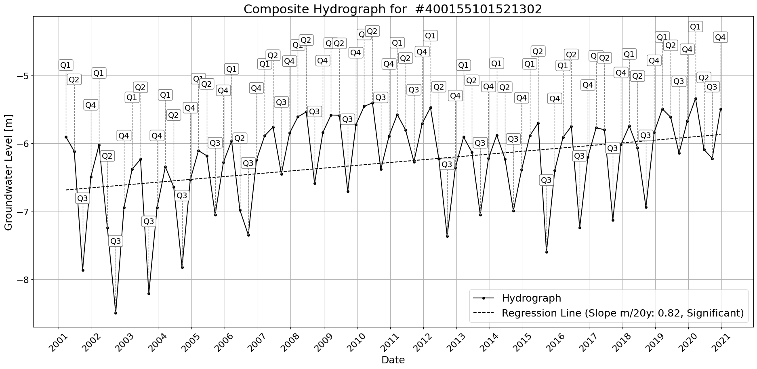

Figure: Site_#400155101521302.png

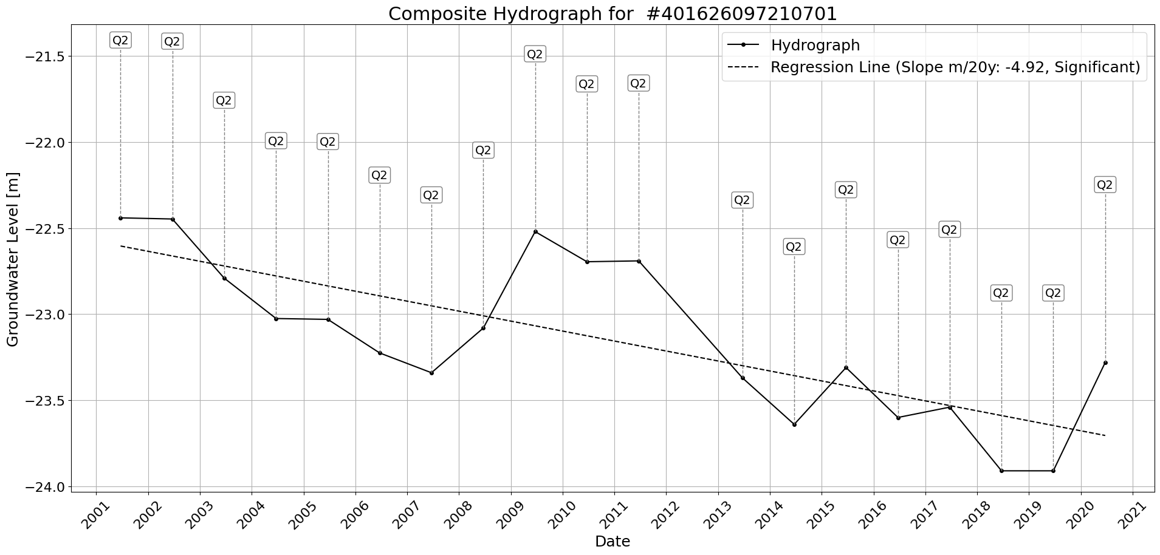

Figure: Site_#401626097210701.png

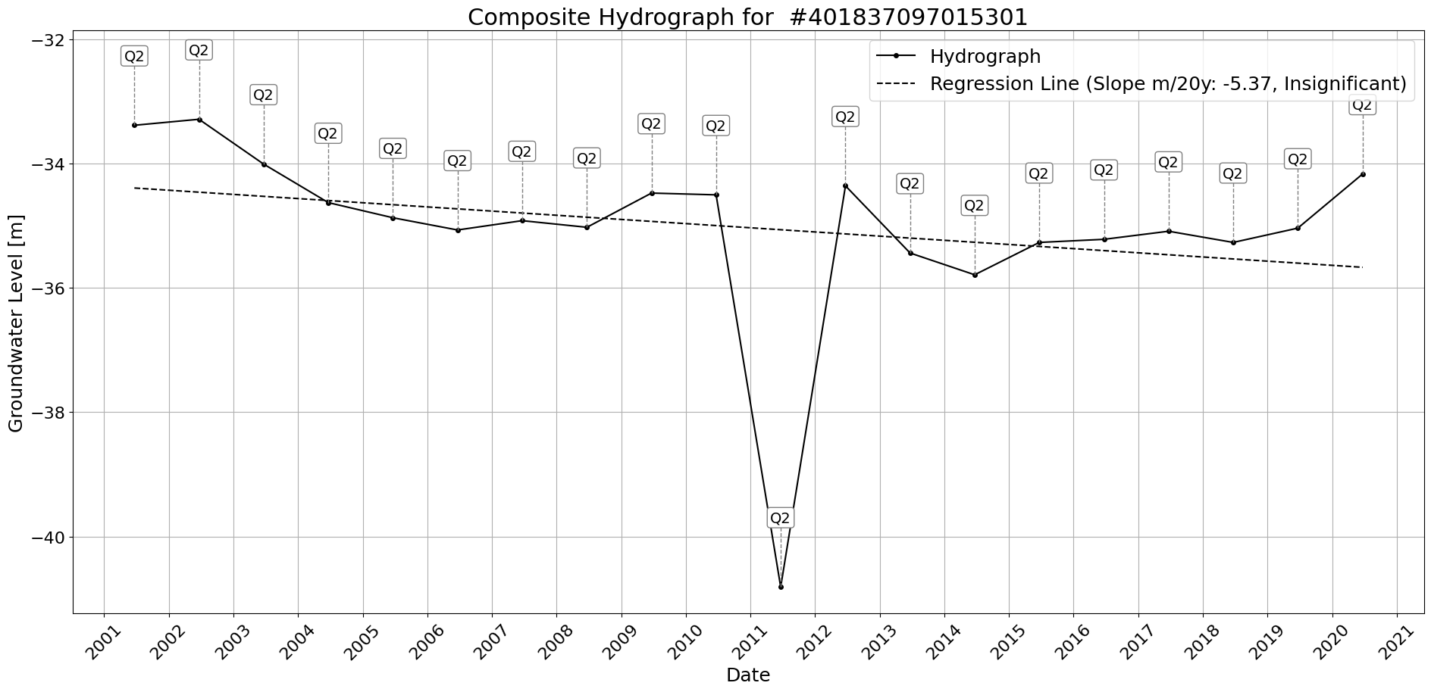

Figure: Site_#401837097015301.png

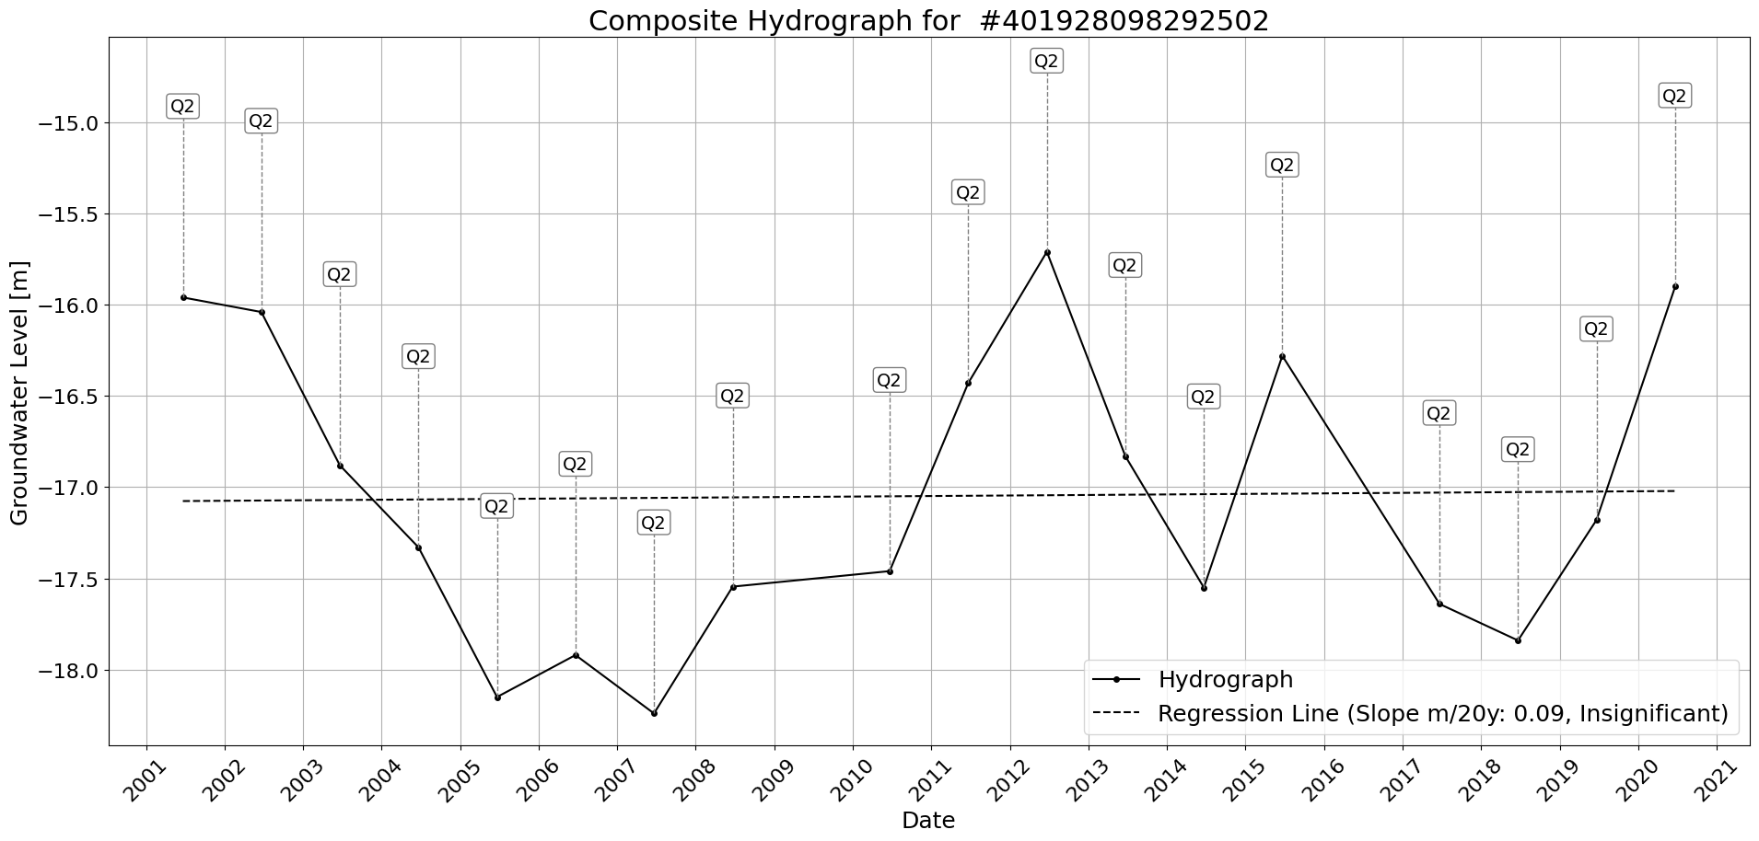

Figure: Site_#401928098292502.png

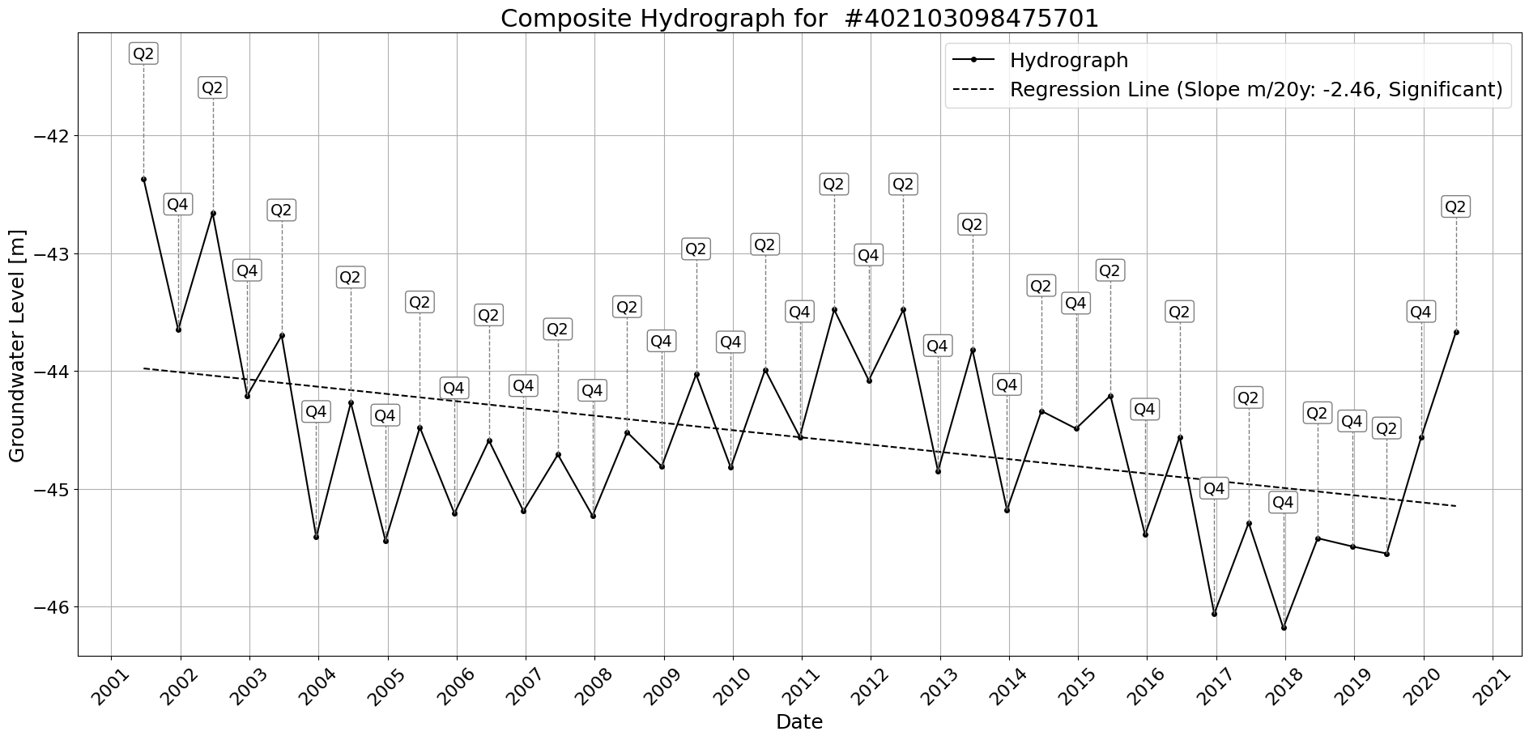

Figure: Site_#402103098475701.png

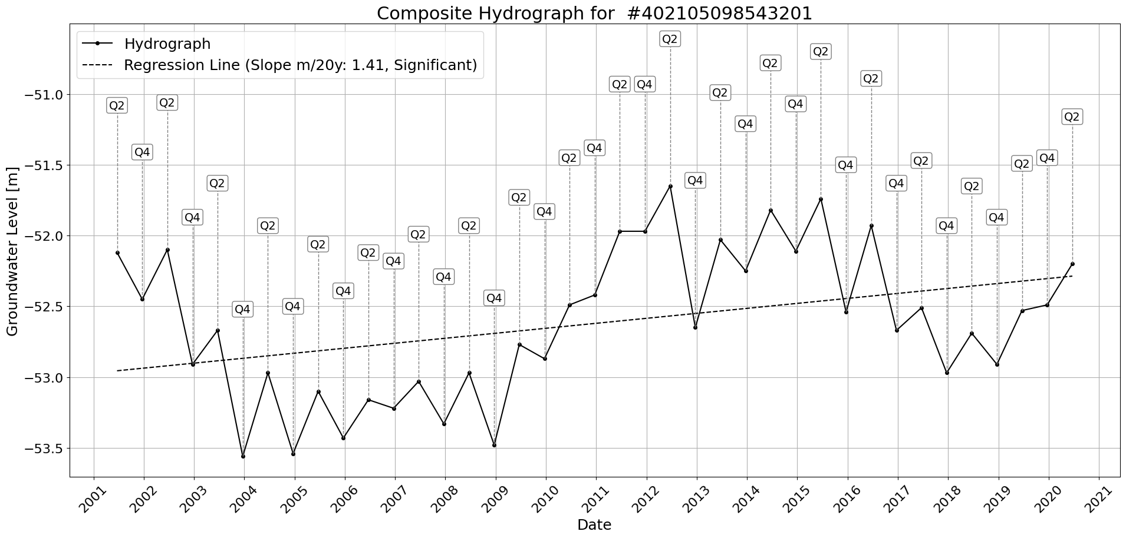

Figure: Site_#402105098543201.png

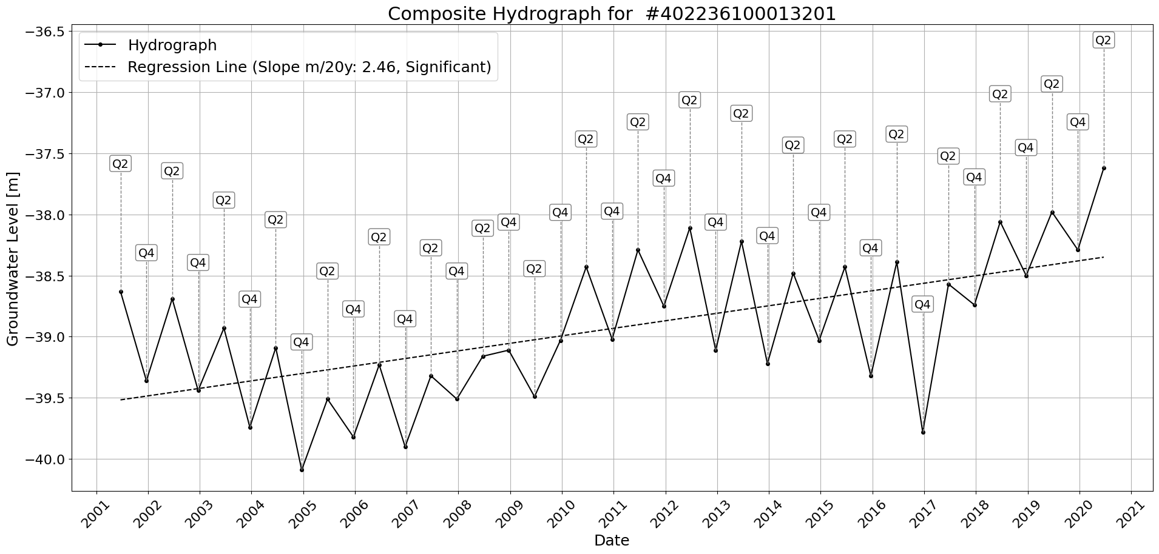

Figure: Site_#402236100013201.png

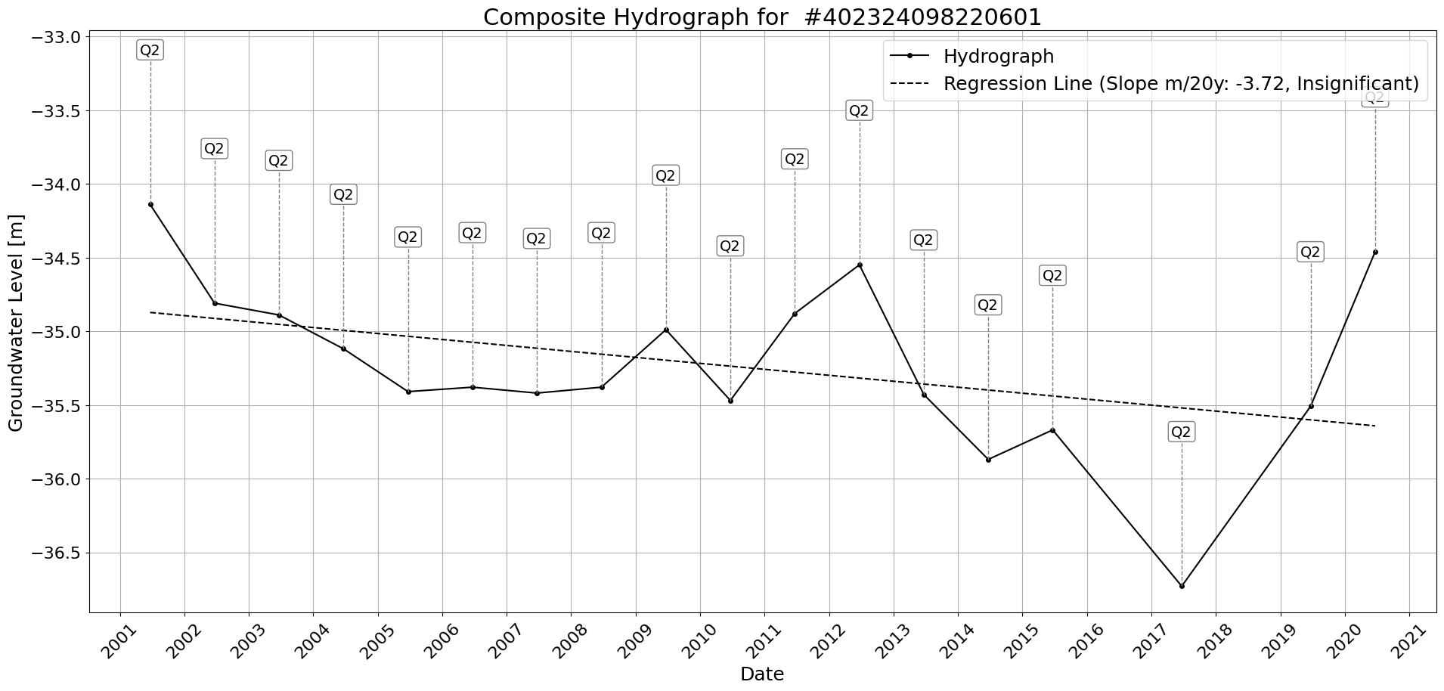

Figure: Site_#402324098220601.png

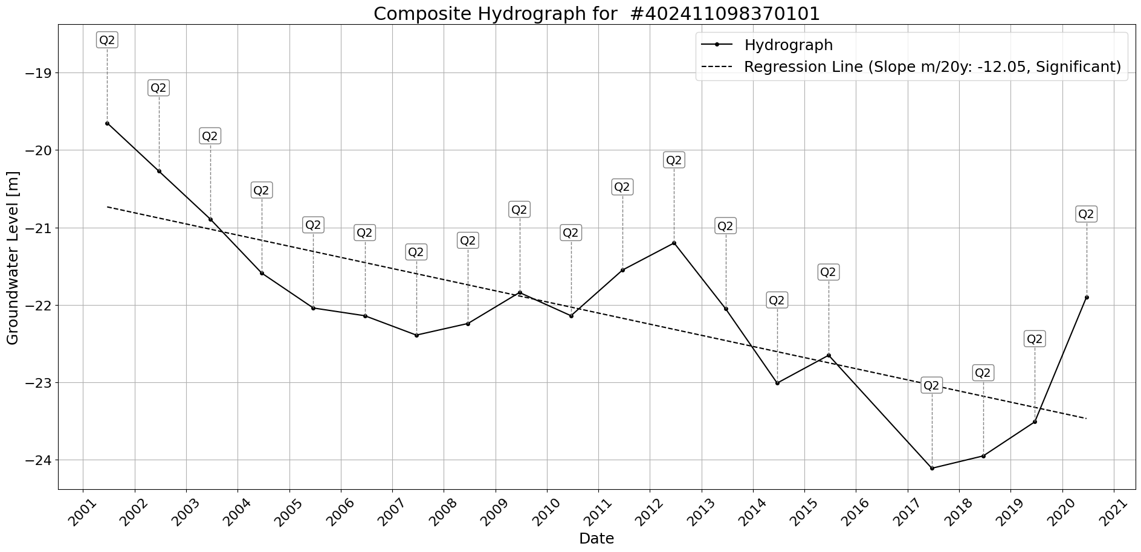

Figure: Site_#402411098370101.png

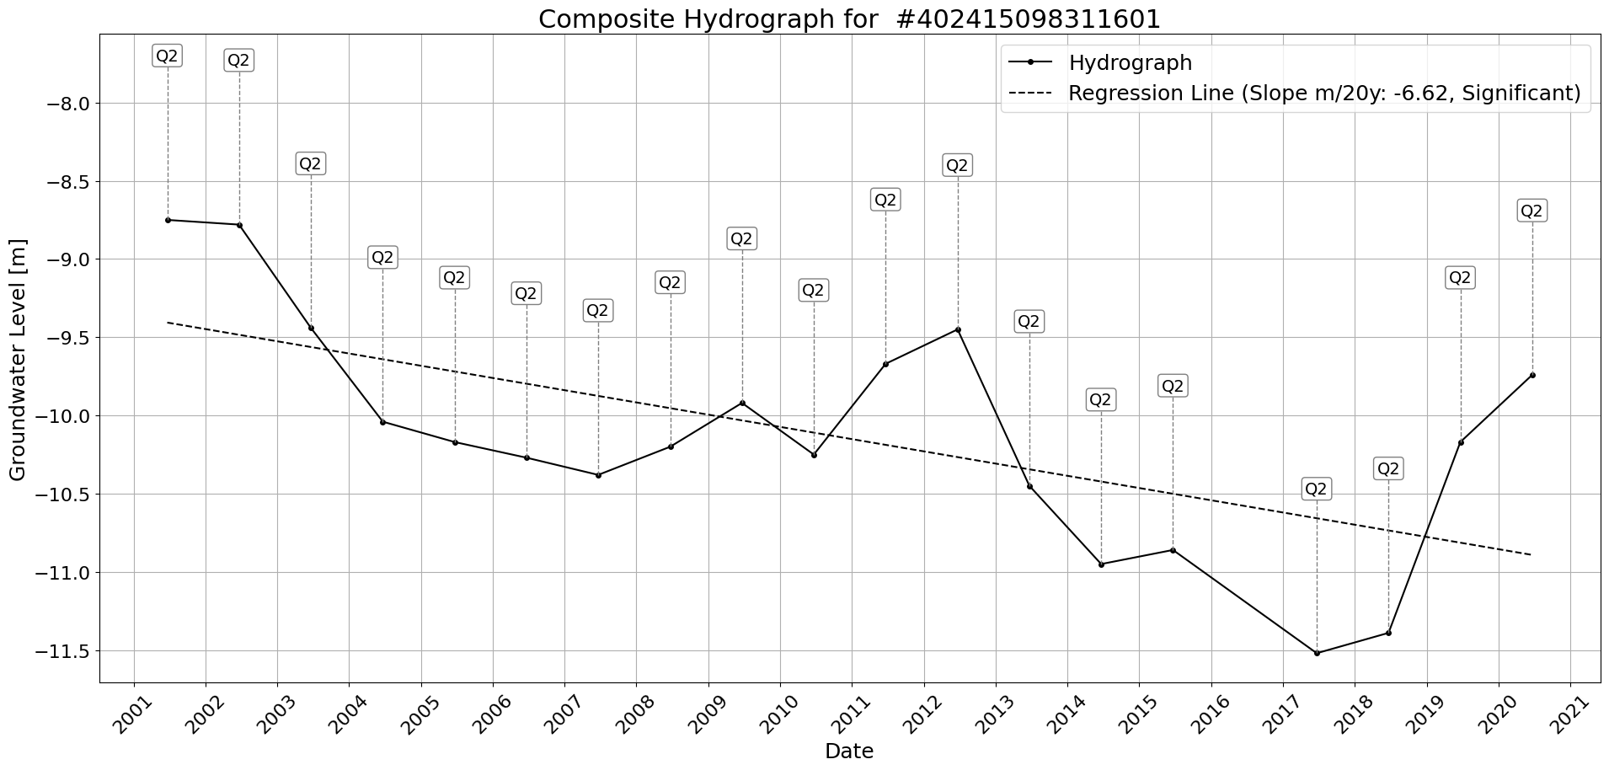

Figure: Site_#402415098311601.png

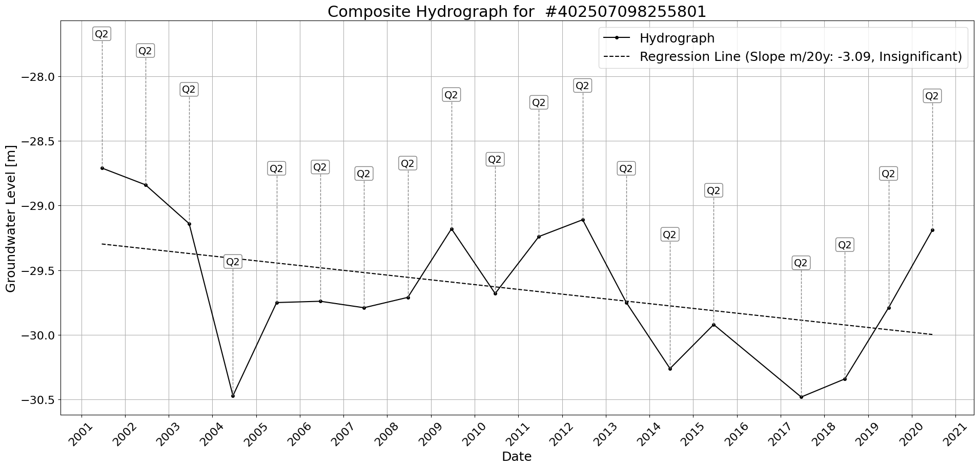

Figure: Site_#402507098255801.png

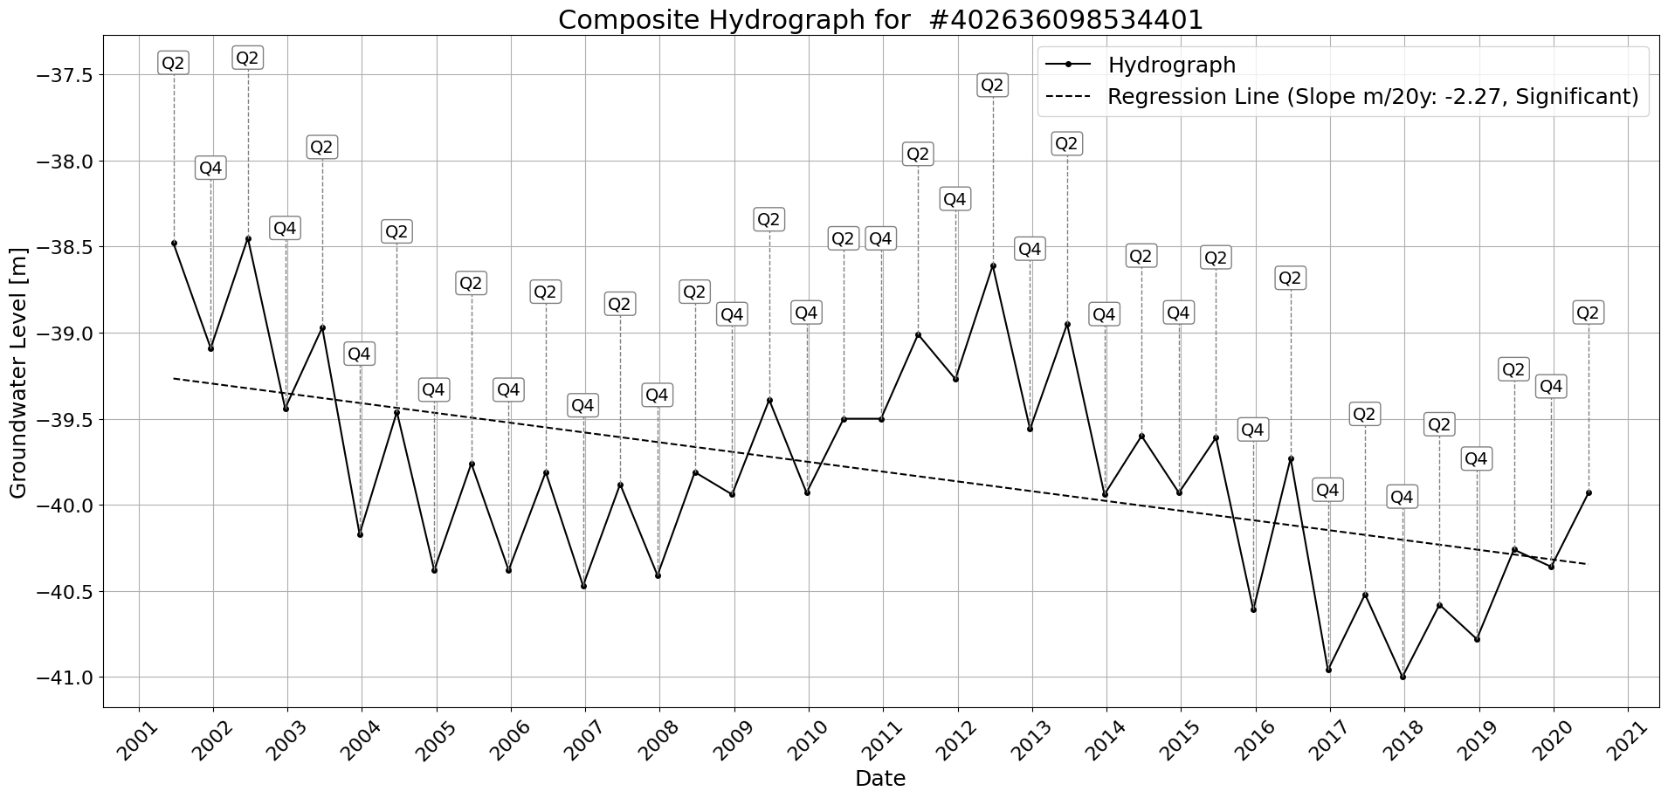

Figure: Site_#402636098534401.png

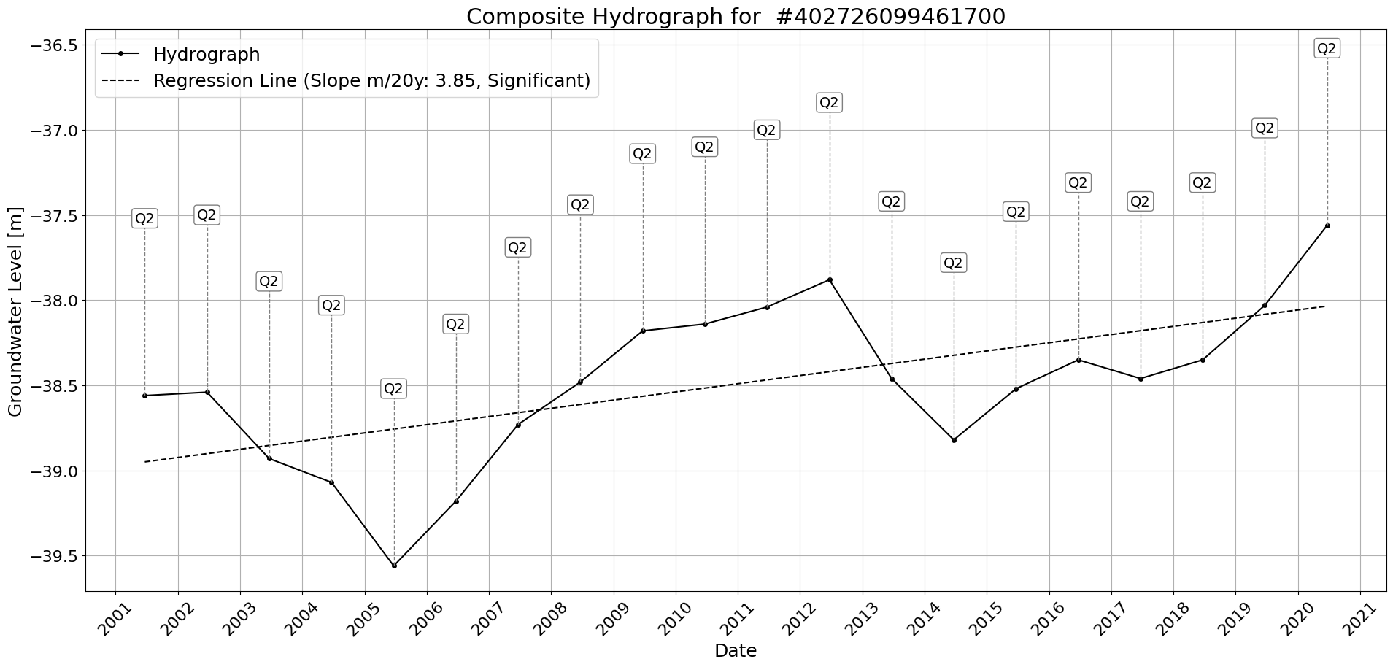

Figure: Site_#402726099461700.png

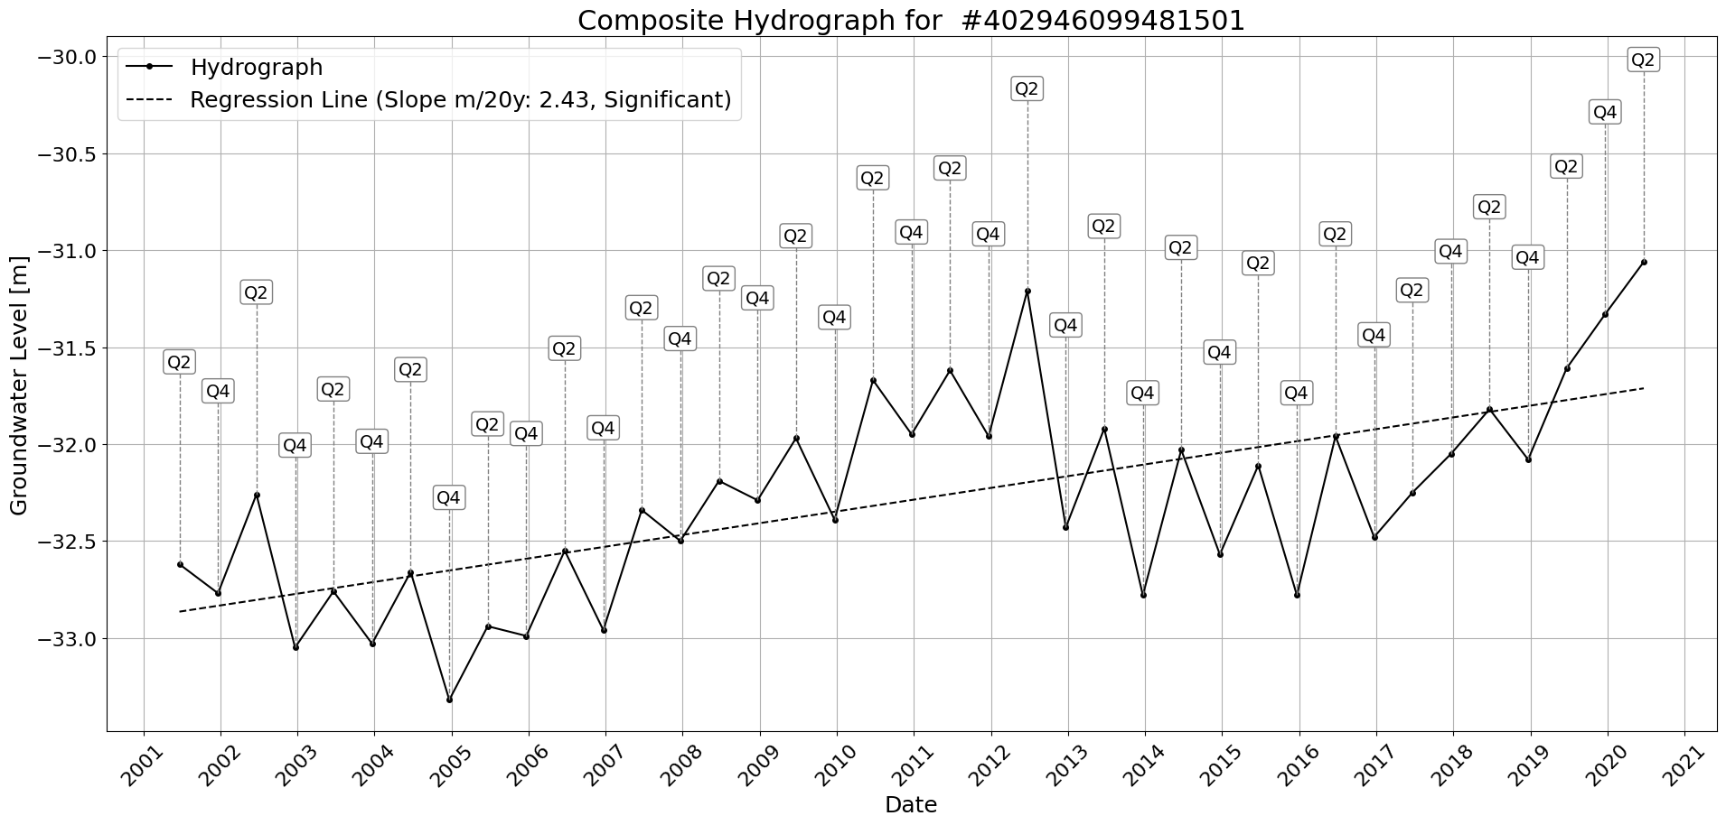

Figure: Site_#402946099481501.png

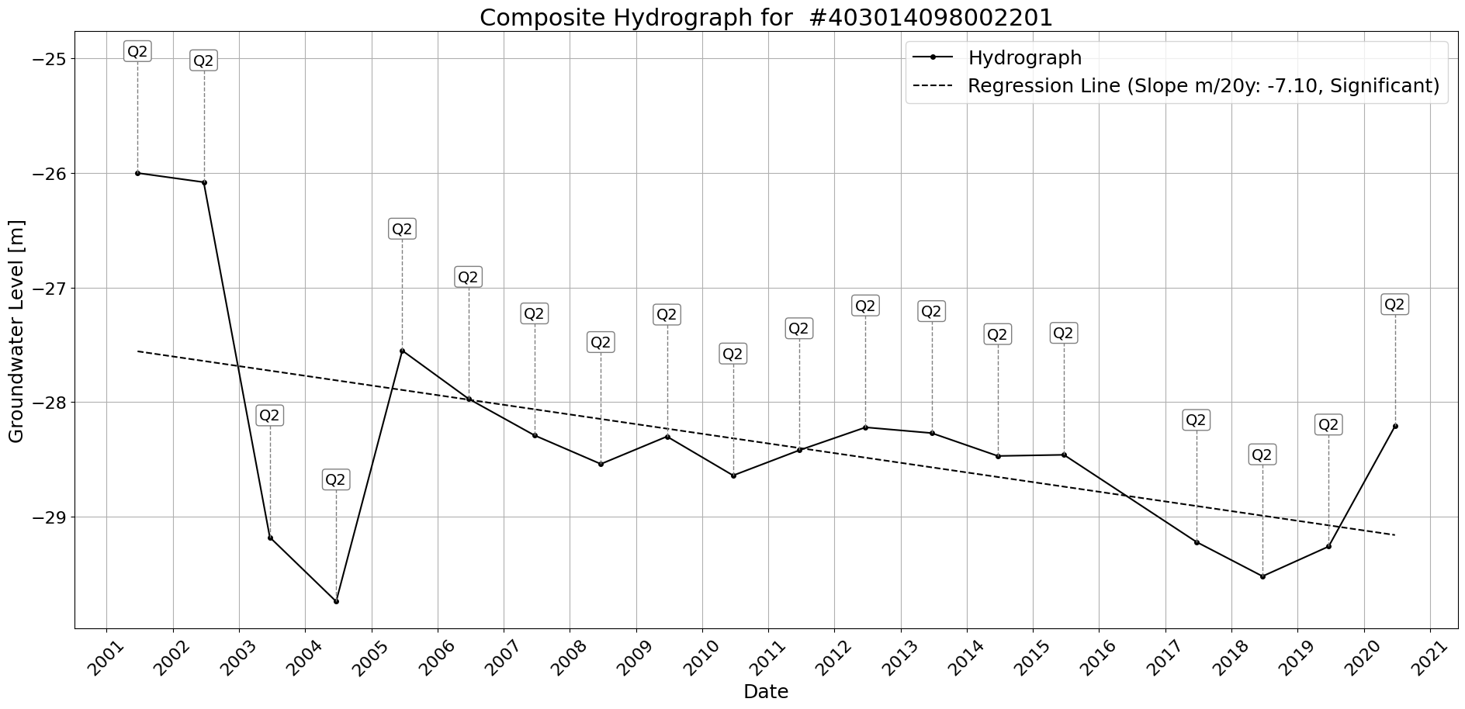

Figure: Site_#403014098002201.png

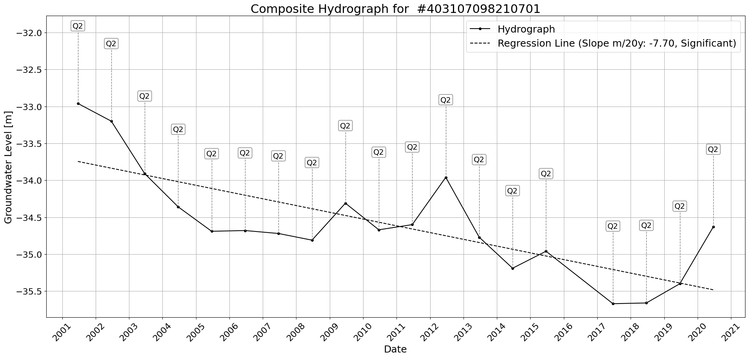

Figure: Site_#403107098210701.png

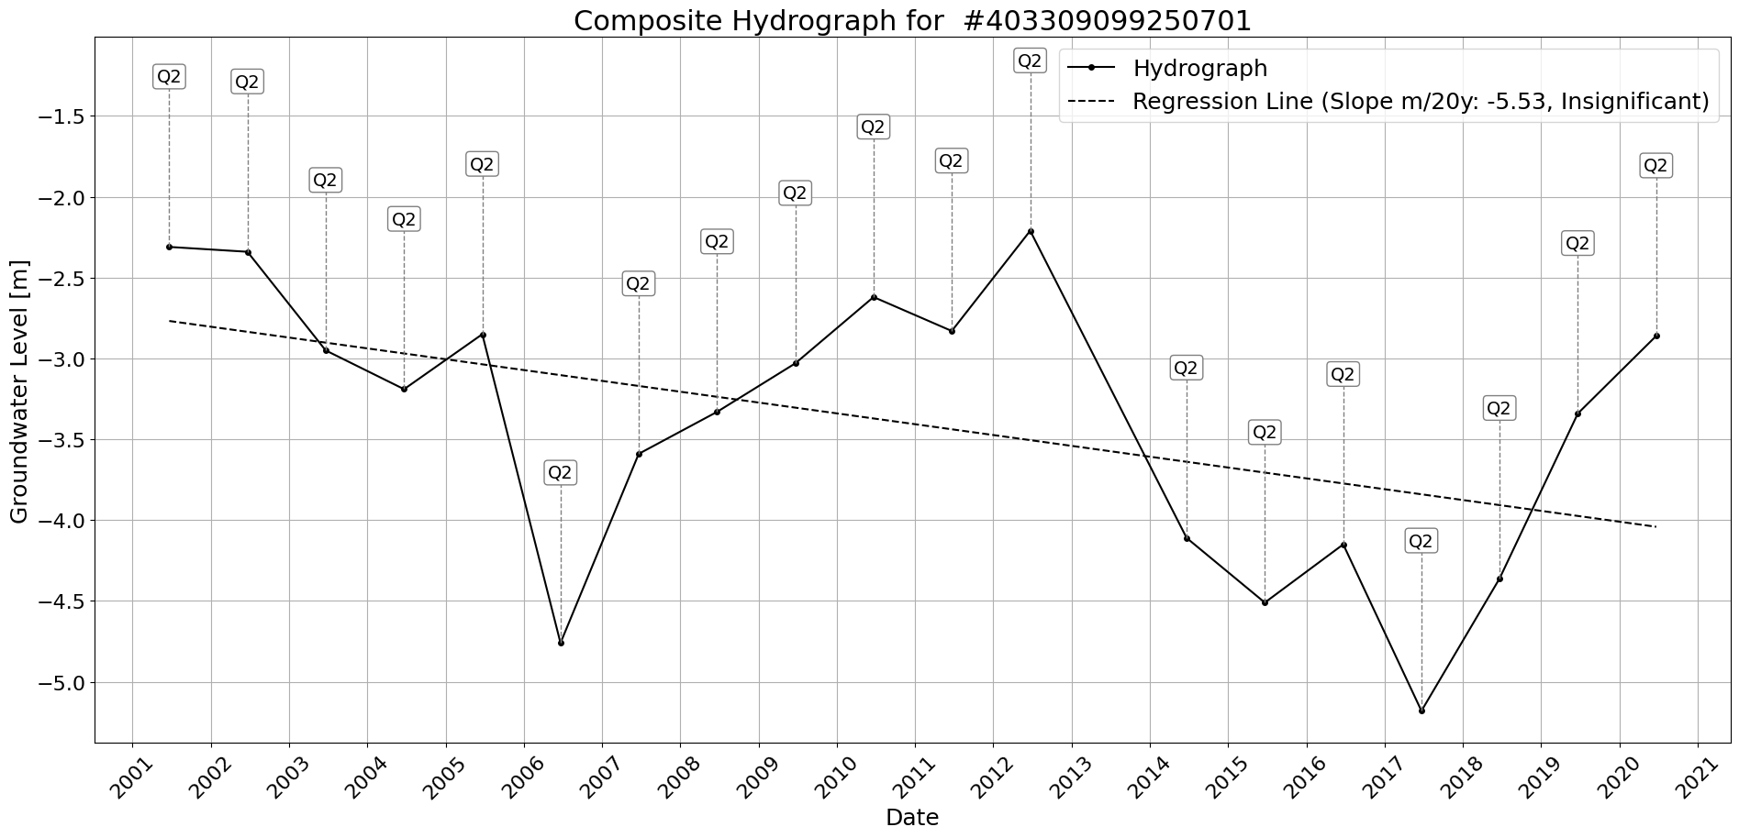

Figure: Site_#403309099250701.png

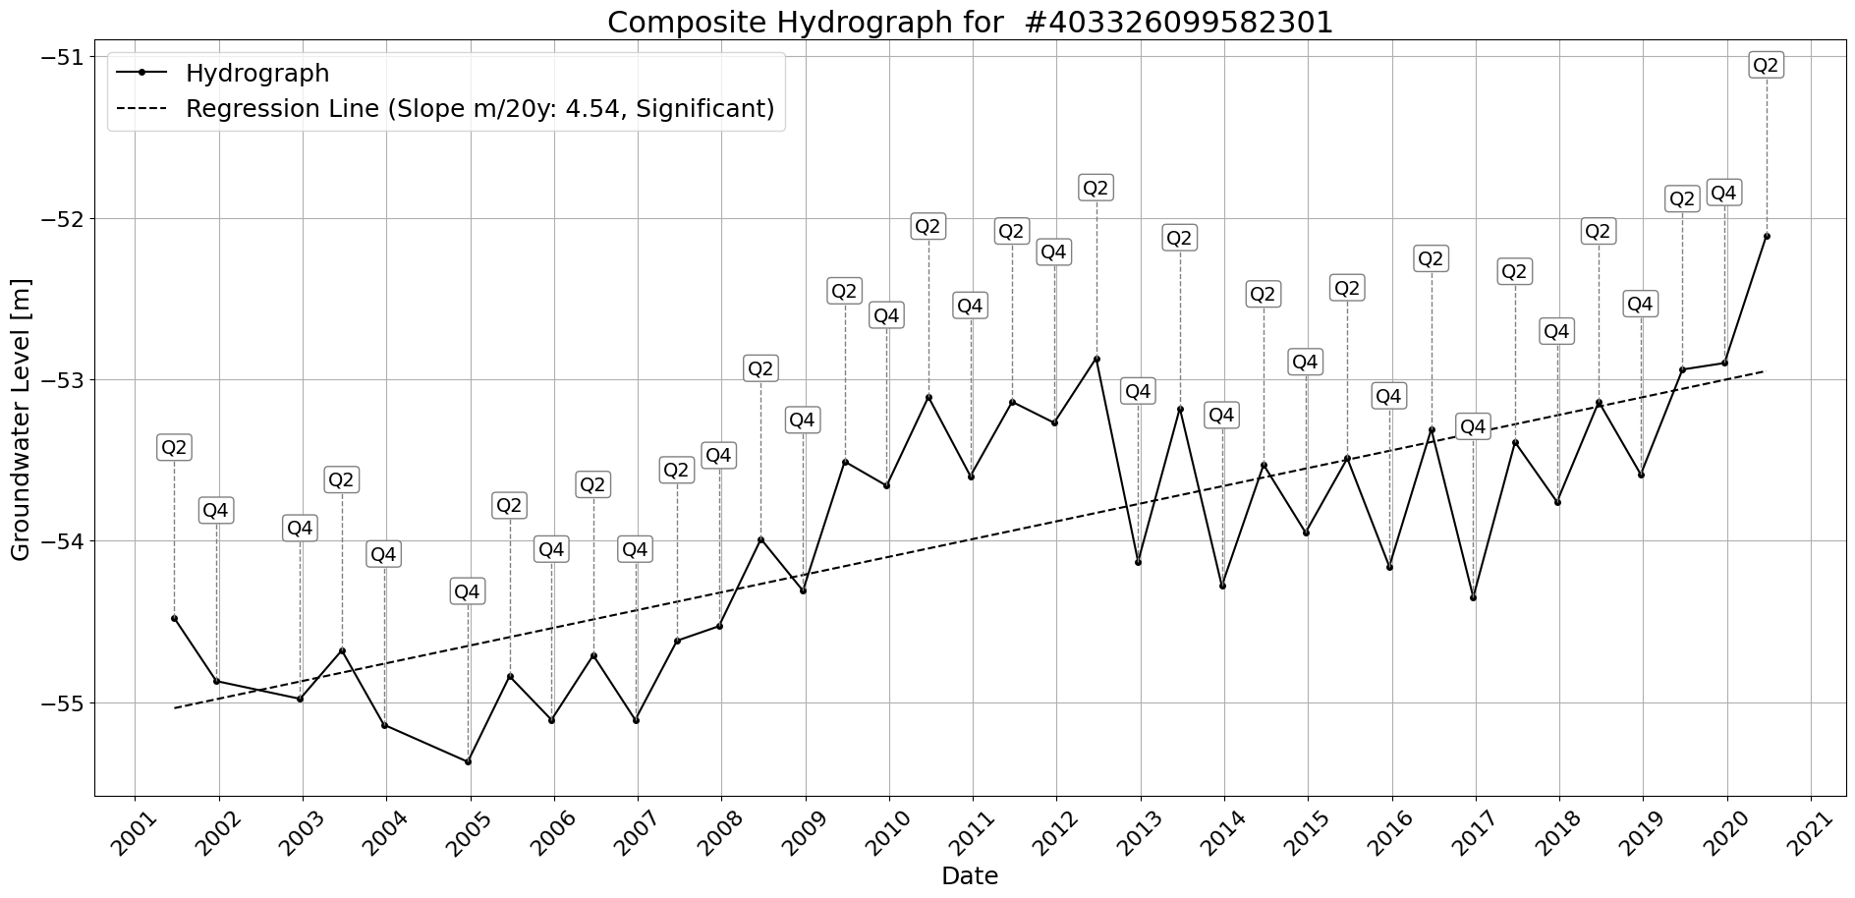

Figure: Site_#403326099582301.png

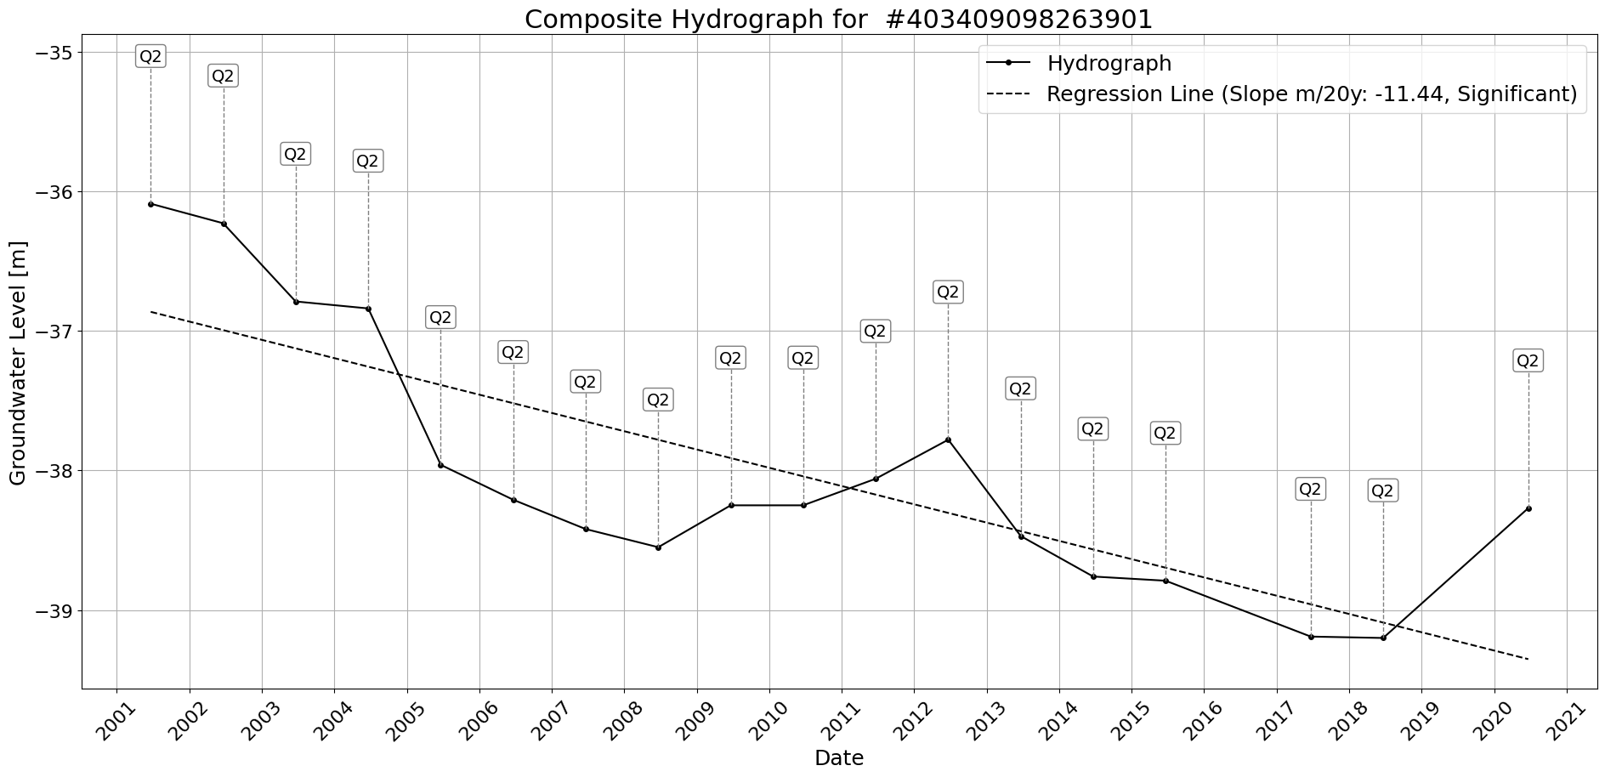

Figure: Site_#403409098263901.png

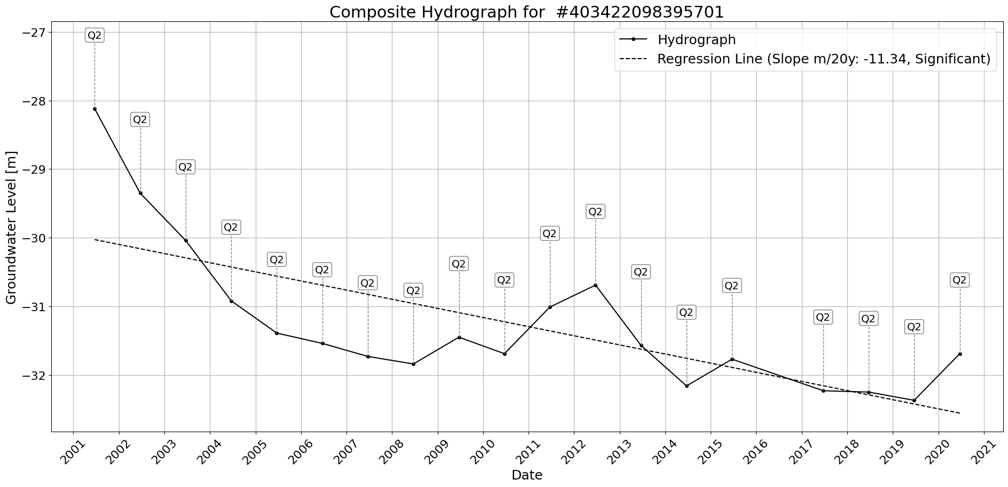

Figure: Site_#403422098395701.png

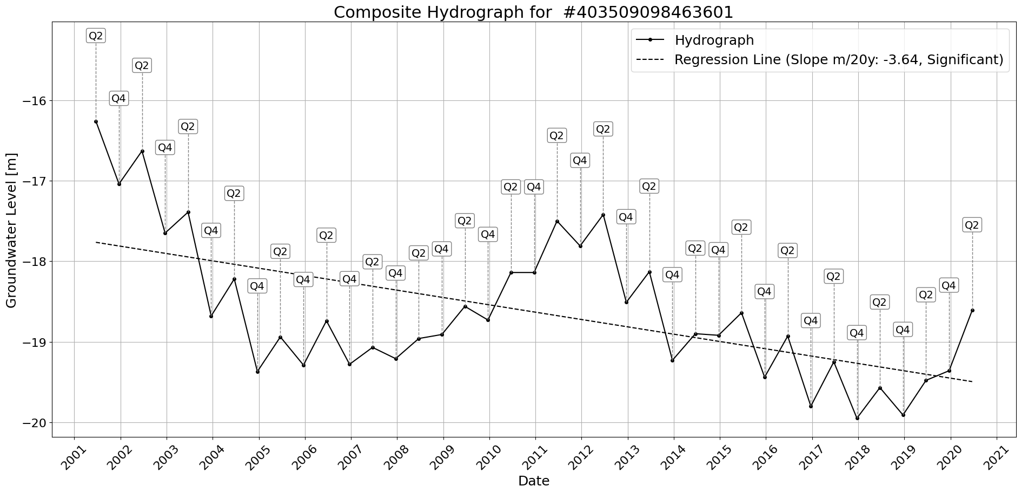

Figure: Site_#403509098463601.png

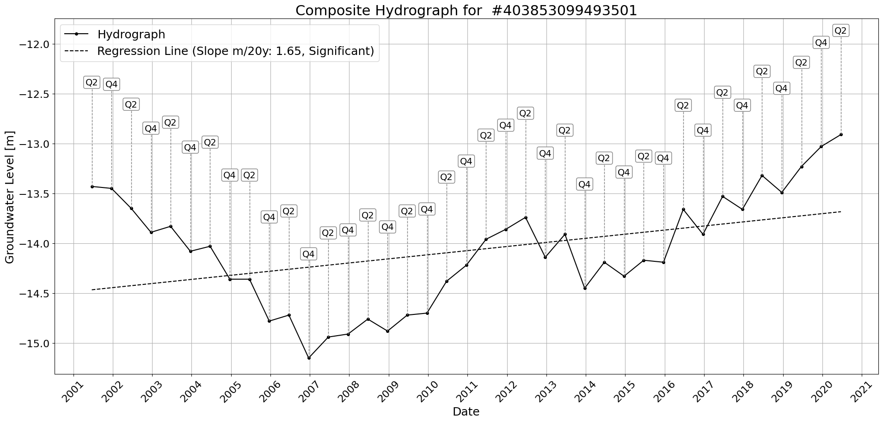

Figure: Site_#403853099493501.png

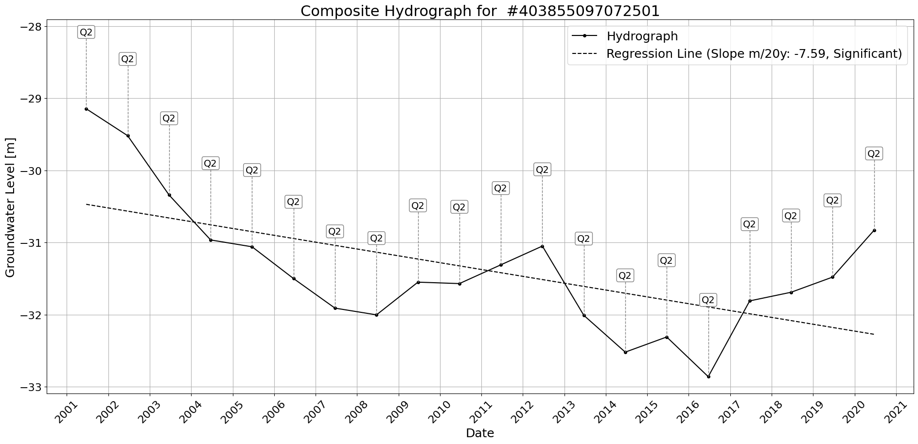

Figure: Site_#403855097072501.png

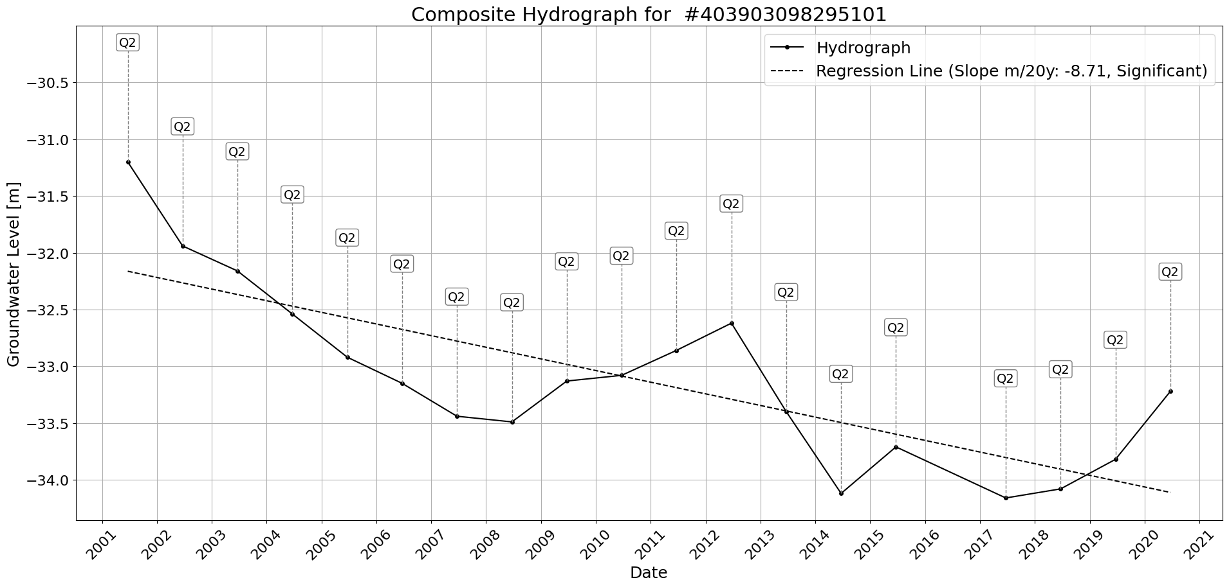

Figure: Site_#403903098295101.png

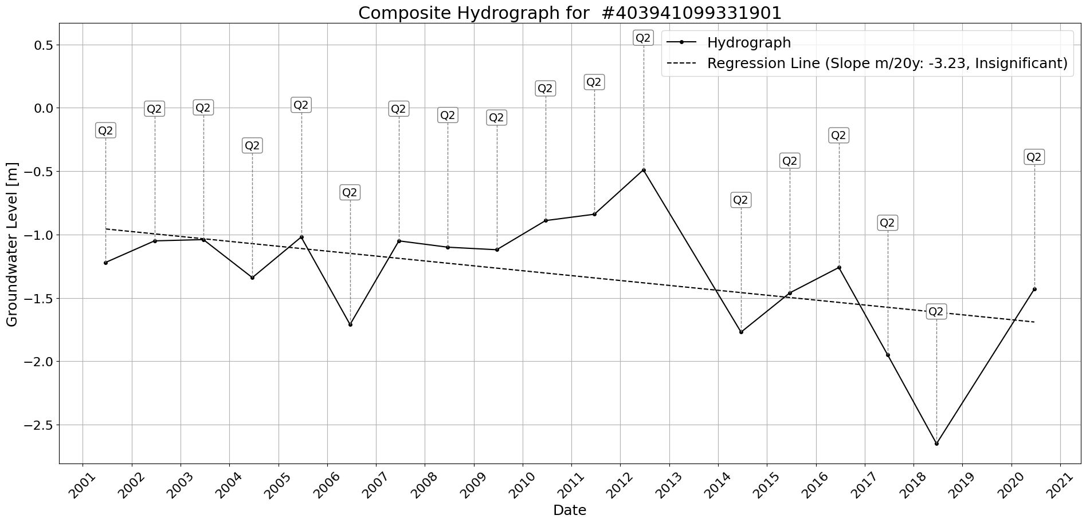

Figure: Site_#403941099331901.png

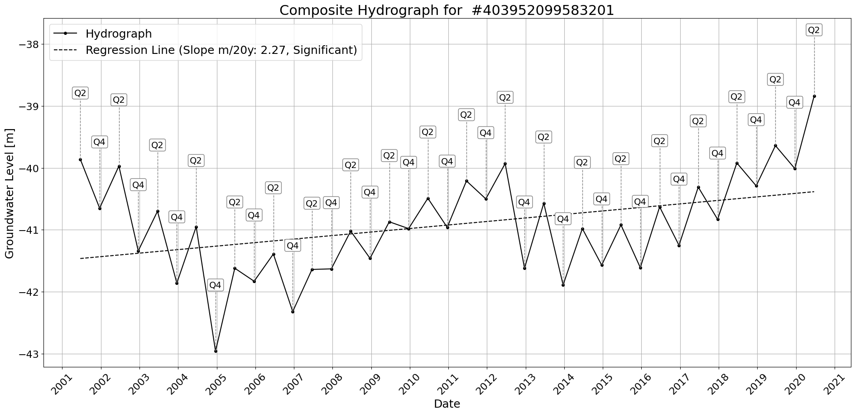

Figure: Site_#403952099583201.png

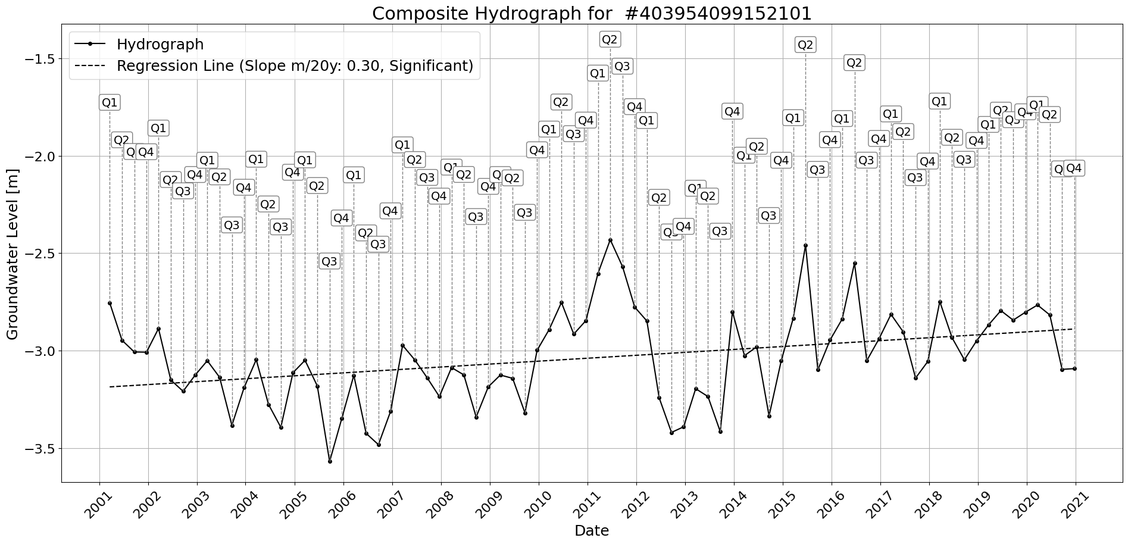

Figure: Site_#403954099152101.png

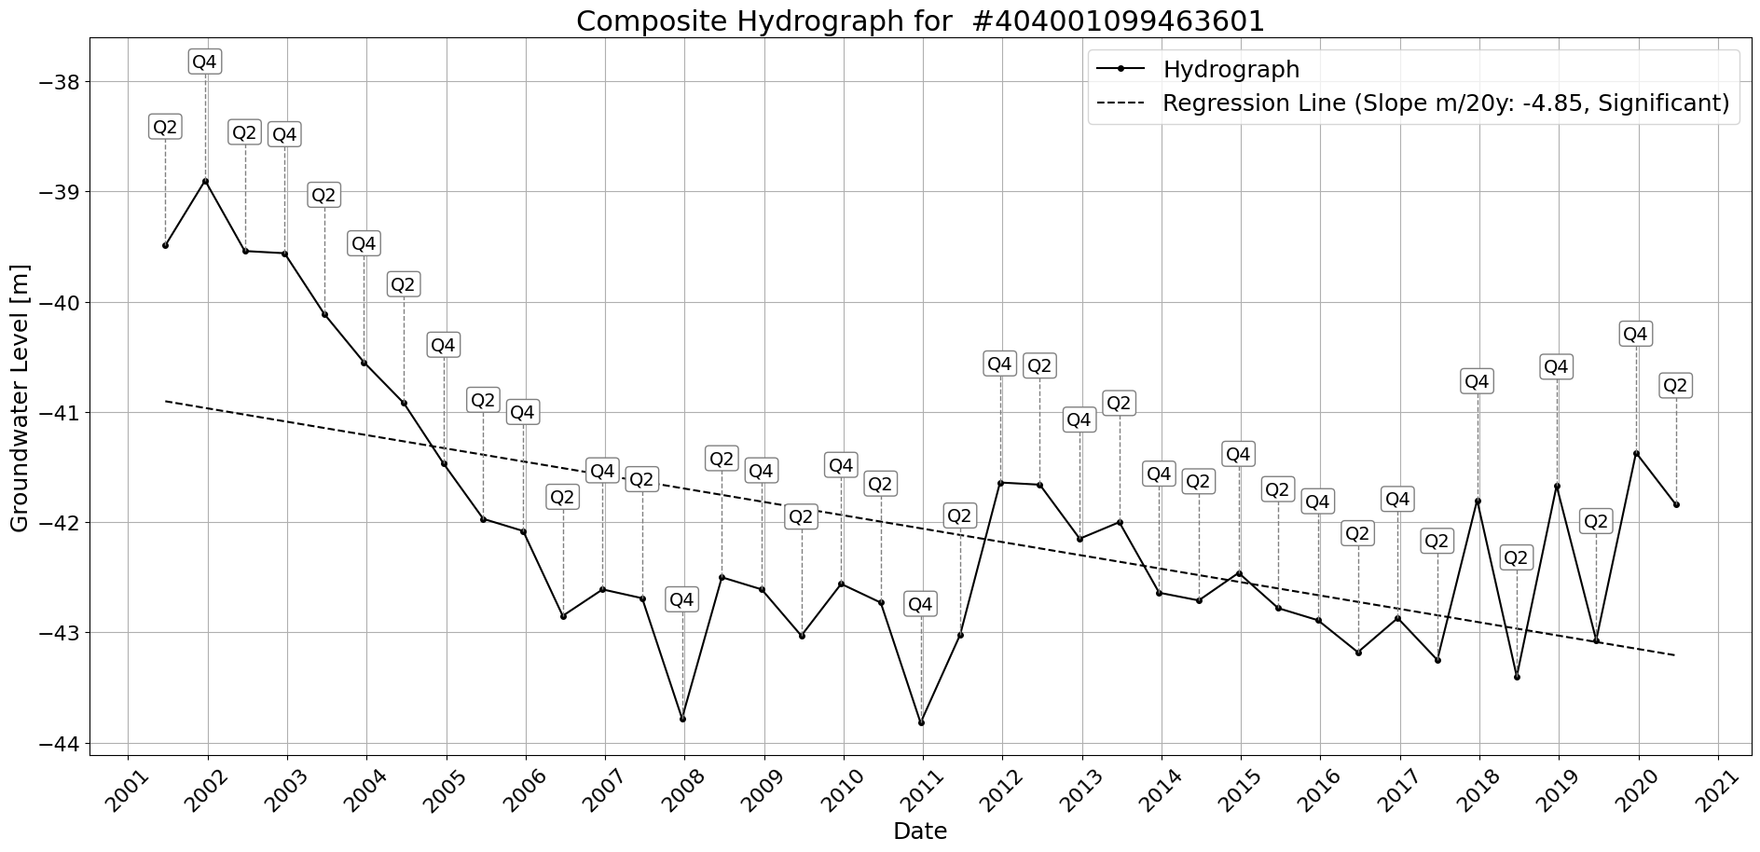

Figure: Site_#404001099463601.png

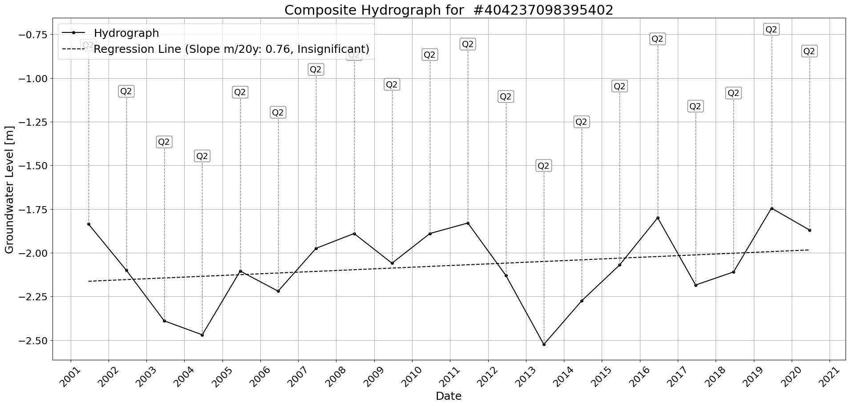

Figure: Site_#404237098395402.png

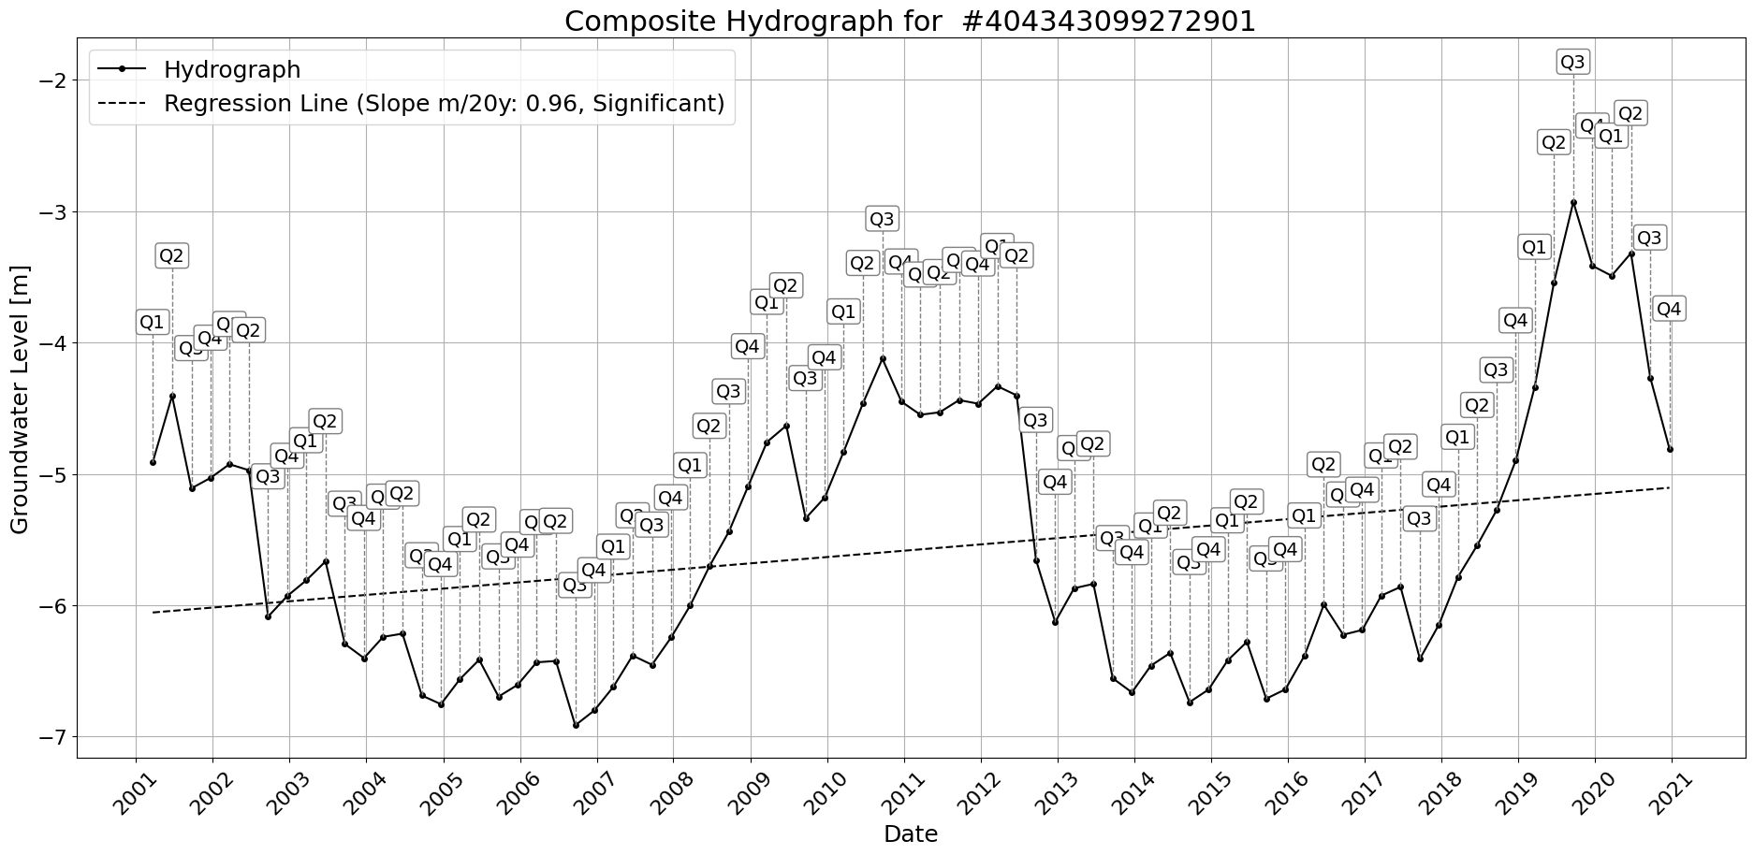

Figure: Site_#404343099272901.png

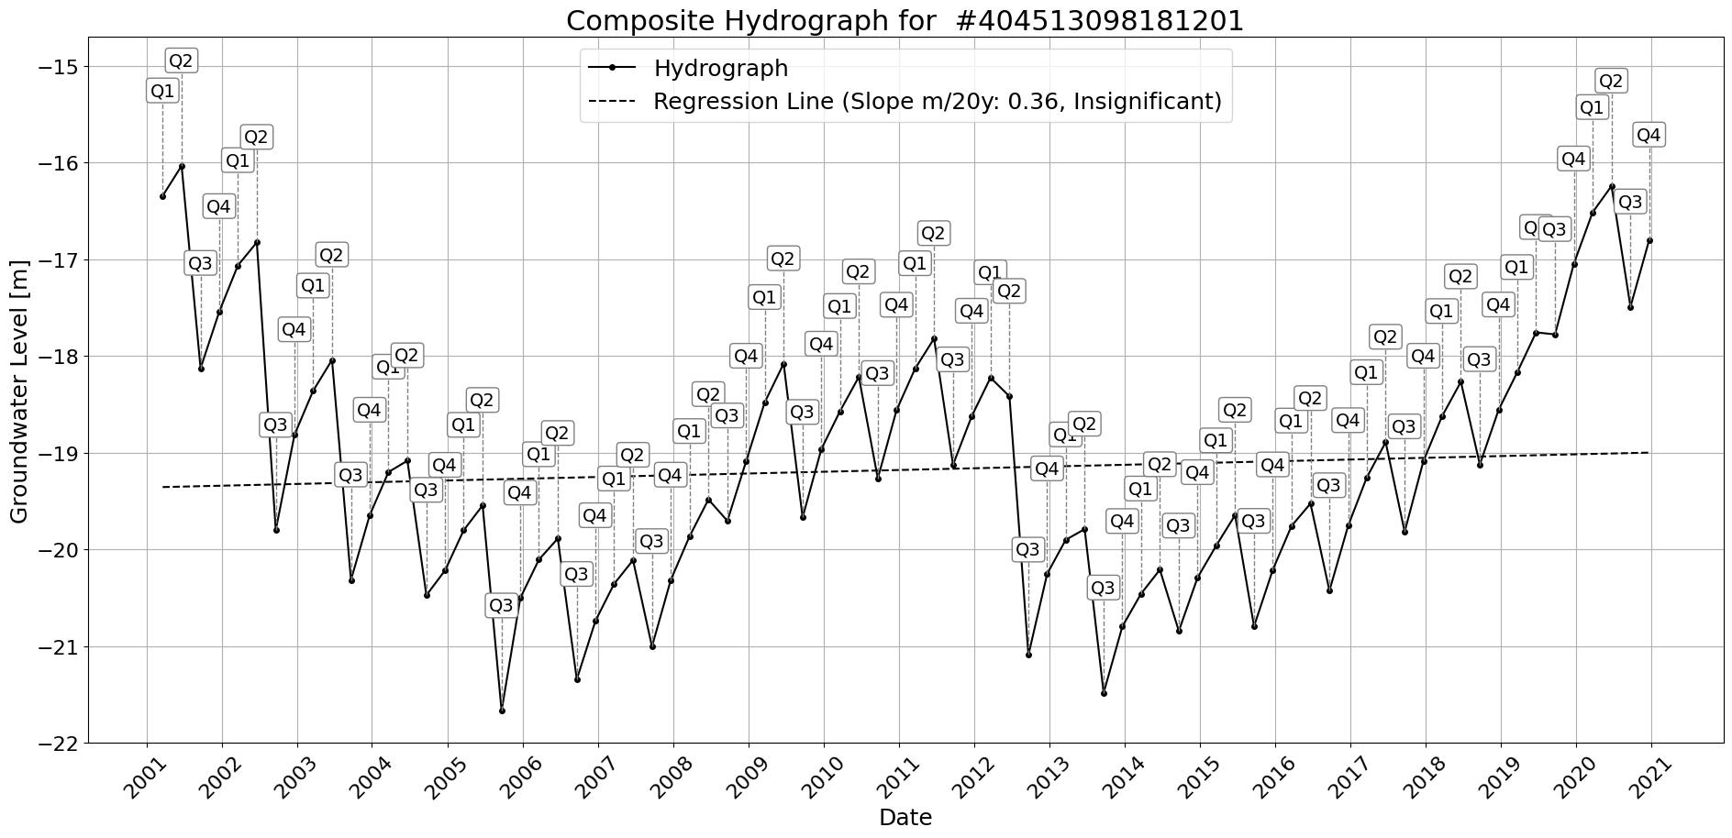

Figure: Site_#404513098181201.png

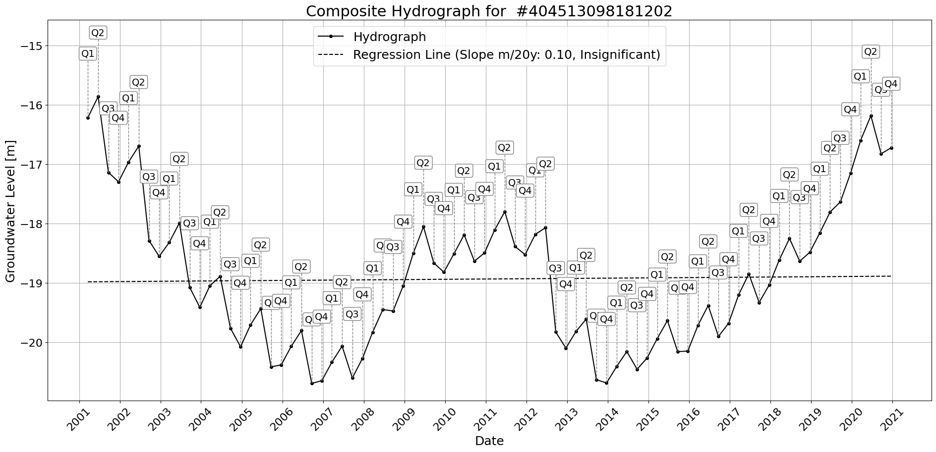

Figure: Site_#404513098181202.png

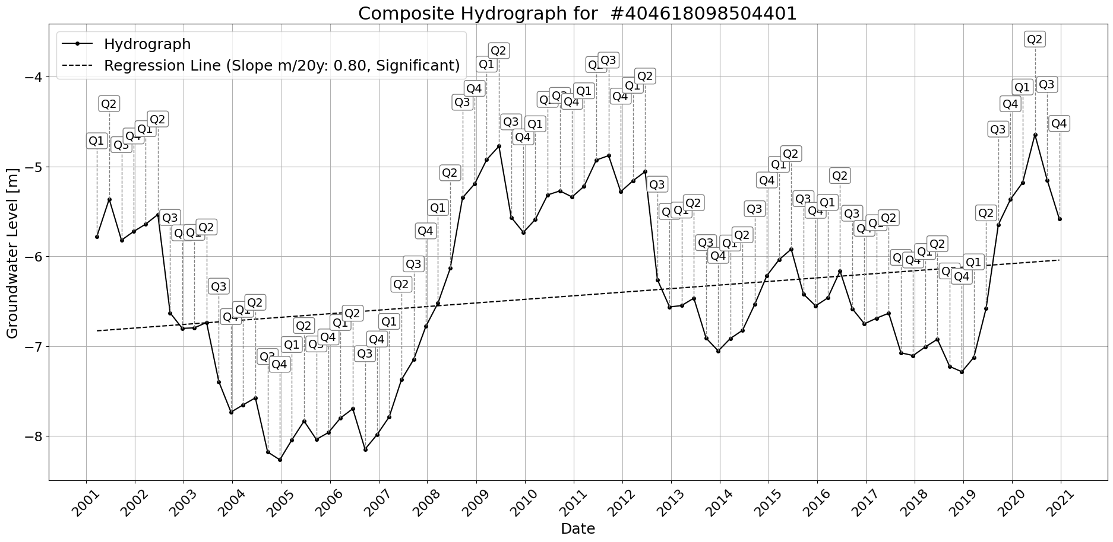

Figure: Site_#404618098504401.png

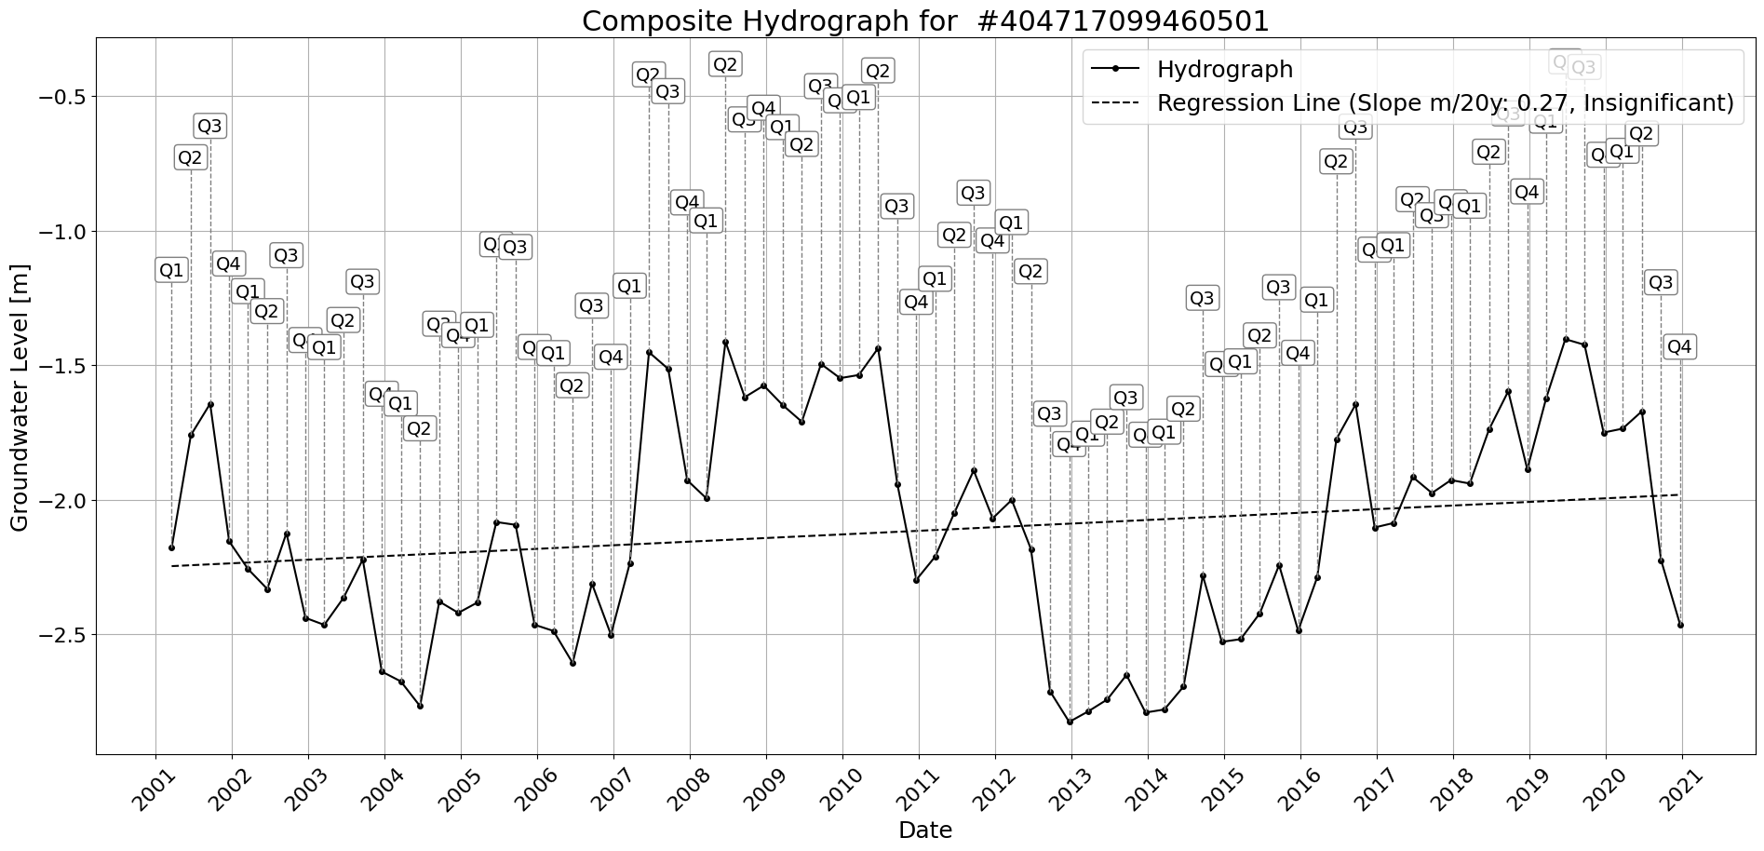

Figure: Site_#404717099460501.png

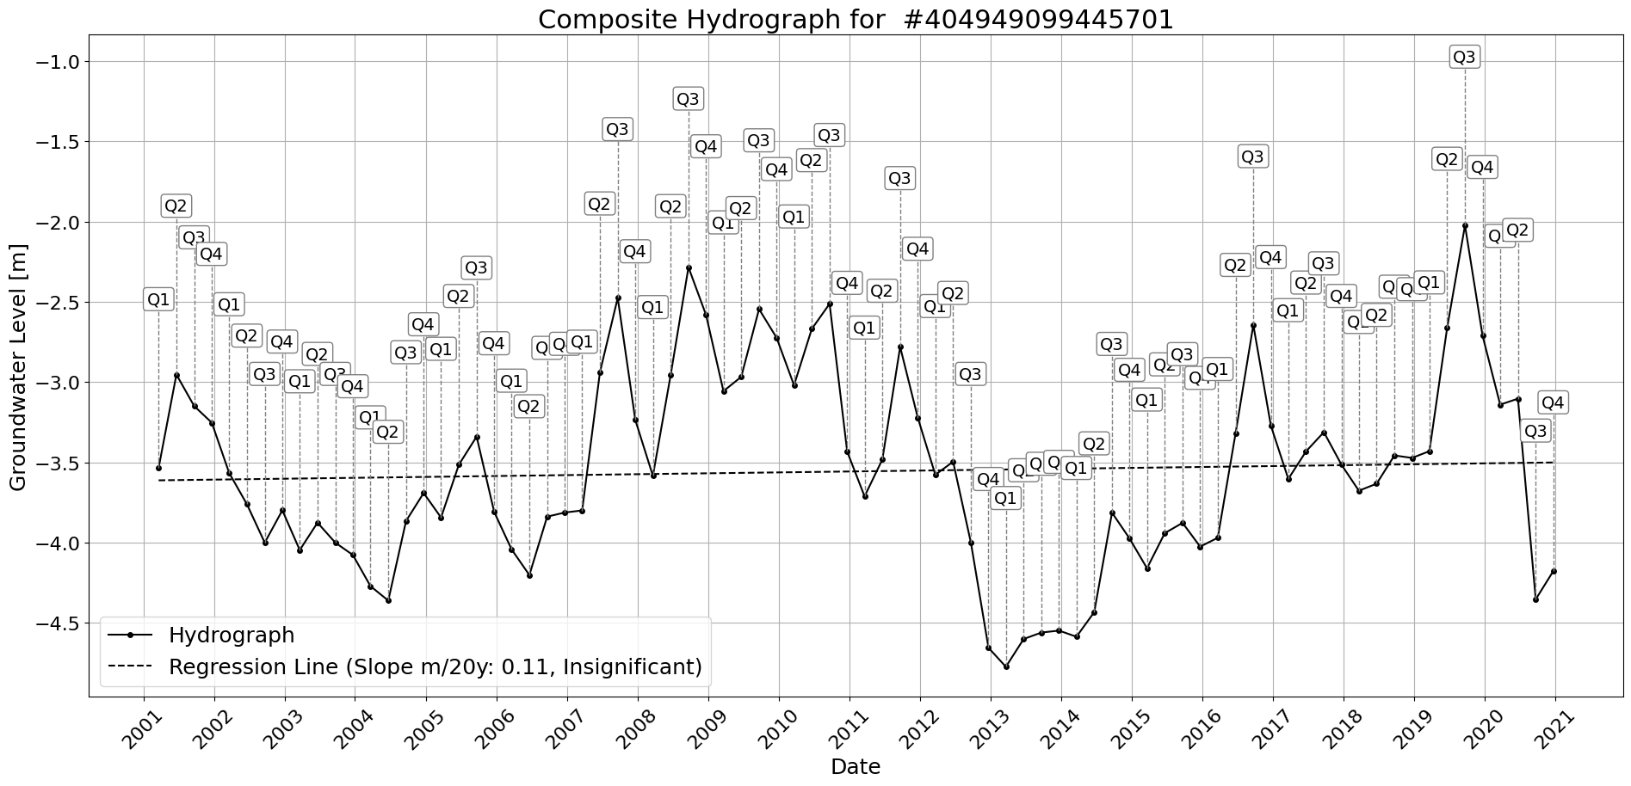

Figure: Site_#404949099445701.png

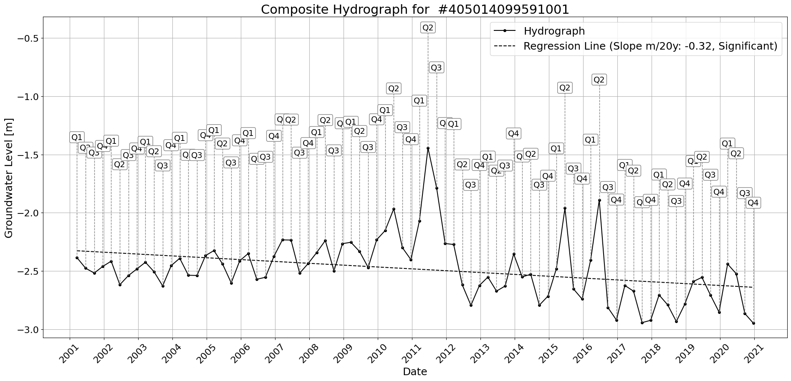

Figure: Site_#405014099591001.png

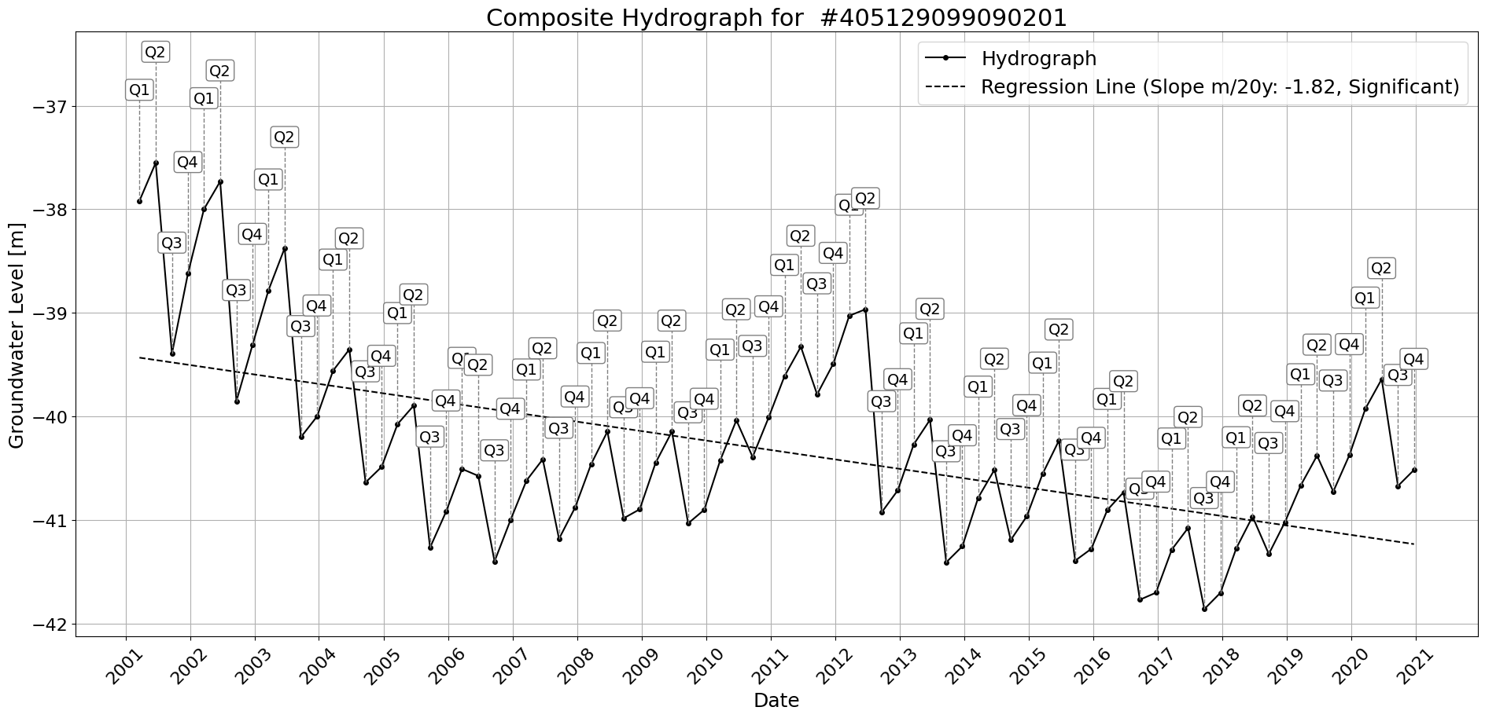

Figure: Site_#405129099090201.png

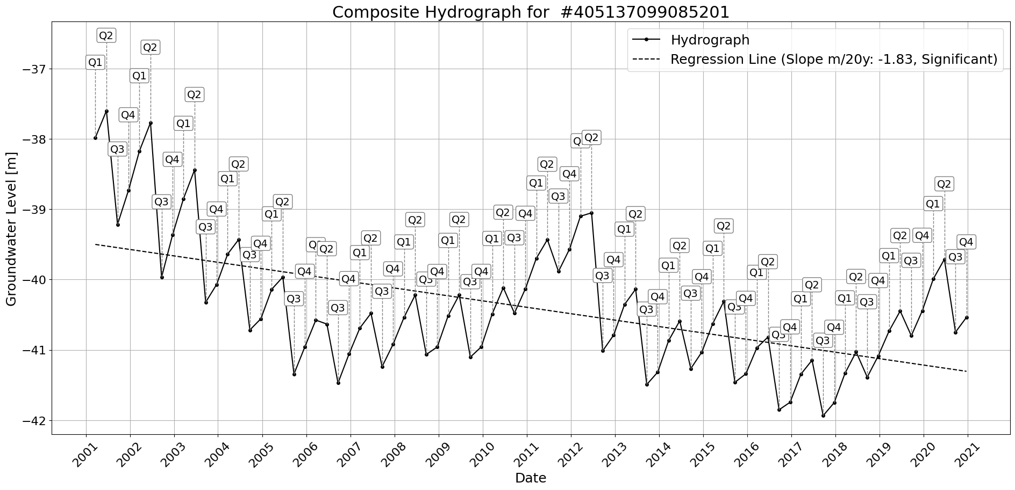

Figure: Site_#405137099085201.png

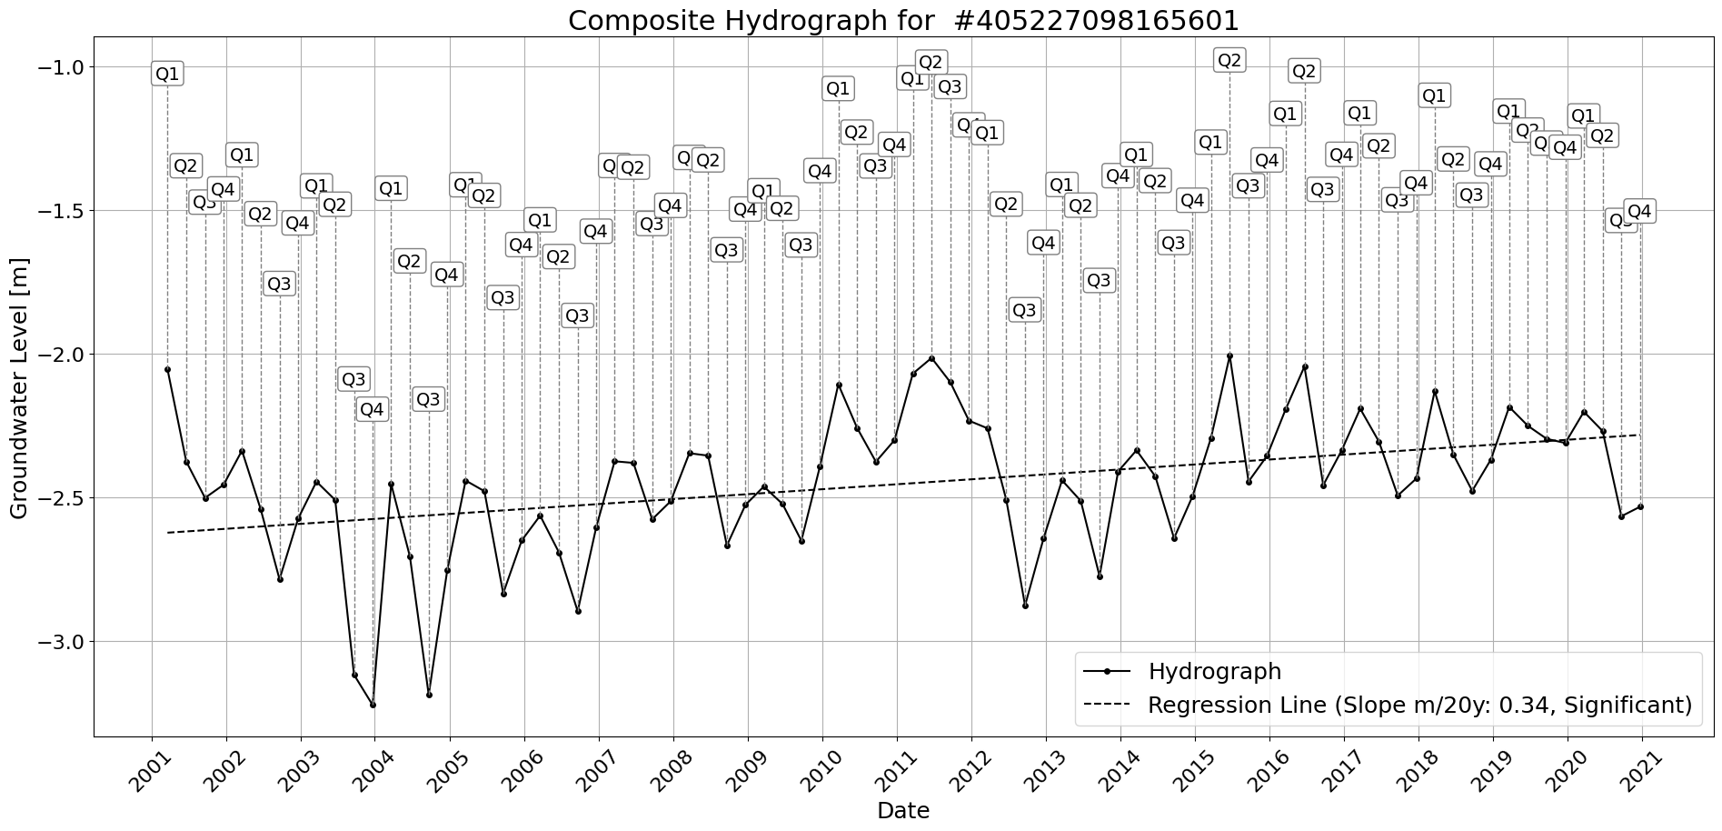

Figure: Site_#405227098165601.png

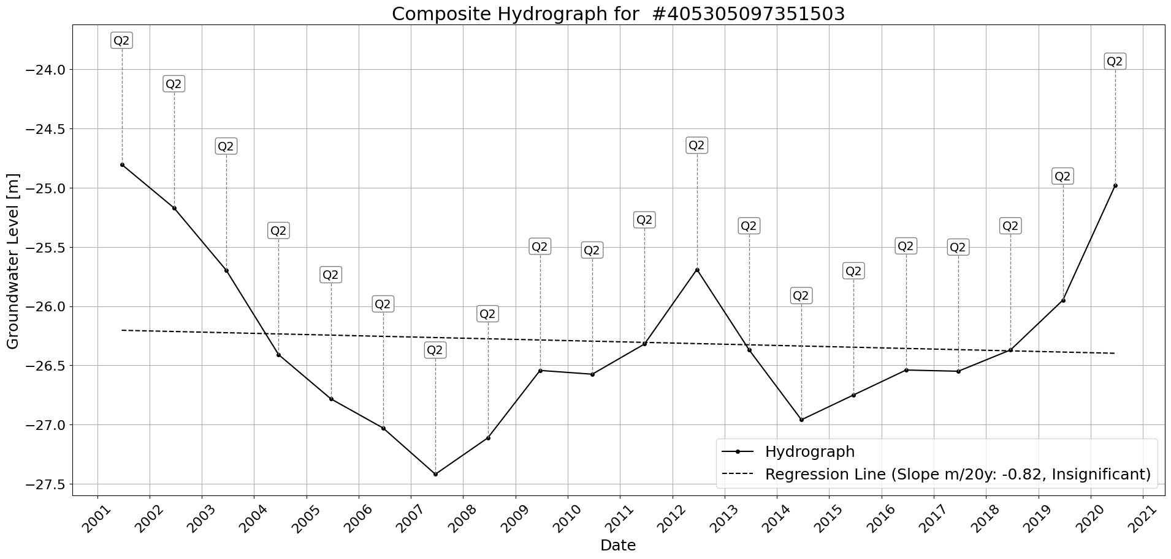

Figure: Site_#405305097351503.png

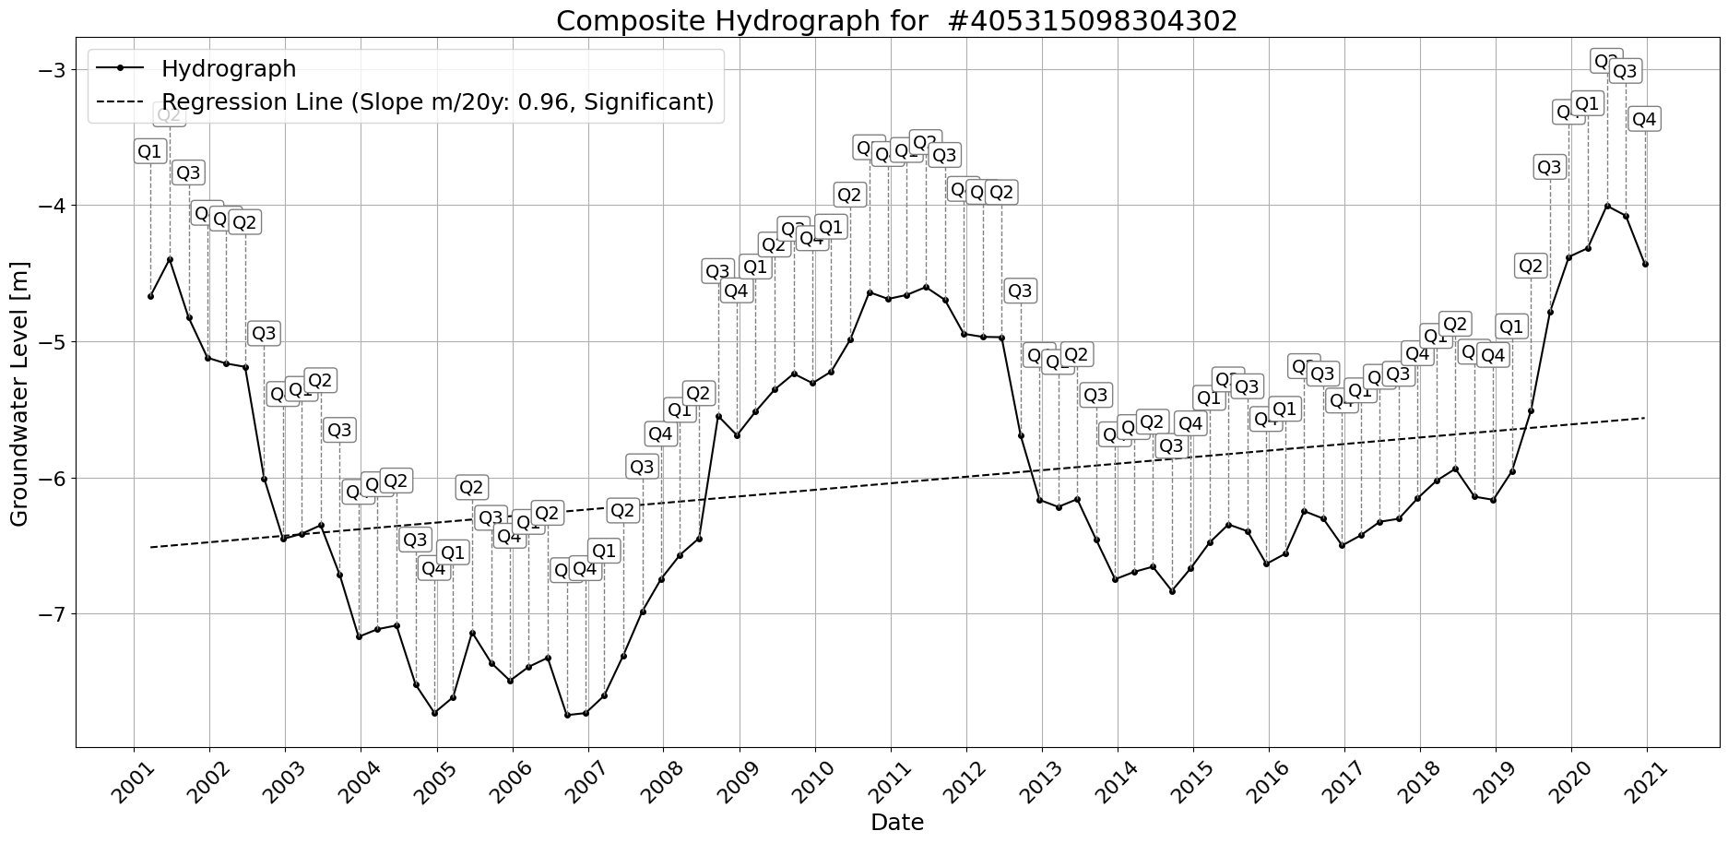

Figure: Site_#405315098304302.png

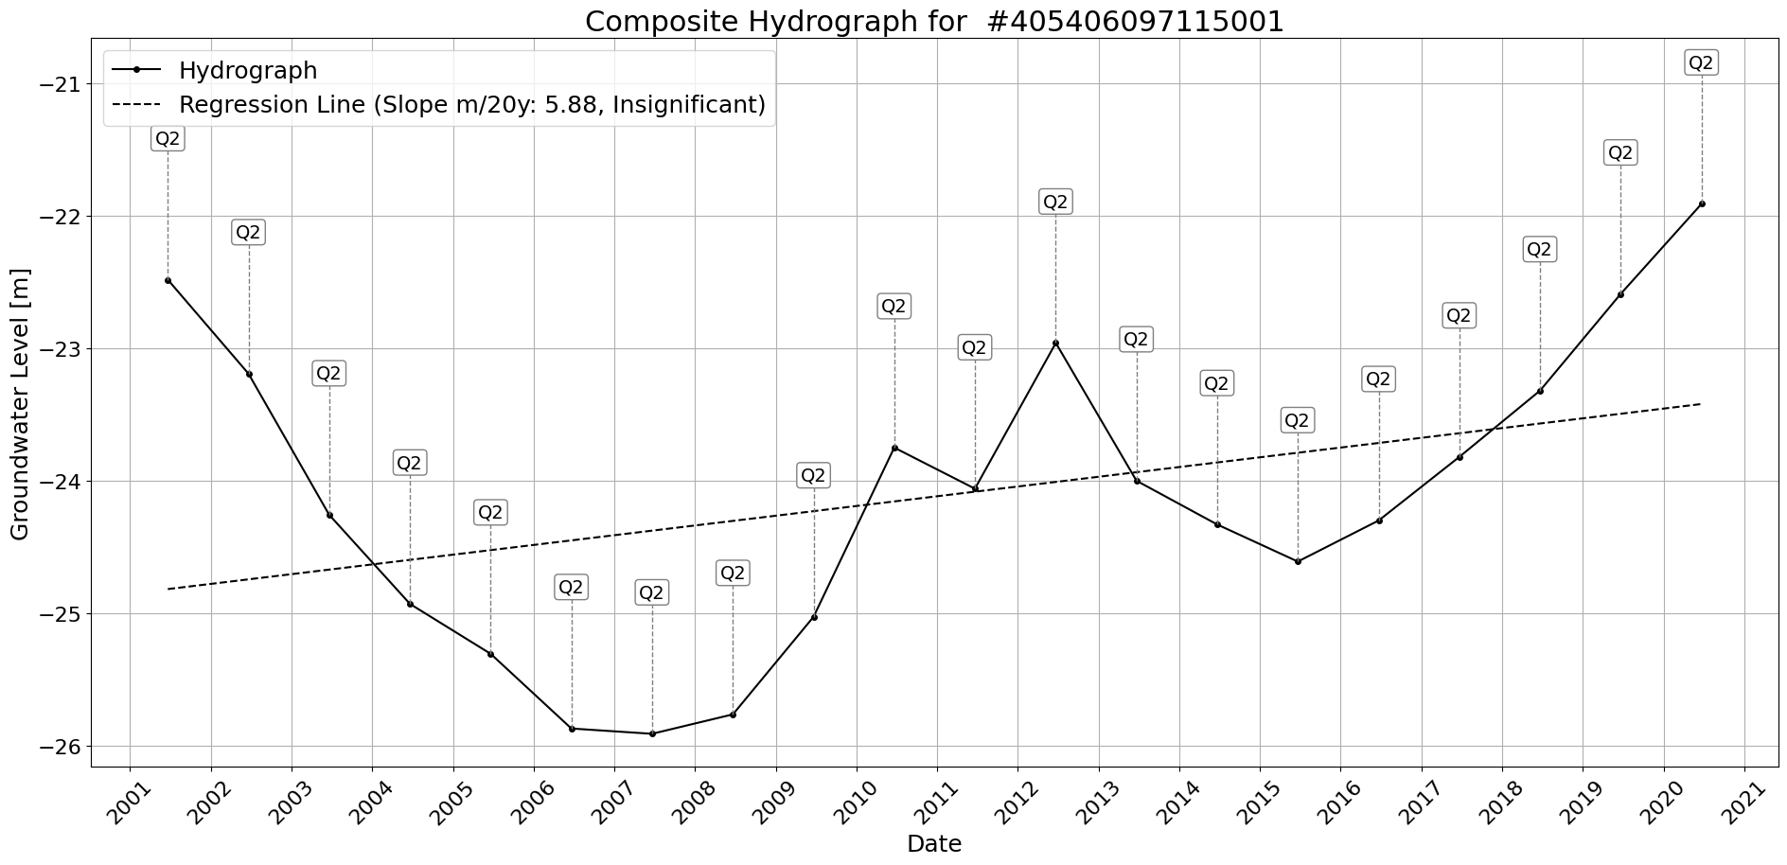

Figure: Site_#405406097115001.png

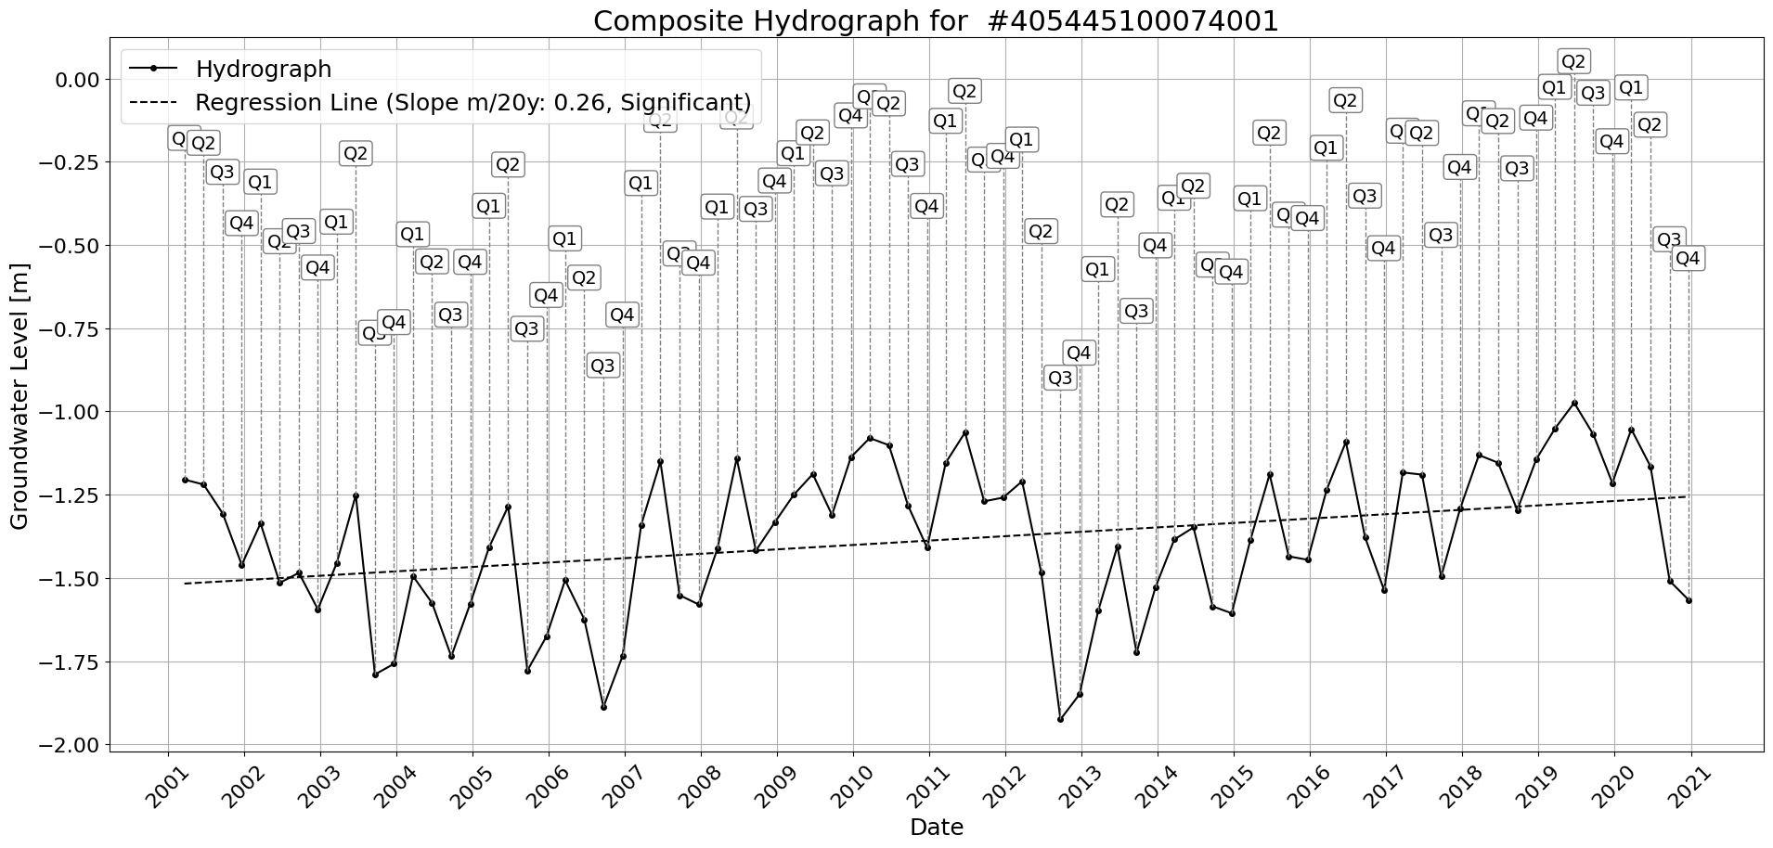

Figure: Site_#405445100074001.png

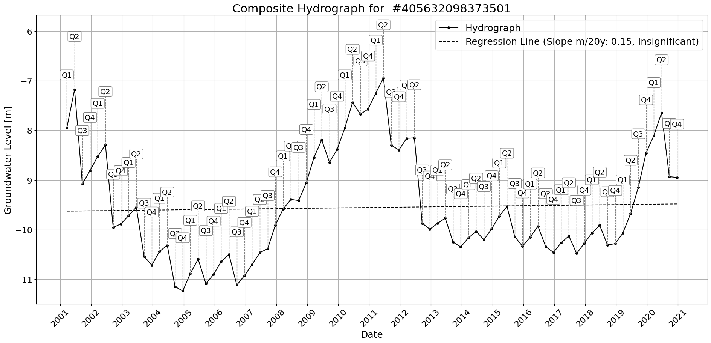

Figure: Site_#405632098373501.png

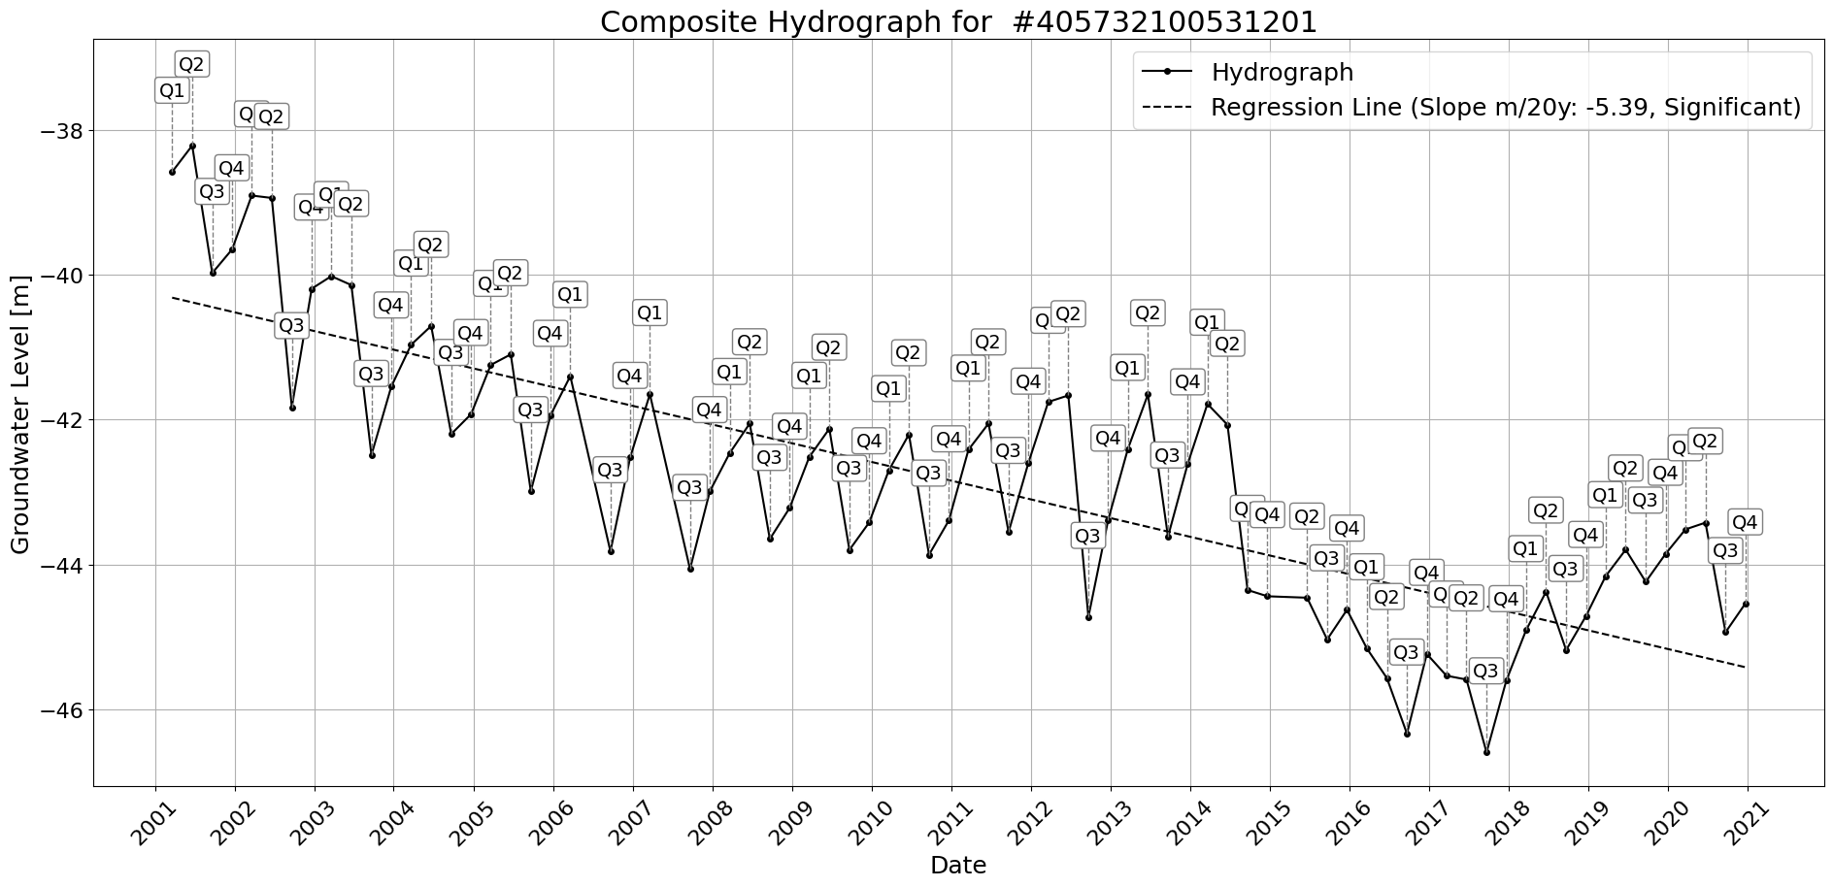

Figure: Site_#405732100531201.png

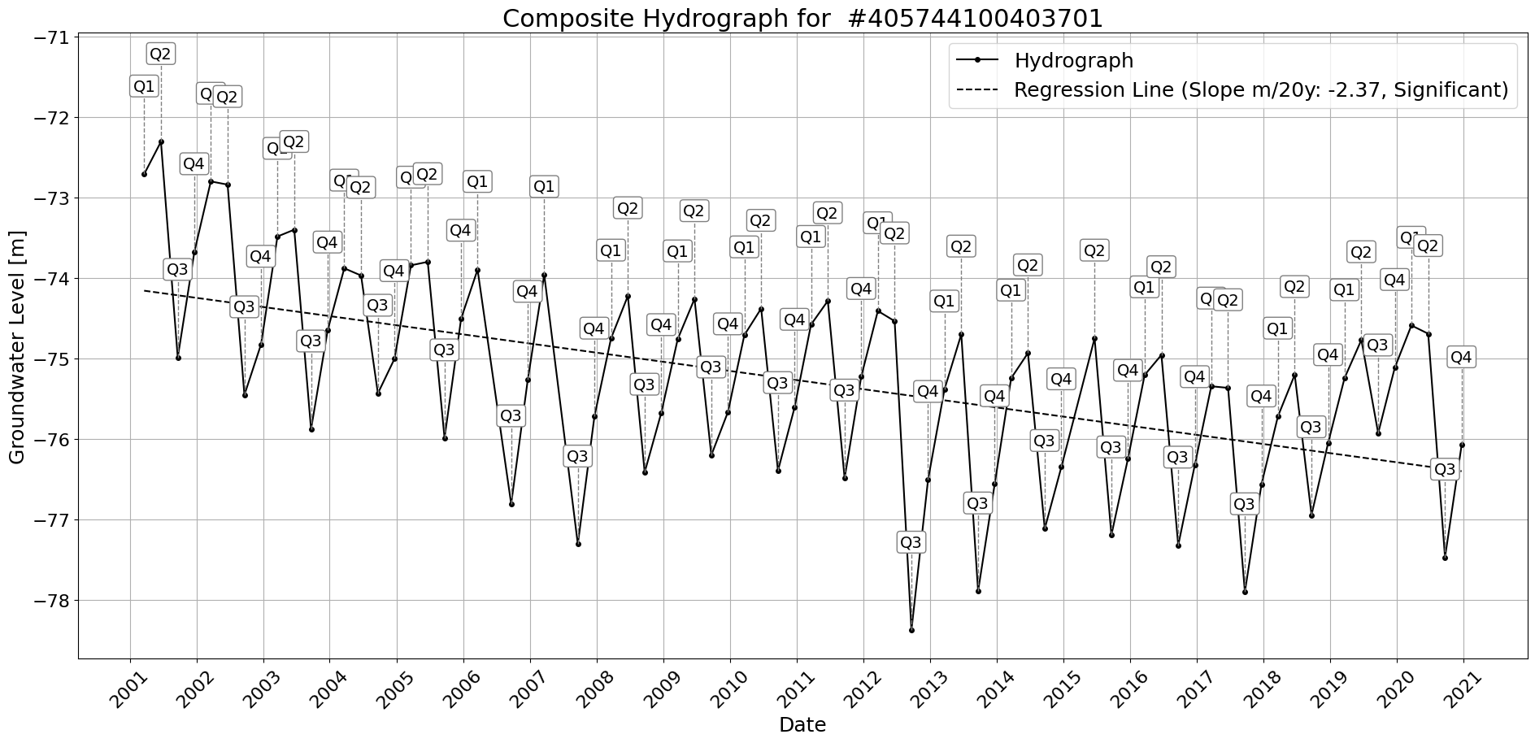

Figure: Site_#405744100403701.png

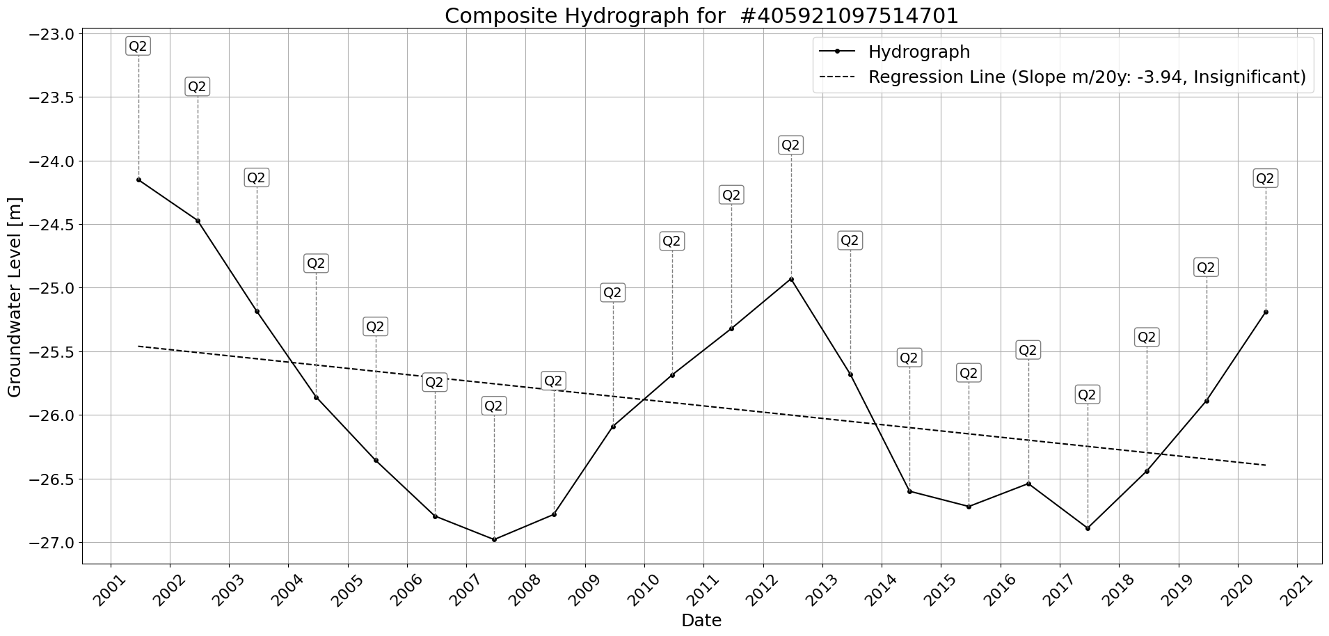

Figure: Site_#405921097514701.png

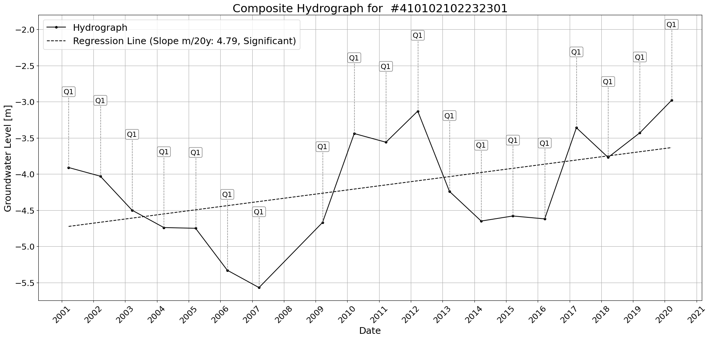

Figure: Site_#410102102232301.png

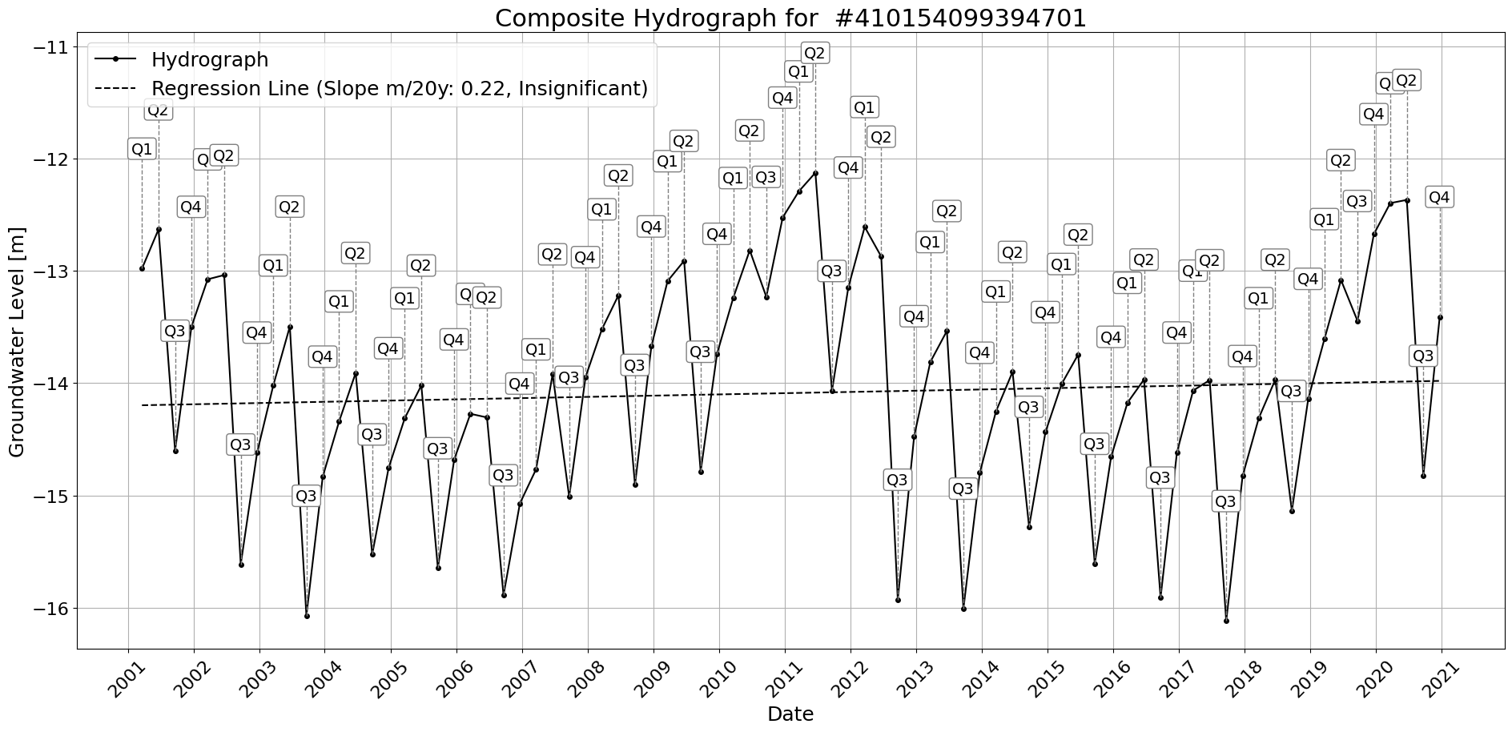

Figure: Site_#410154099394701.png

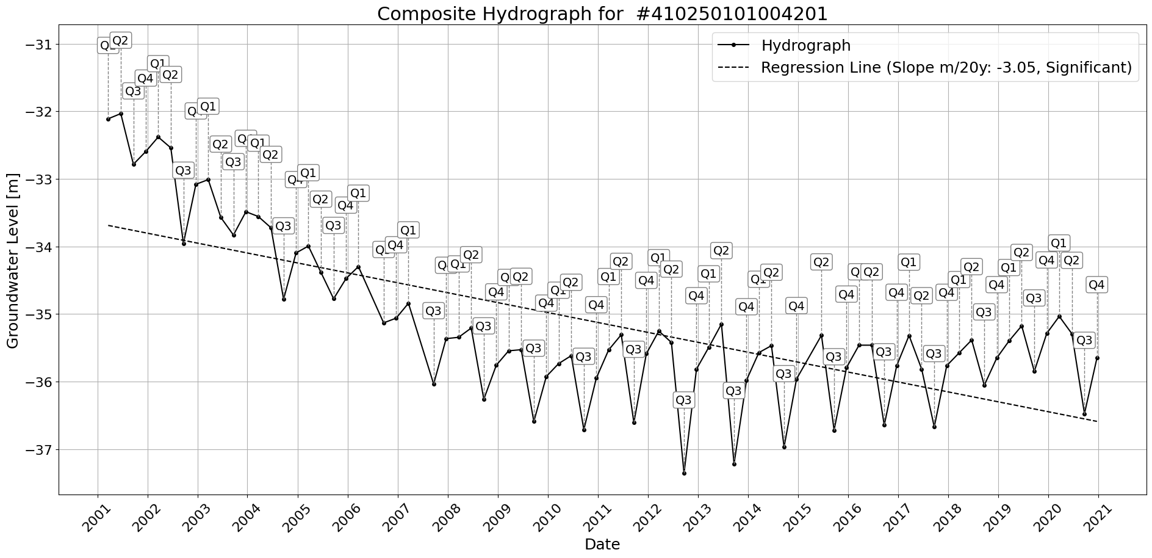

Figure: Site_#410250101004201.png

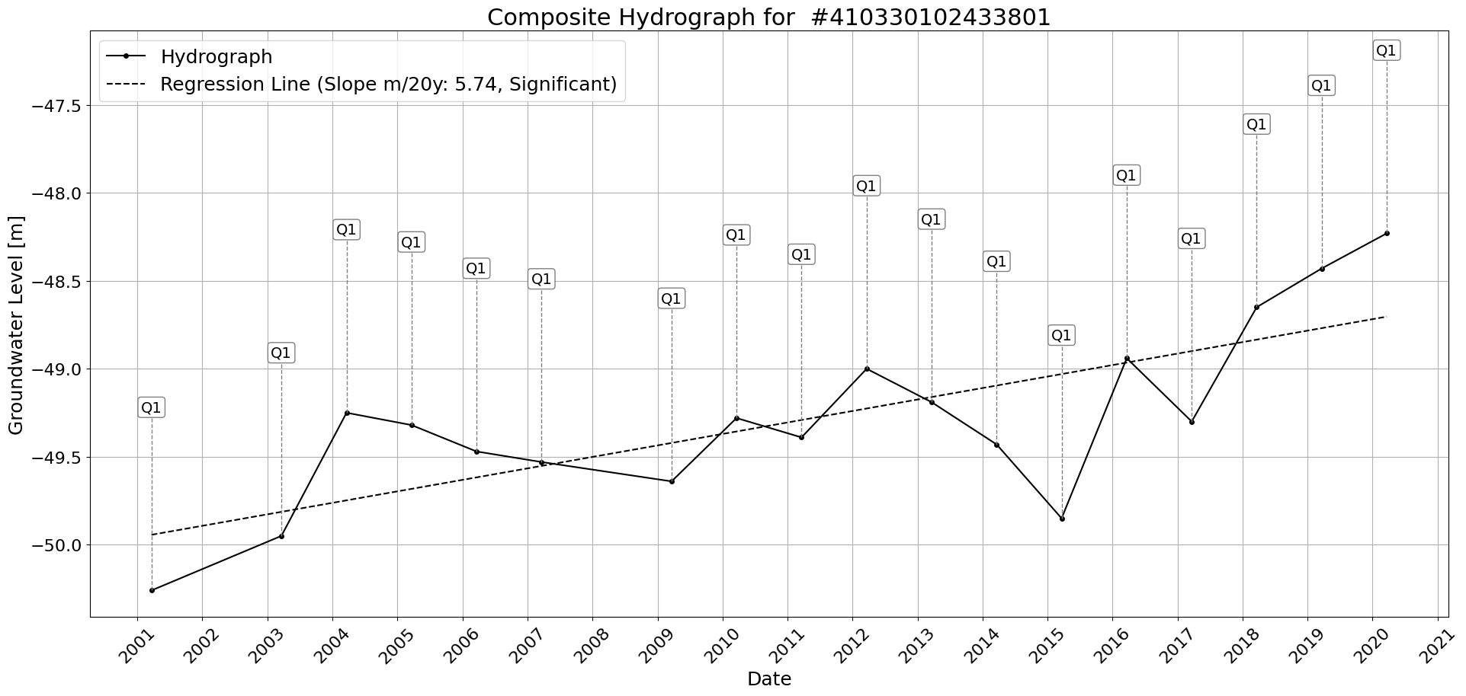

Figure: Site_#410330102433801.png

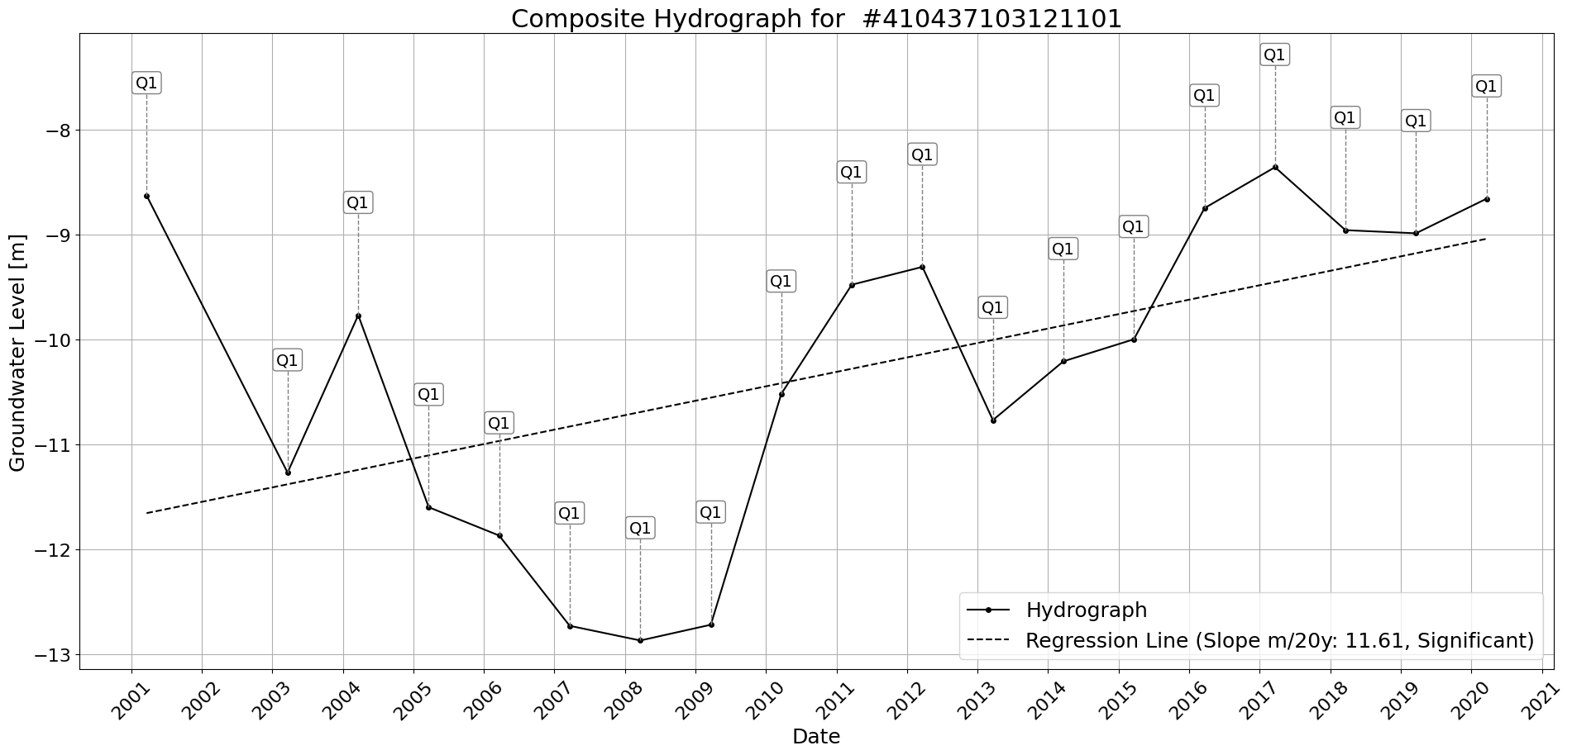

Figure: Site_#410437103121101.png

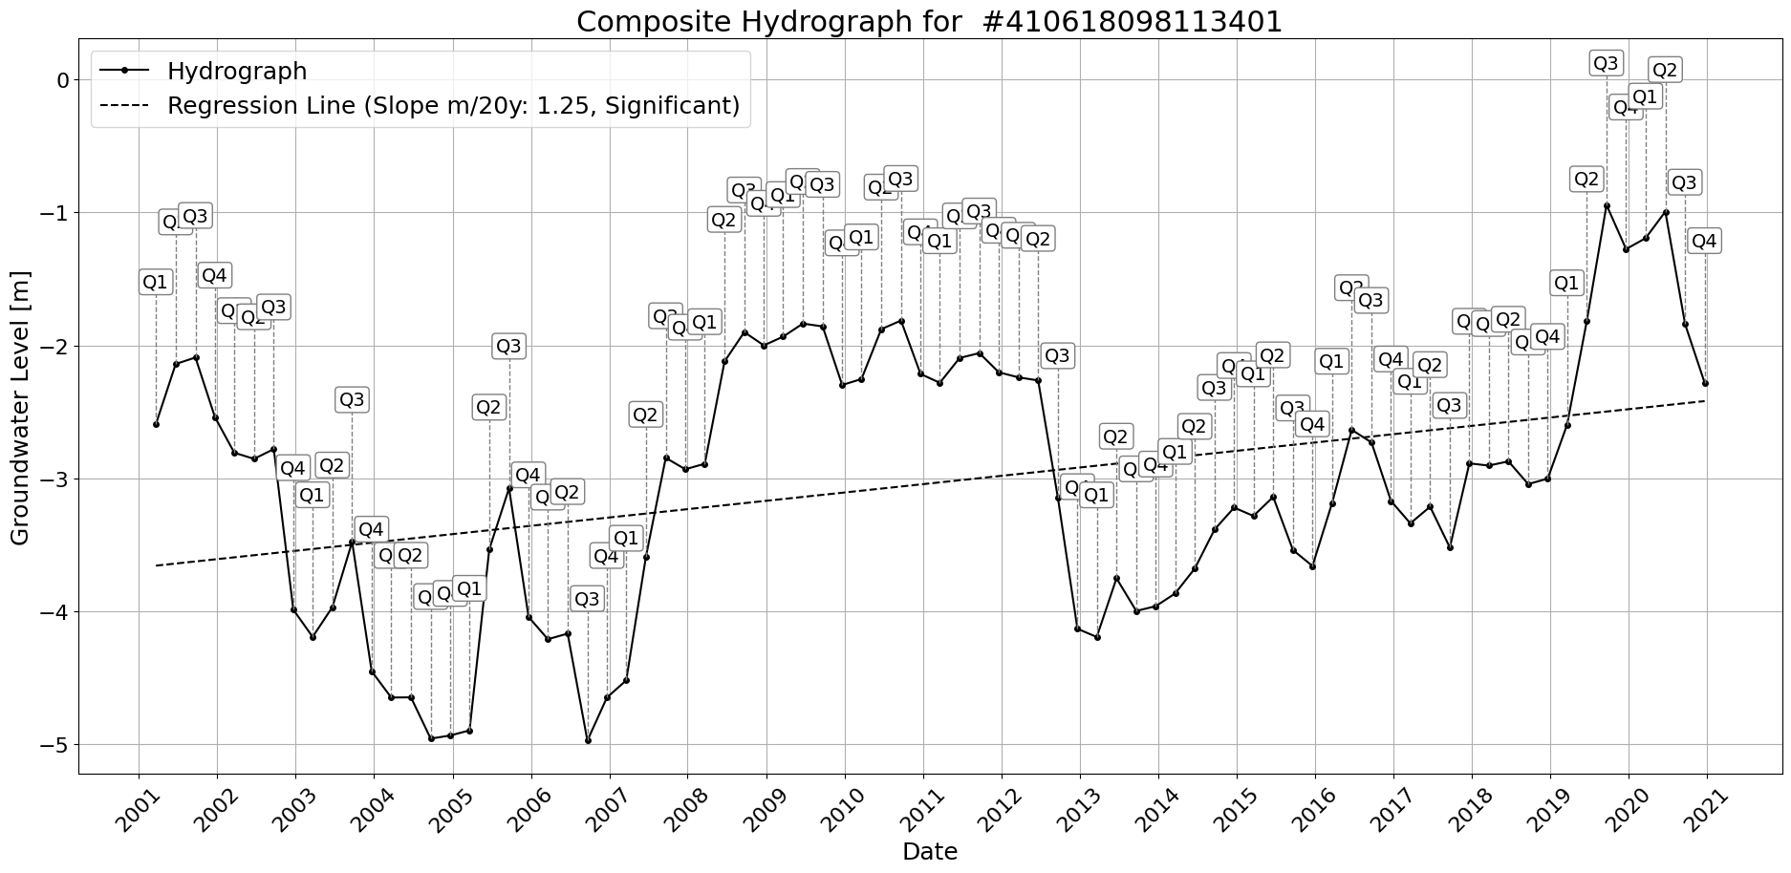

Figure: Site_#410618098113401.png

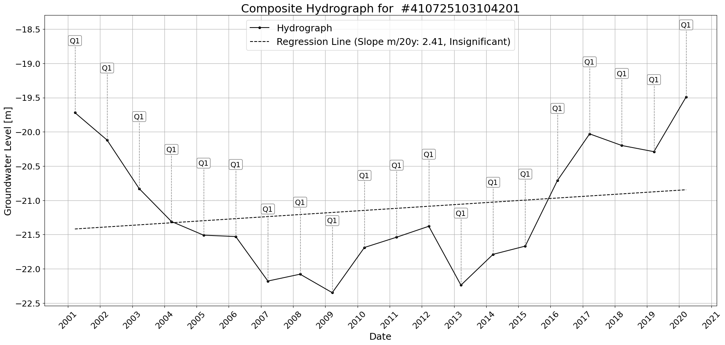

Figure: Site_#410725103104201.png

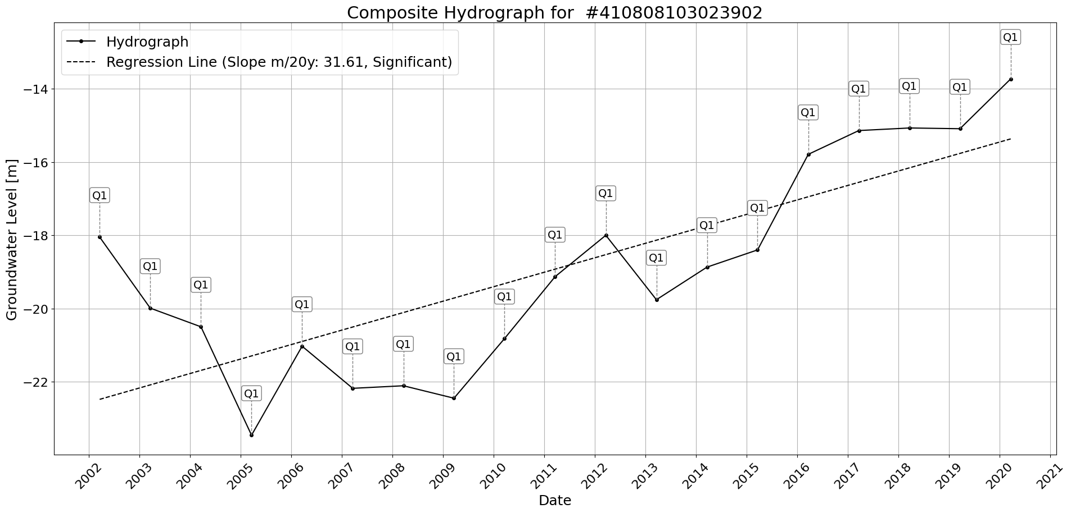

Figure: Site_#410808103023902.png

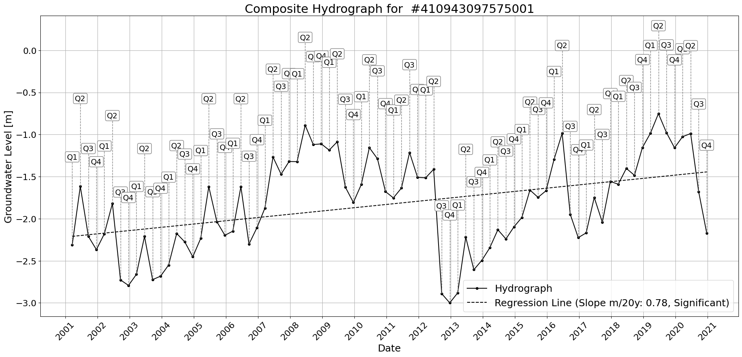

Figure: Site_#410943097575001.png

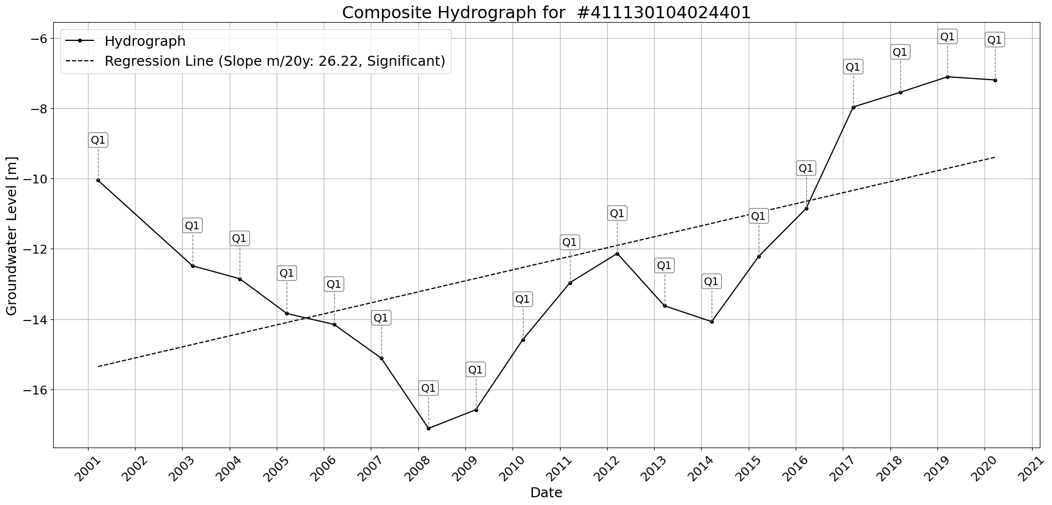

Figure: Site_#411130104024401.png

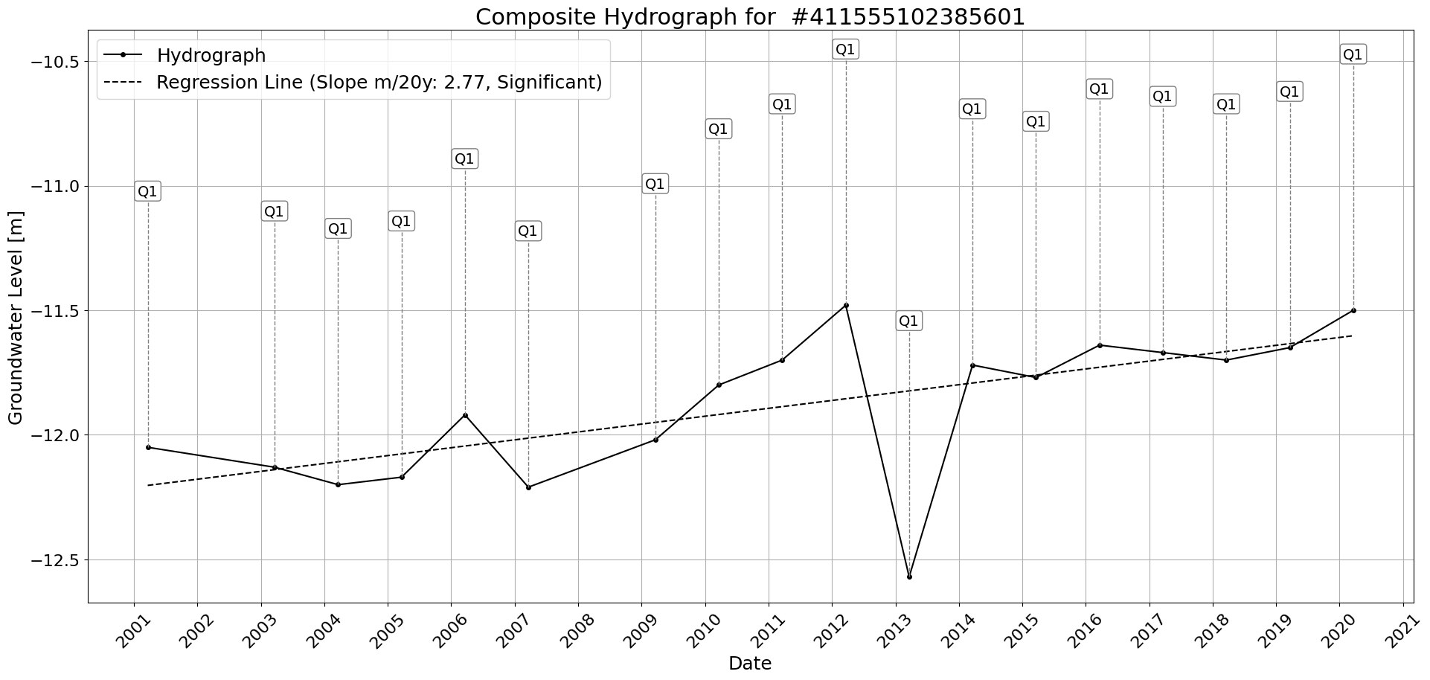

Figure: Site_#411555102385601.png

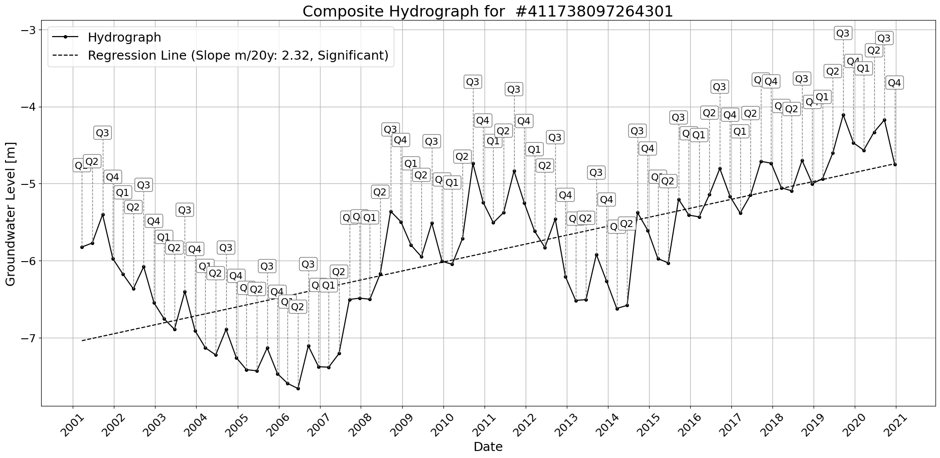

Figure: Site_#411738097264301.png

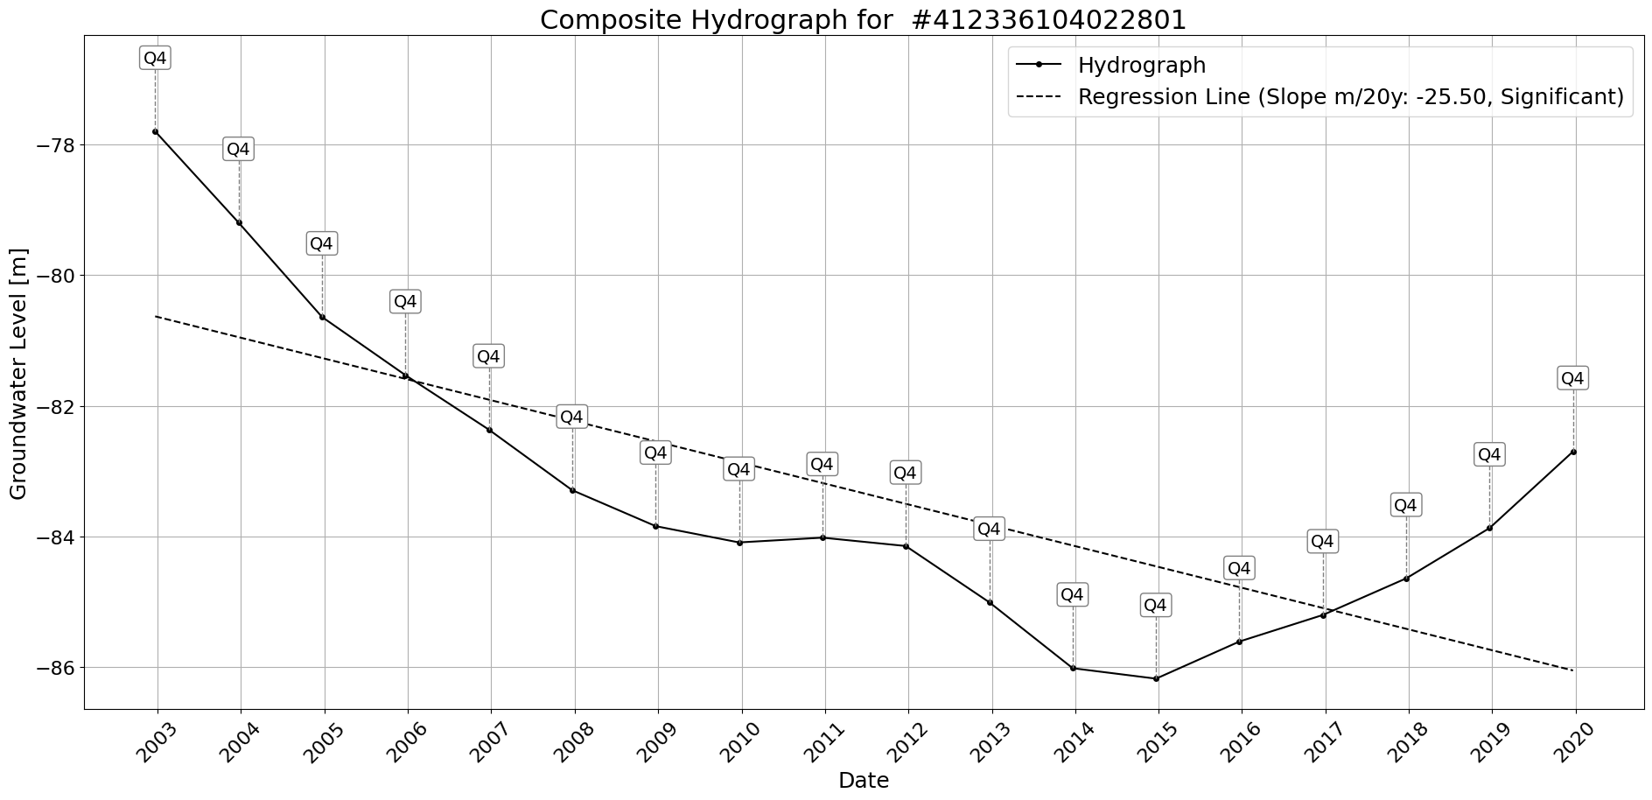

Figure: Site_#412336104022801.png

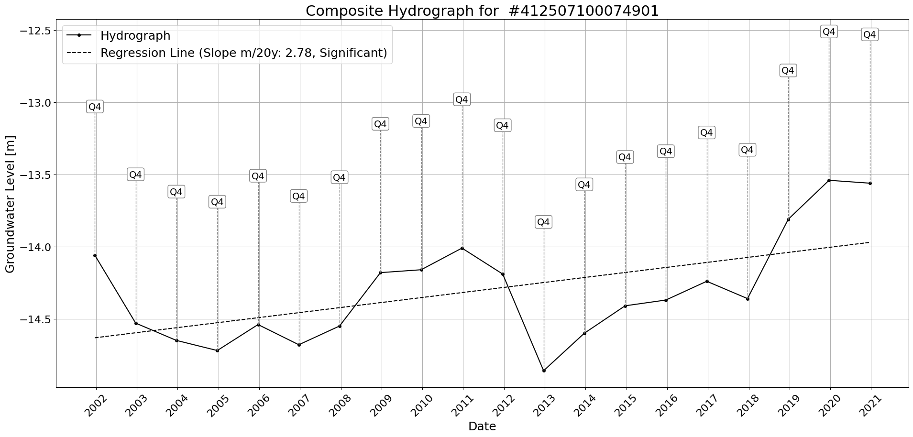

Figure: Site_#412507100074901.png

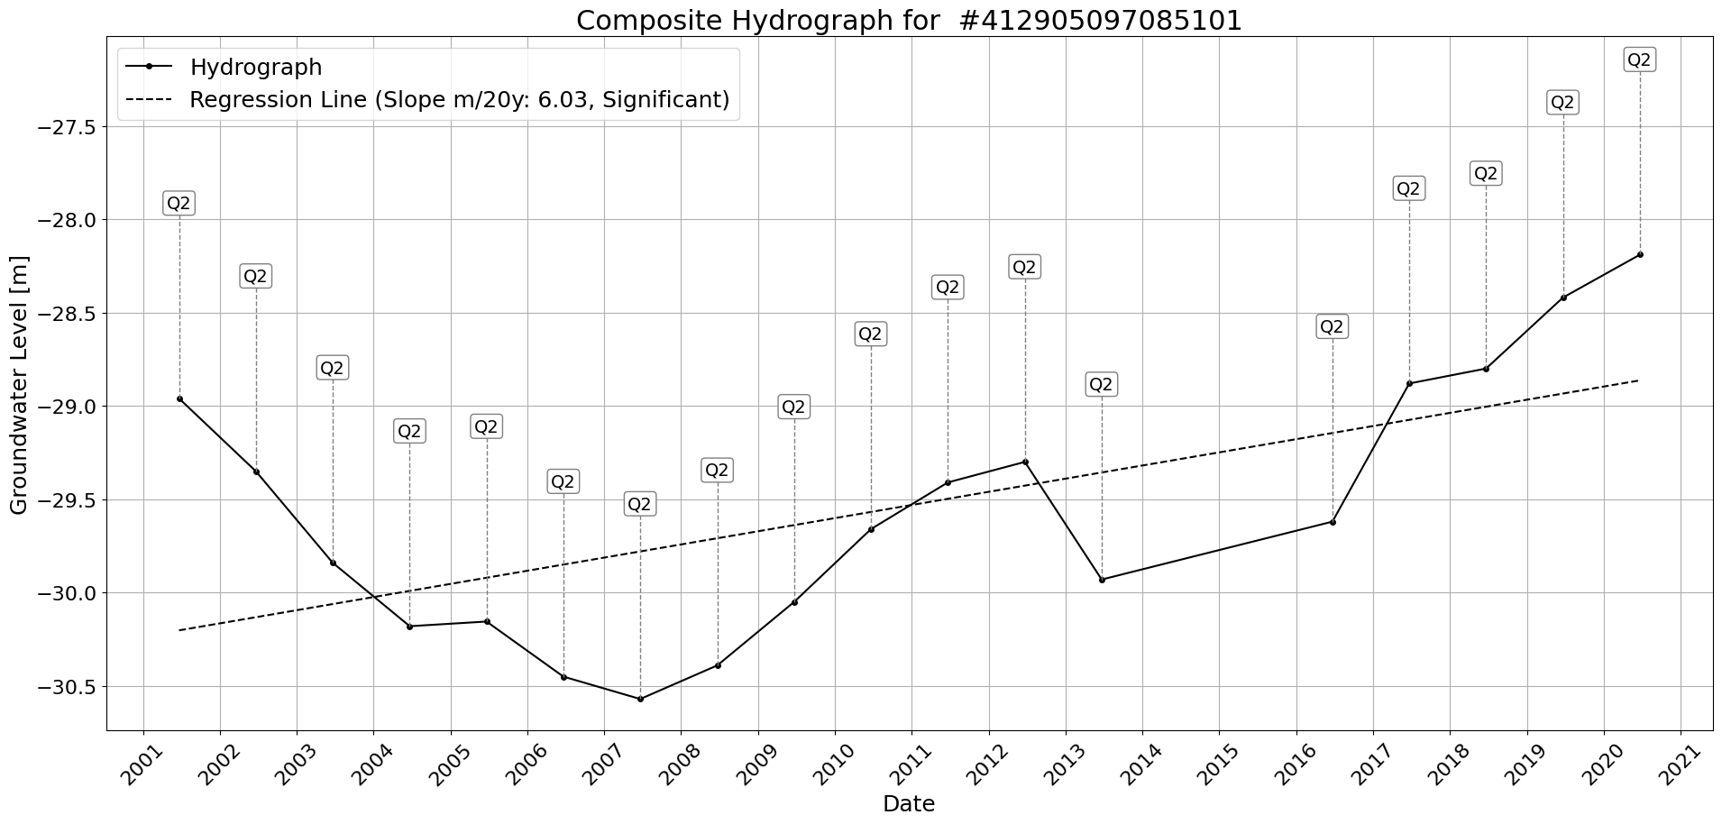

Figure: Site_#412905097085101.png

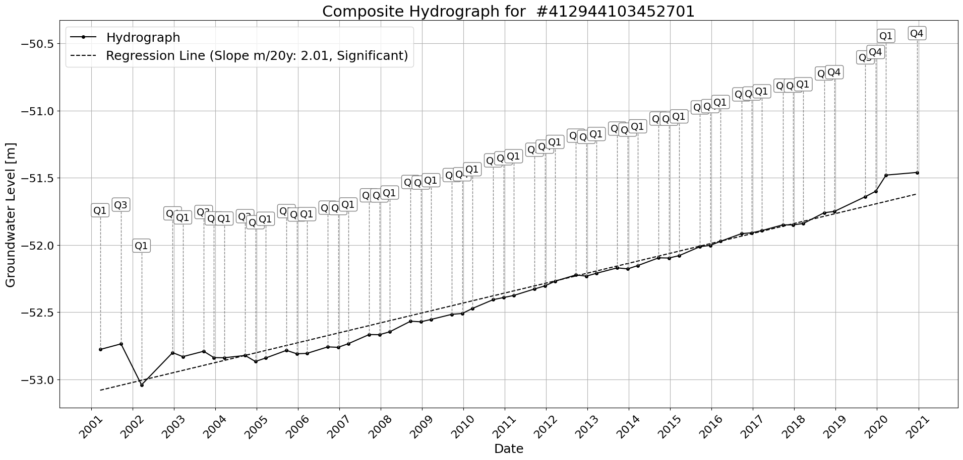

Figure: Site_#412944103452701.png

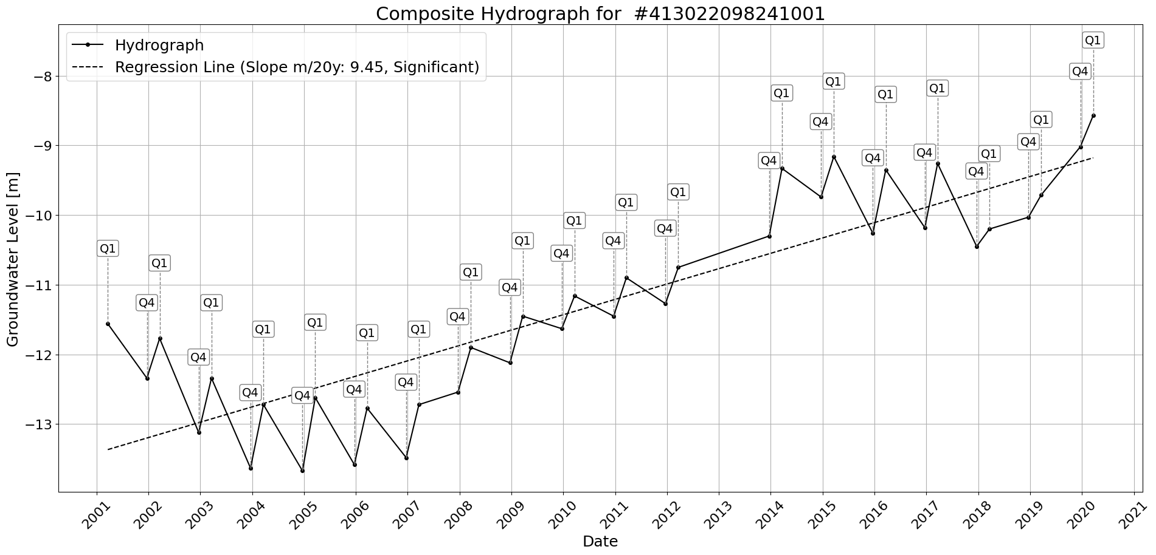

Figure: Site_#413022098241001.png

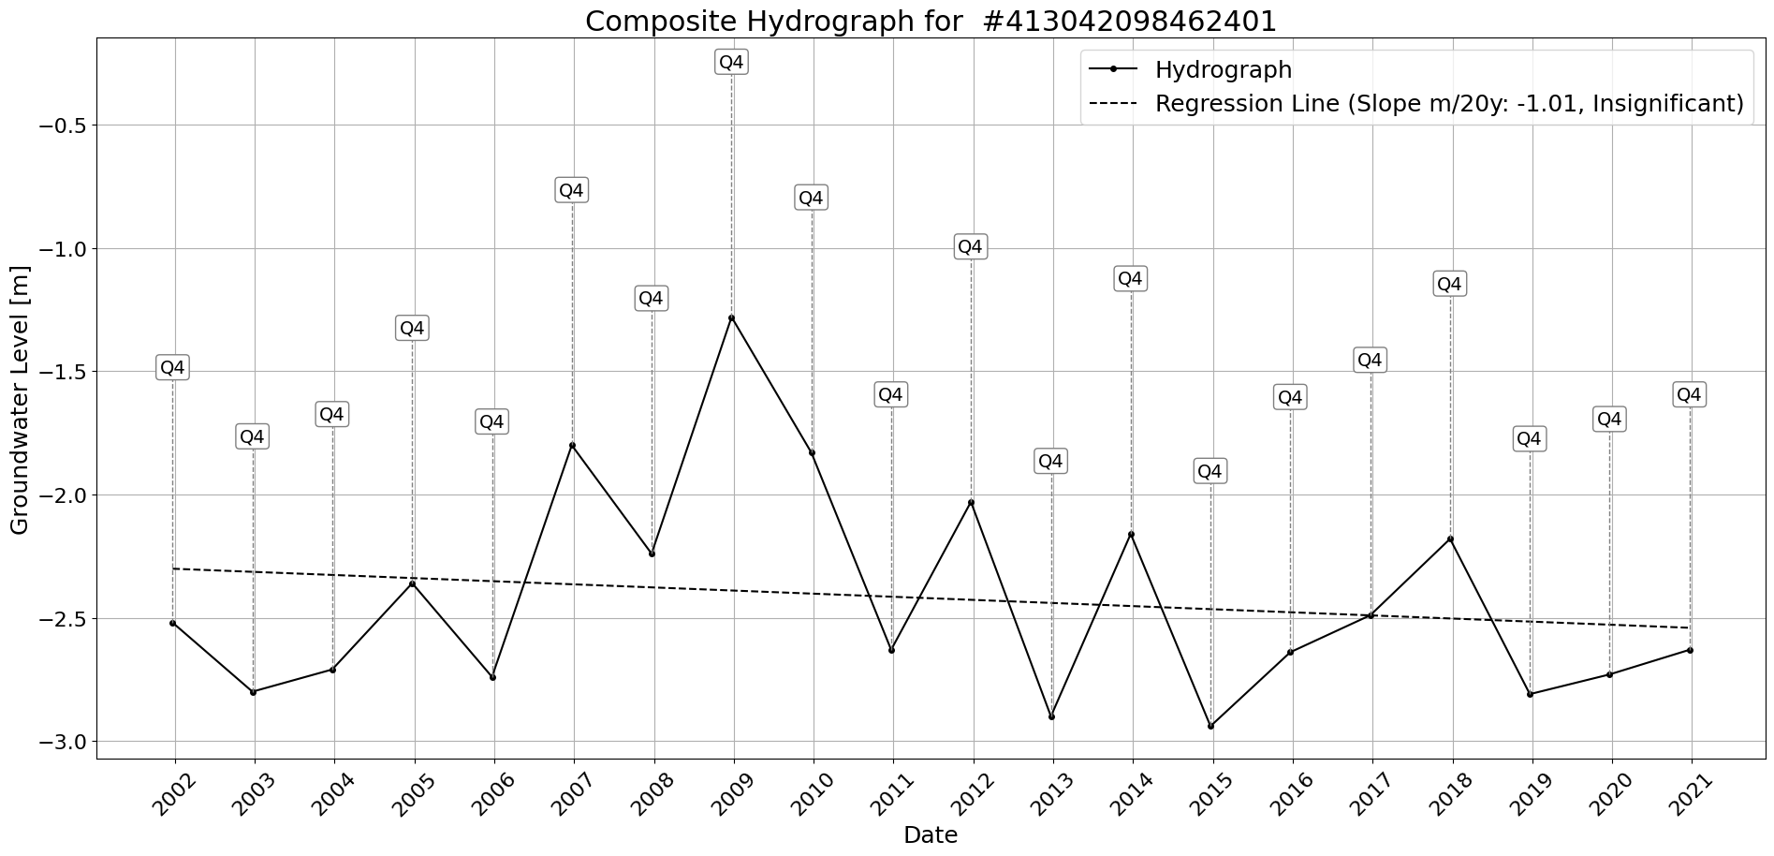

Figure: Site_#413042098462401.png

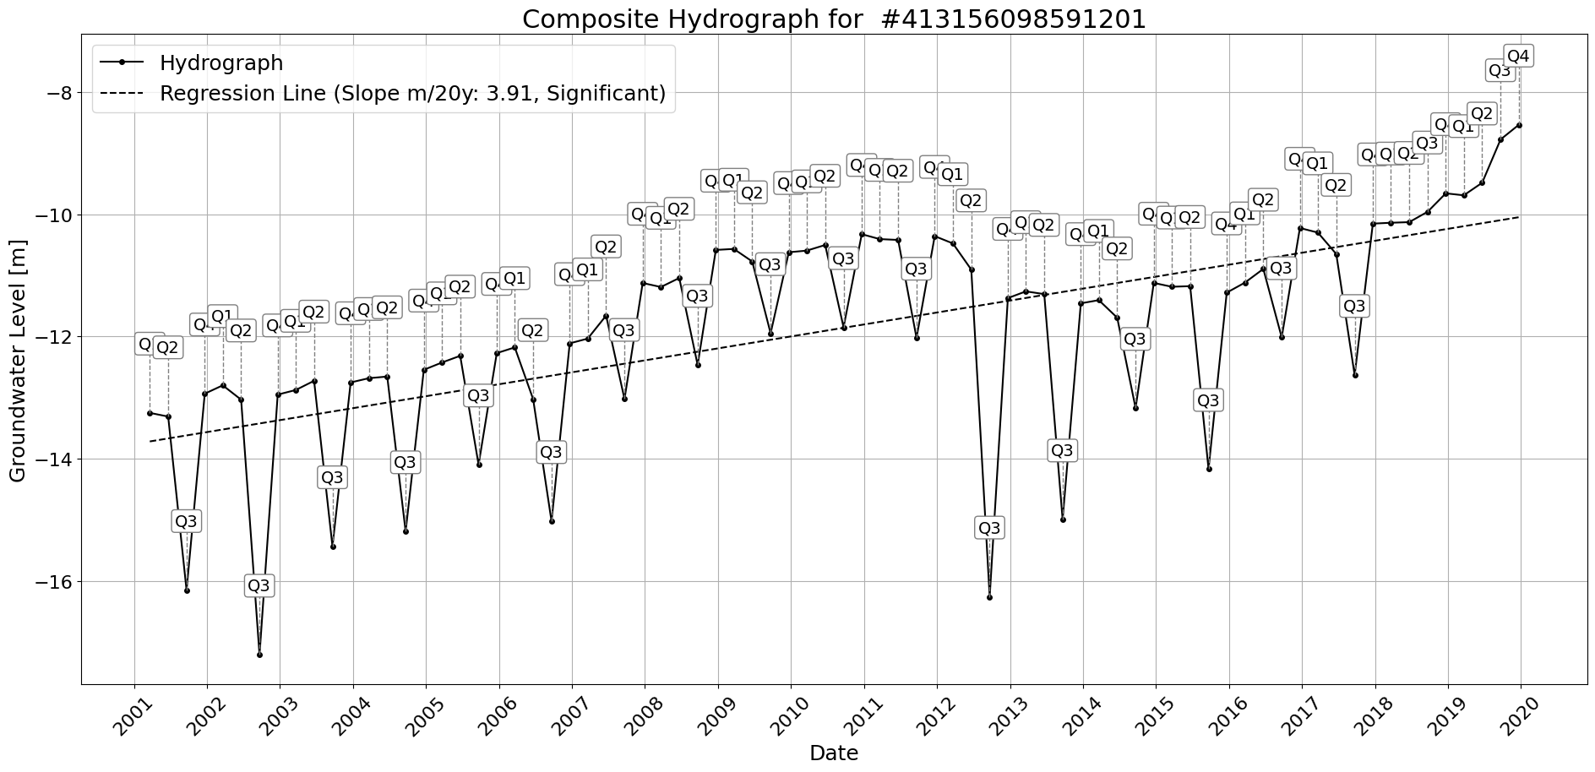

Figure: Site_#413156098591201.png

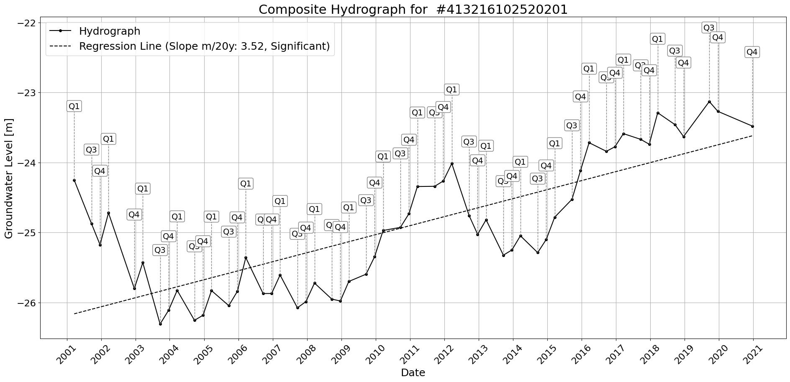

Figure: Site_#413216102520201.png

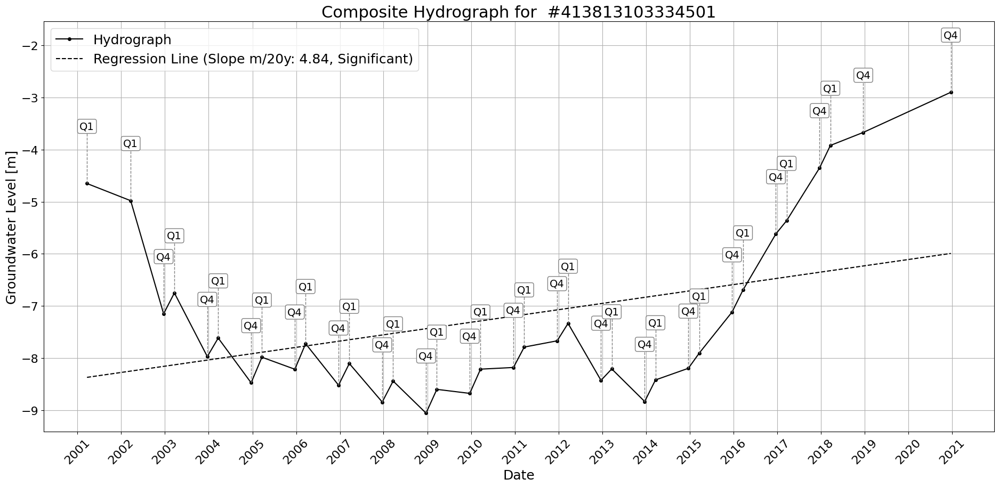

Figure: Site_#413813103334501.png

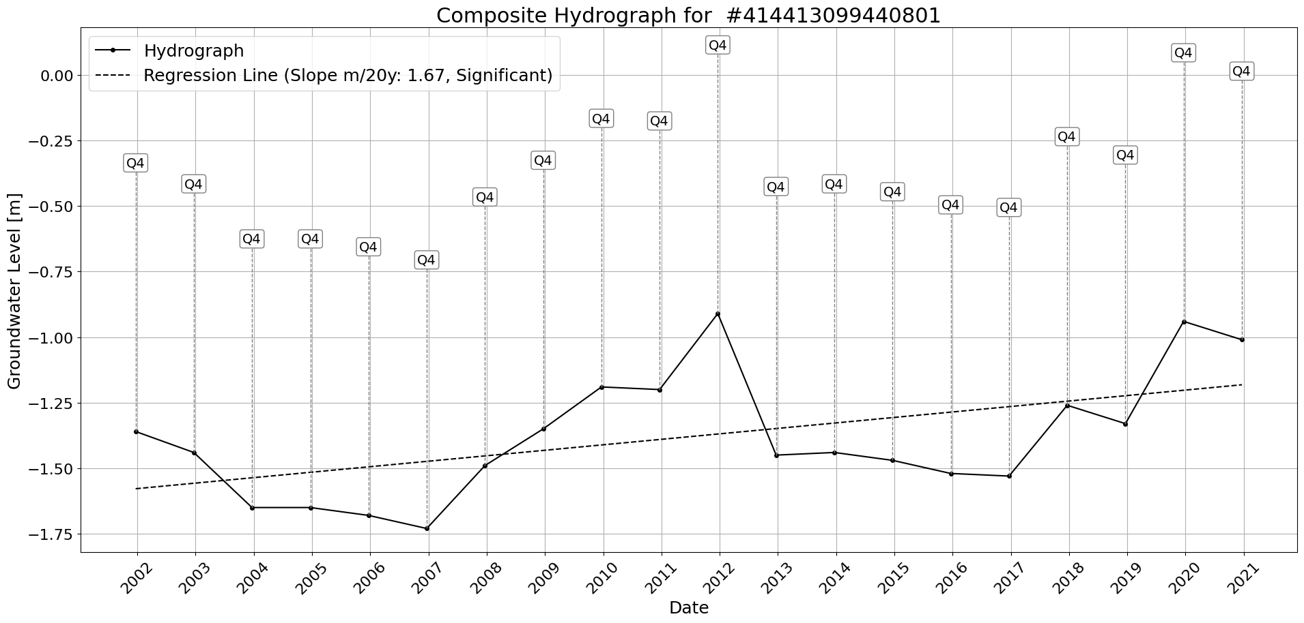

Figure: Site_#414413099440801.png

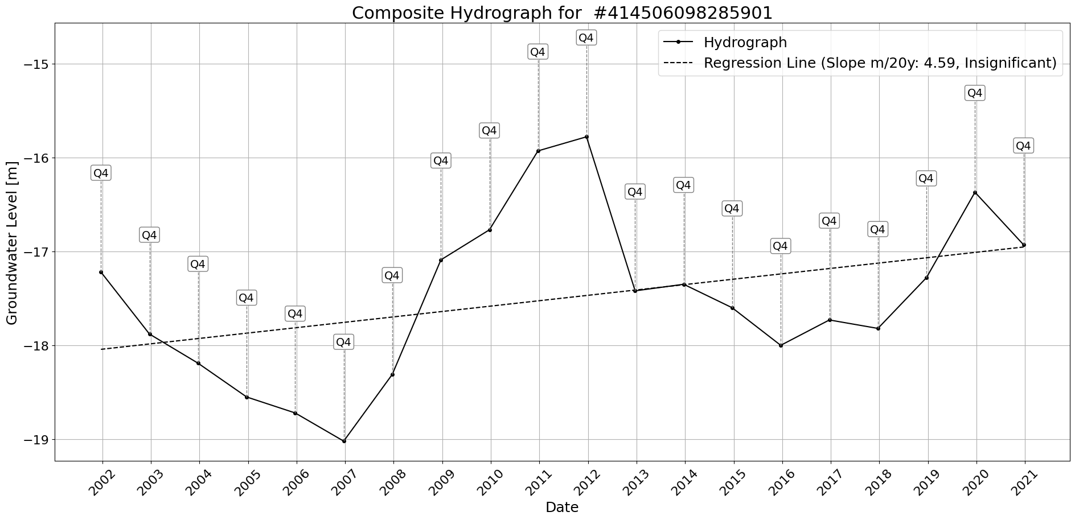

Figure: Site_#414506098285901.png

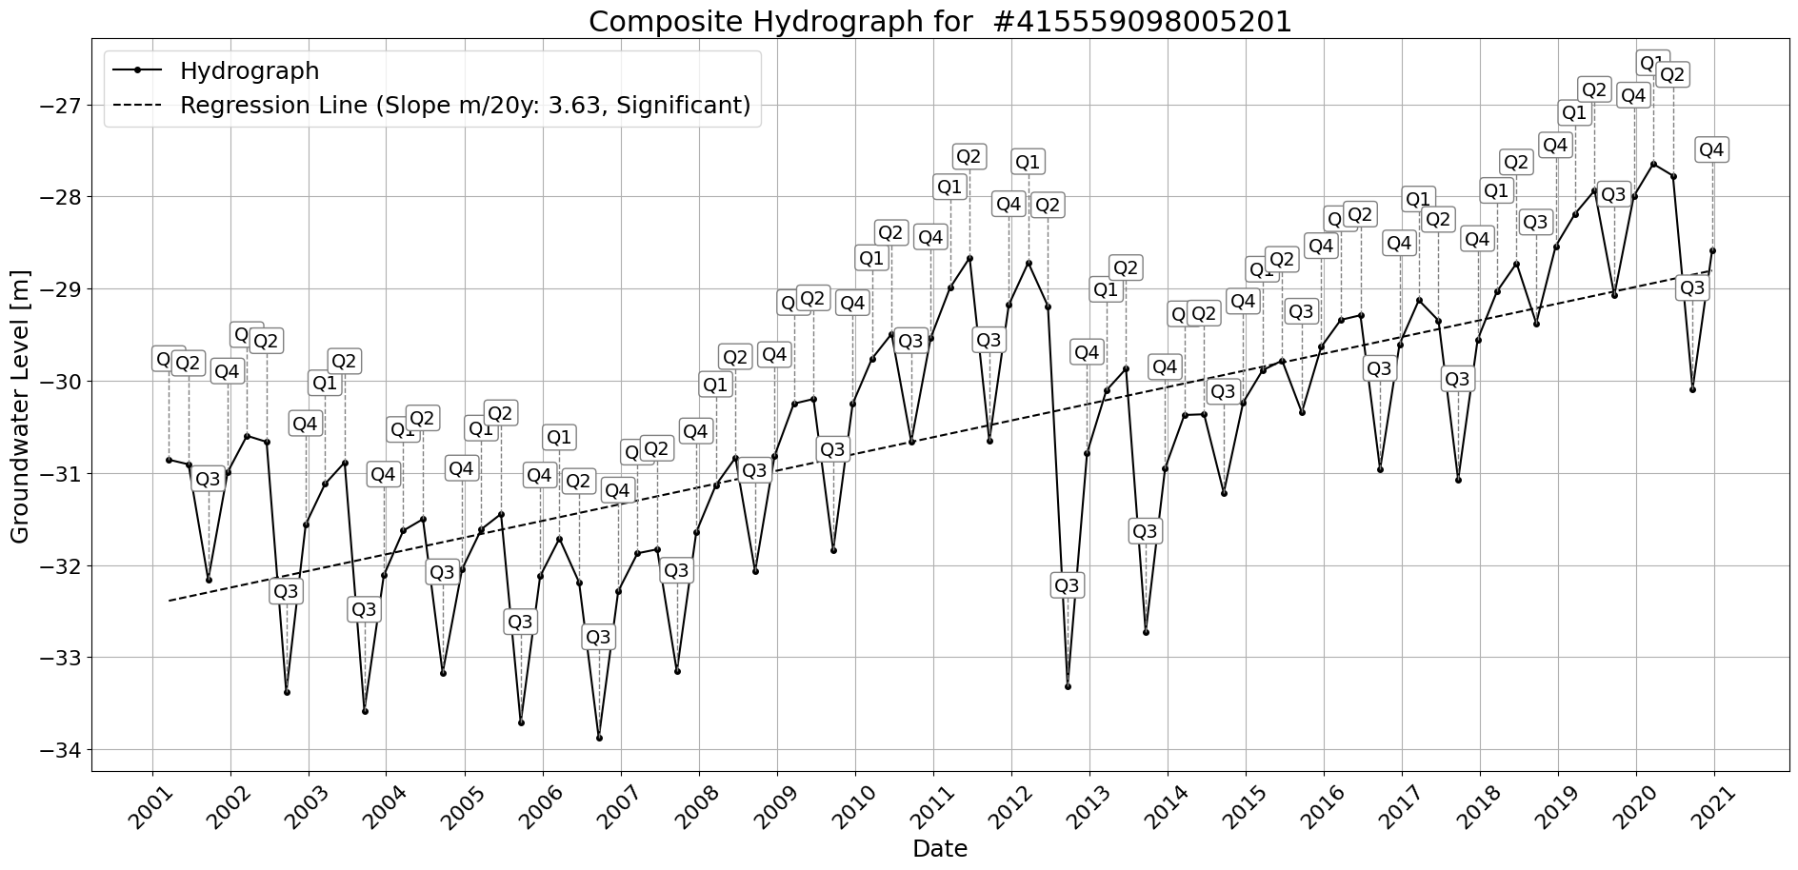

Figure: Site_#415559098005201.png

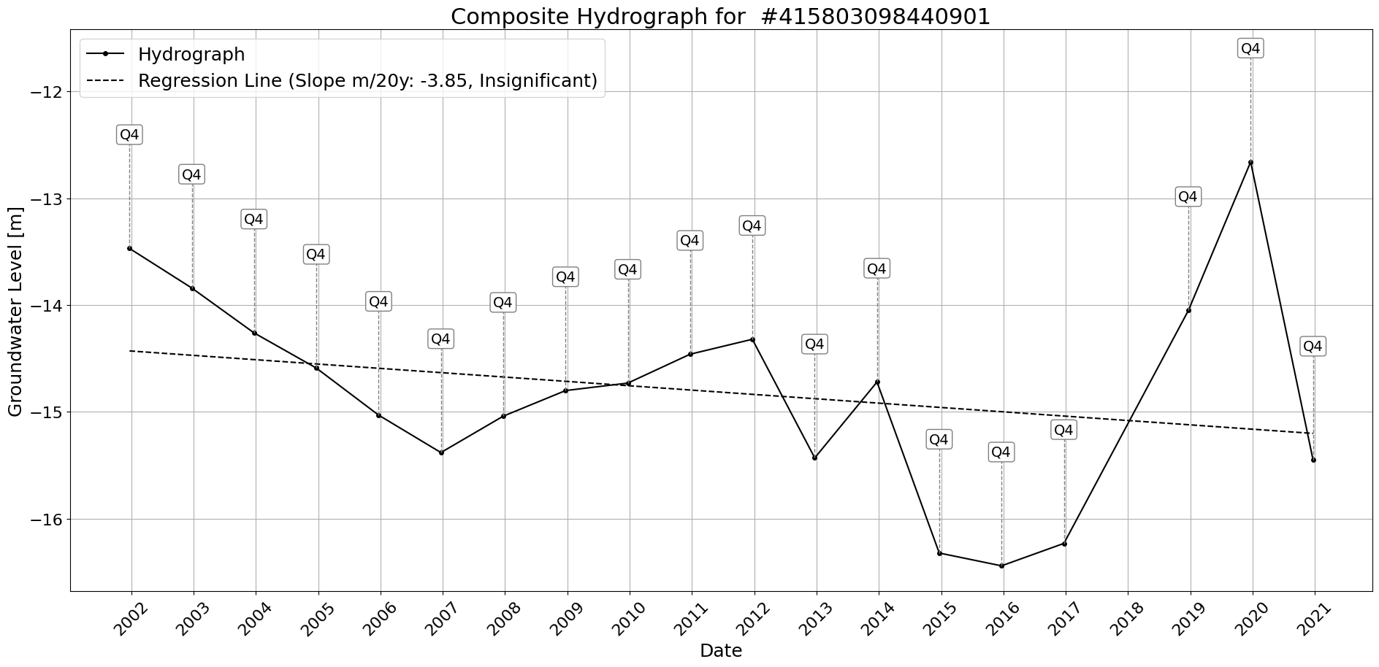

Figure: Site_#415803098440901.png

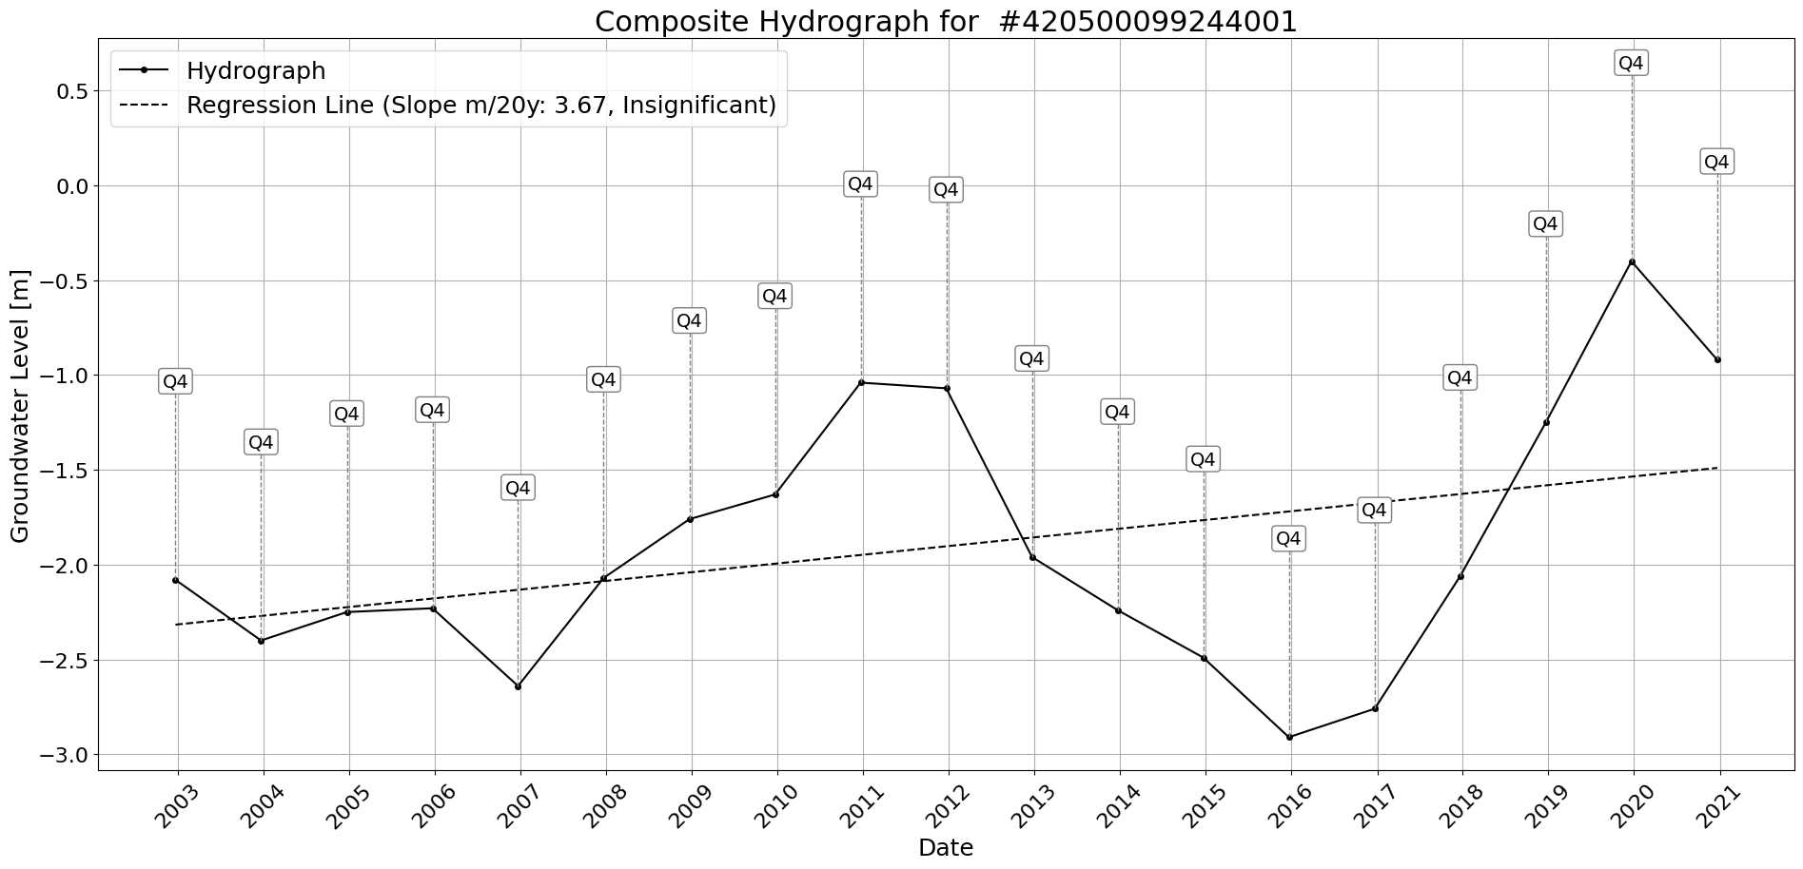

Figure: Site_#420500099244001.png

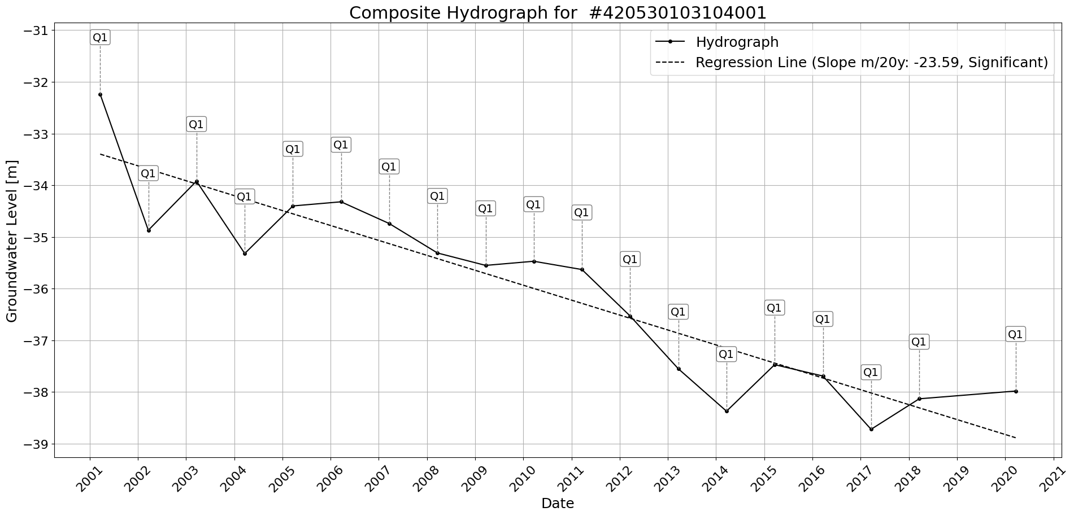

Figure: Site_#420530103104001.png

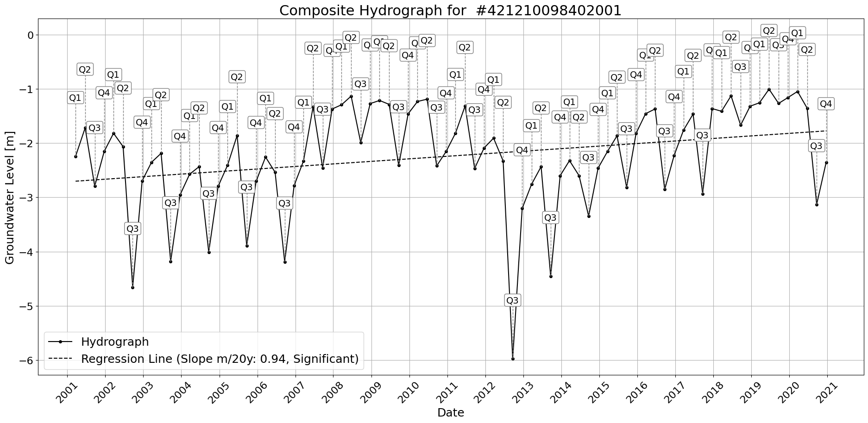

Figure: Site_#421210098402001.png

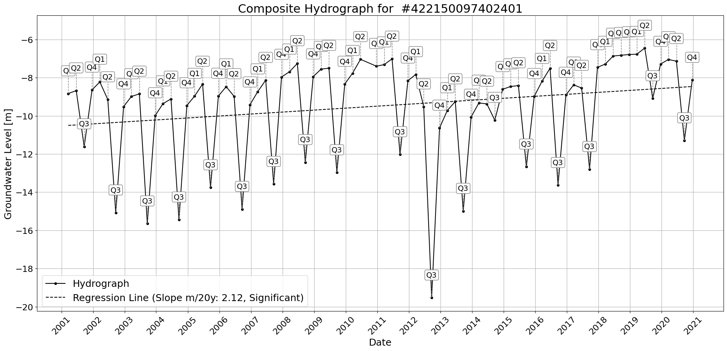

Figure: Site_#422150097402401.png

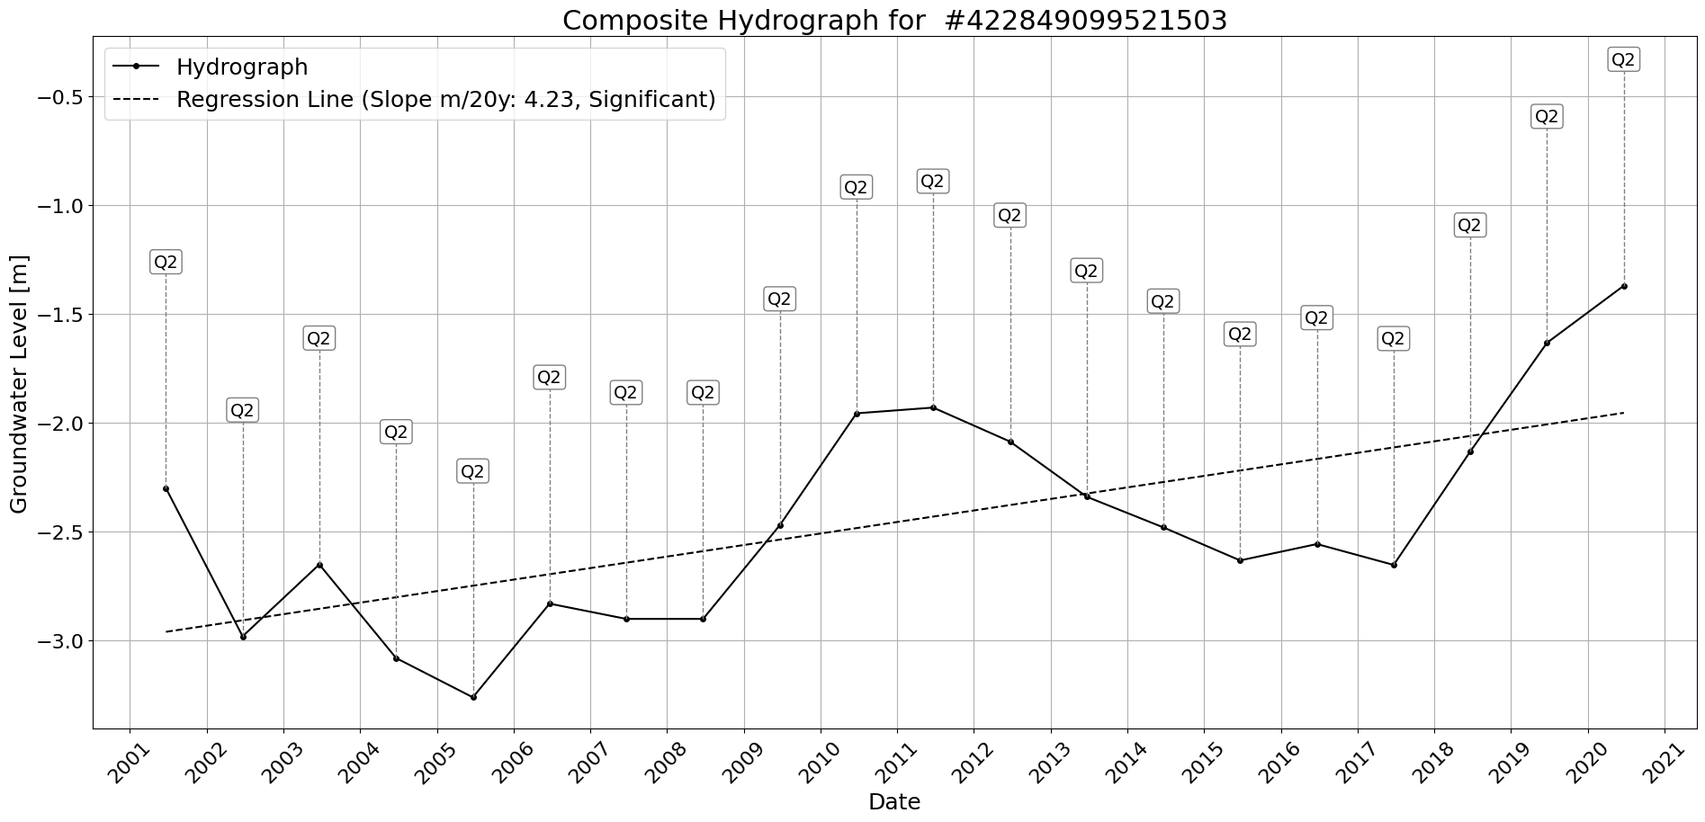

Figure: Site_#422849099521503.png

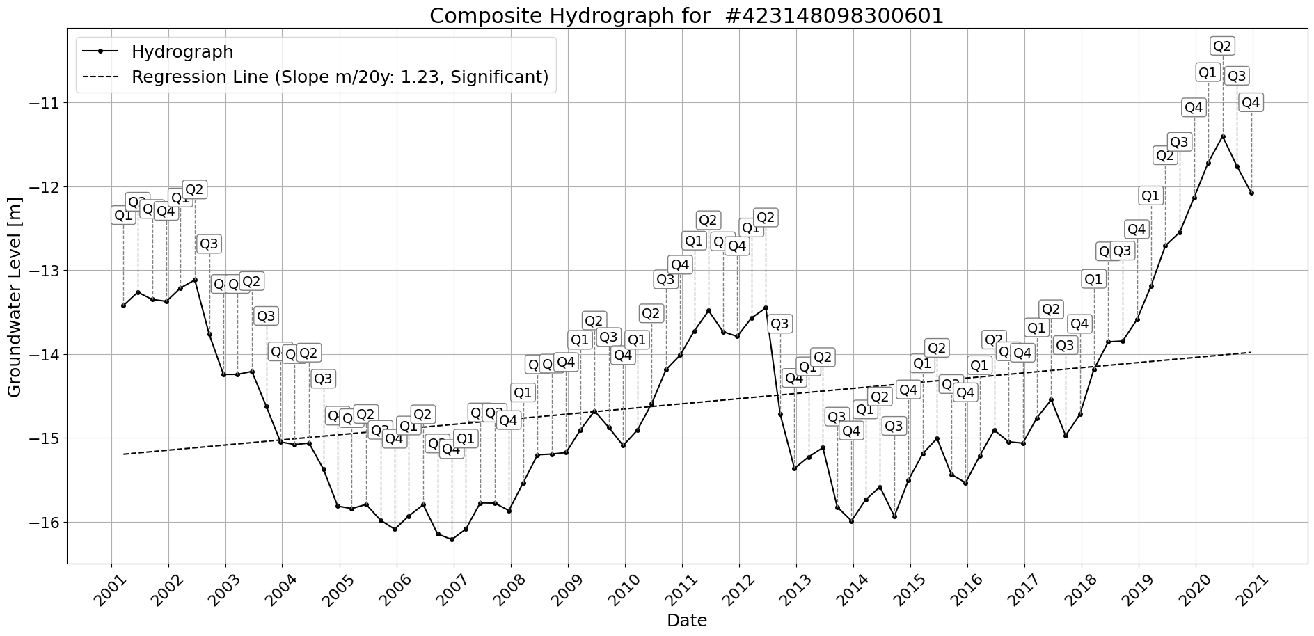

Figure: Site_#423148098300601.png

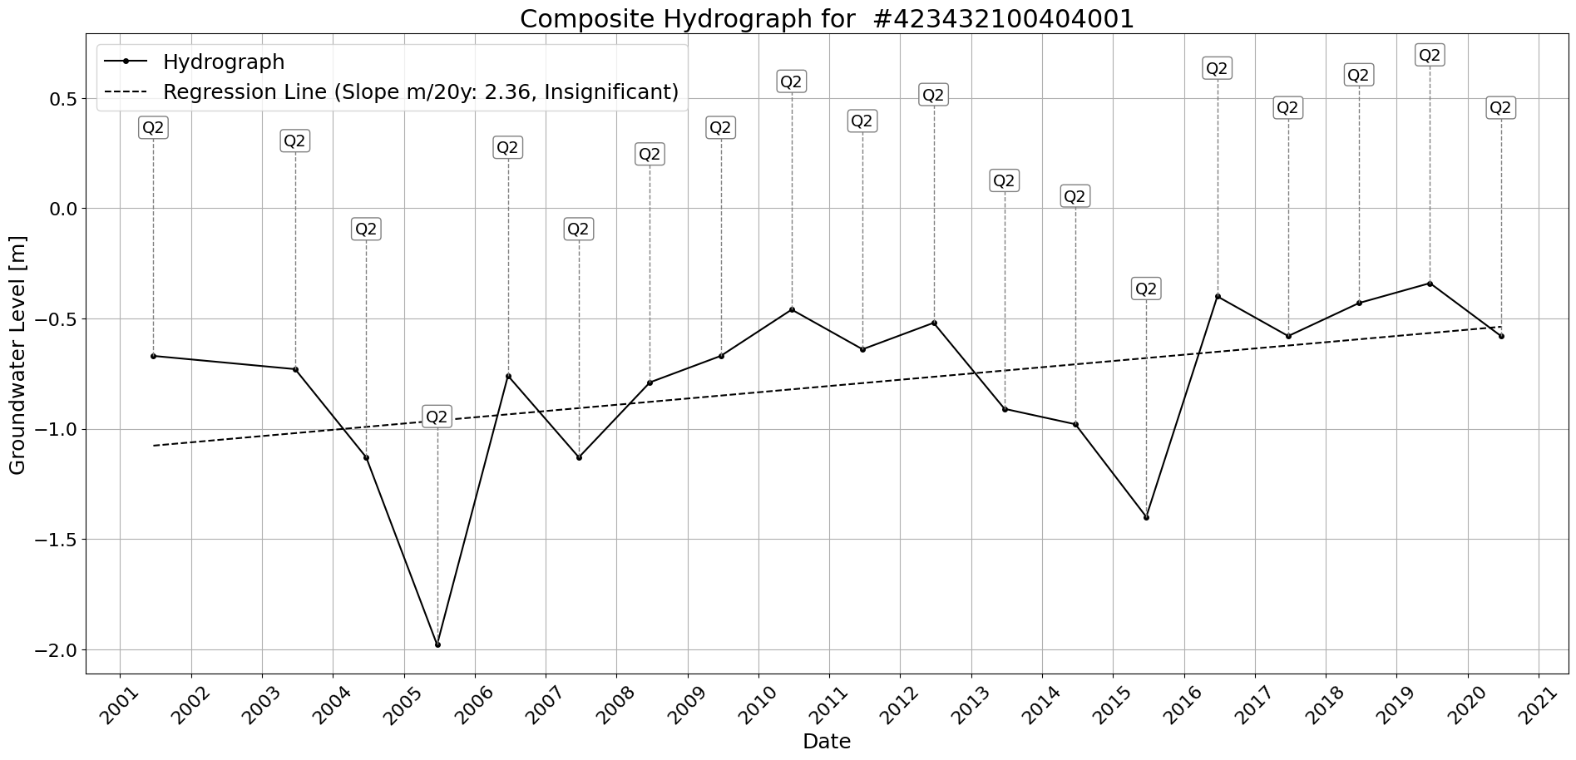

Figure: Site_#423432100404001.png

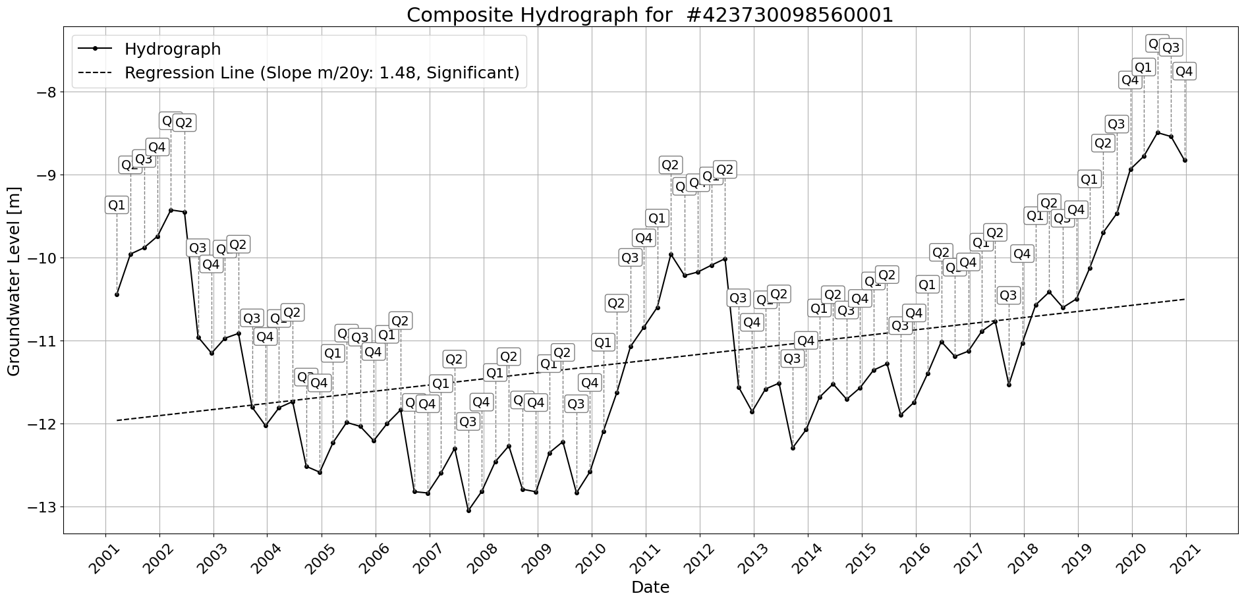

Figure: Site_#423730098560001.png

# Table of Figures

Figure Description Page

|  |  |  |
| --- | --- | --- |
|  |  |  |
| 1 | Figure 1: Site_#400155101521302.png | 1 |
| 2 | Figure 2: Site_#401626097210701.png | 2 |
| 3 | Figure 3: Site_#401837097015301.png | 3 |
| 4 | Figure 4: Site_#401928098292502.png | 4 |
| 5 | Figure 5: Site_#402103098475701.png | 5 |
| 6 | Figure 6: Site_#402105098543201.png | 6 |
| 7 | Figure 7: Site_#402236100013201.png | 7 |
| 8 | Figure 8: Site_#402324098220601.png | 8 |
| 9 | Figure 9: Site_#402411098370101.png | 9 |
| 10 | Figure 10: Site_#402415098311601.png | 10 |
| 11 | Figure 11: Site_#402507098255801.png | 11 |
| 12 | Figure 12: Site_#402636098534401.png | 12 |
| 13 | Figure 13: Site_#402726099461700.png | 13 |
| 14 | Figure 14: Site_#402946099481501.png | 14 |
| 15 | Figure 15: Site_#403014098002201.png | 15 |
| 16 | Figure 16: Site_#403107098210701.png | 16 |
| 17 | Figure 17: Site_#403309099250701.png | 17 |
| 18 | Figure 18: Site_#403326099582301.png | 18 |
| 19 | Figure 19: Site_#403409098263901.png | 19 |
| 20 | Figure 20: Site_#403422098395701.png | 20 |
| 21 | Figure 21: Site_#403509098463601.png | 21 |
| 22 | Figure 22: Site_#403853099493501.png | 22 |
| 23 | Figure 23: Site_#403855097072501.png | 23 |
| 24 | Figure 24: Site_#403903098295101.png | 24 |
| 25 | Figure 25: Site_#403941099331901.png | 25 |
| 26 | Figure 26: Site_#403952099583201.png | 26 |
| 27 | Figure 27: Site_#403954099152101.png | 27 |
| 28 | Figure 28: Site_#404001099463601.png | 28 |
| 29 | Figure 29: Site_#404237098395402.png | 29 |
| 30 | Figure 30: Site_#404343099272901.png | 30 |
| 31 | Figure 31: Site_#404513098181201.png | 31 |
| 32 | Figure 32: Site_#404513098181202.png | 32 |
| 33 | Figure 33: Site_#404618098504401.png | 33 |
| 34 | Figure 34: Site_#404717099460501.png | 34 |
| 35 | Figure 35: Site_#404949099445701.png | 35 |
| 36 | Figure 36: Site_#405014099591001.png | 36 |
| 37 | Figure 37: Site_#405129099090201.png | 37 |
| 38 | Figure 38: Site_#405137099085201.png | 38 |
| 39 | Figure 39: Site_#405227098165601.png | 39 |
| 40 | Figure 40: Site_#405305097351503.png | 40 |
| 41 | Figure 41: Site_#405315098304302.png | 41 |
| 42 | Figure 42: Site_#405406097115001.png | 42 |
| 43 | Figure 43: Site_#405445100074001.png | 43 |
| 44 | Figure 44: Site_#405632098373501.png | 44 |
| 45 | Figure 45: Site_#405732100531201.png | 45 |
| 46 | Figure 46: Site_#405744100403701.png | 46 |
| 47 | Figure 47: Site_#405921097514701.png | 47 |
| 48 | Figure 48: Site_#410102102232301.png | 48 |
| 49 | Figure 49: Site_#410154099394701.png | 49 |
| 50 | Figure 50: Site_#410250101004201.png | 50 |
| 51 | Figure 51: Site_#410330102433801.png | 51 |
| 52 | Figure 52: Site_#410437103121101.png | 52 |
| 53 | Figure 53: Site_#410618098113401.png | 53 |
| 54 | Figure 54: Site_#410725103104201.png | 54 |
| 55 | Figure 55: Site_#410808103023902.png | 55 |
| 56 | Figure 56: Site_#410943097575001.png | 56 |
| 57 | Figure 57: Site_#411130104024401.png | 57 |
| 58 | Figure 58: Site_#411555102385601.png | 58 |
| 59 | Figure 59: Site_#411738097264301.png | 59 |
| 60 | Figure 60: Site_#412336104022801.png | 60 |
| 61 | Figure 61: Site_#412507100074901.png | 61 |
| 62 | Figure 62: Site_#412905097085101.png | 62 |
| 63 | Figure 63: Site_#412944103452701.png | 63 |
| 64 | Figure 64: Site_#413022098241001.png | 64 |
| 65 | Figure 65: Site_#413042098462401.png | 65 |
| 66 | Figure 66: Site_#413156098591201.png | 66 |
| 67 | Figure 67: Site_#413216102520201.png | 67 |
| 68 | Figure 68: Site_#413813103334501.png | 68 |
| 69 | Figure 69: Site_#414413099440801.png | 69 |
| 70 | Figure 70: Site_#414506098285901.png | 70 |
| 71 | Figure 71: Site_#415559098005201.png | 71 |
| 72 | Figure 72: Site_#415803098440901.png | 72 |
| 73 | Figure 73: Site_#420500099244001.png | 73 |
| 74 | Figure 74: Site_#420530103104001.png | 74 |
| 75 | Figure 75: Site_#421210098402001.png | 75 |
| 76 | Figure 76: Site_#422150097402401.png | 76 |
| 77 | Figure 77: Site_#422849099521503.png | 77 |
| 78 | Figure 78: Site_#423148098300601.png | 78 |
| 79 | Figure 79: Site_#423432100404001.png | 79 |
| 80 | Figure 80: Site_#423730098560001.png | 80 |